Introduction to C Programming
Looping Constructs
Computers are very good at performing repetitive tasks very quickly. In this section we will learn how to make computer repeat actions either a specified number of times or until some stopping condition is met.

while Loops ( Condition-Controlled Loops )
- Both while loops and do-while loops ( see below ) are condition-controlled, meaning that they continue to loop until some condition is met.
- Both while and do-while loops alternate between performing actions and testing for the stopping condition.
- While loops check for the stopping condition first, and may not execute the body of the loop at all if the condition is initially false.
- Syntax:
while( condition )
body;
where the body can be either a single statement or a block of statements within { curly braces }.
- Example:
int i = 0;
while( i < 5 )
printf( "i = %d\n", i++ );
printf( "After loop, i = %d\n", i );

do-while Loops
- do-while loops are exactly like while loops, except that the test is performed at the end of the loop rather than the beginning.
- This guarantees that the loop will be performed at least once, which is useful for checking user input among other things ( see example below. )
- Syntax:
do {
body;
} while( condition );
- In theory the body can be either a single statement or a block of statements within { curly braces }, but in practice the curly braces are almost always used with do-whiles.
- Example:
int month;
do {
printf( "Please enter the month of your birth > " );
scanf( "%d", &month );
} while ( month < 1 || month > 12 );
- Note that the above example could be improved by reporting to the user what the problem is if month is not in the range 1 to 12, and that it could also be done using a while loop if month were initialized to a value that ensures entering the loop.
- The following diagram shows the difference between while and do-while loops. Note that once you enter the loop, the operation is identical from that point forward:

for Loops
- for-loops are counter-controlled, meaning that they are normally used whenever the number of iterations is known in advance.
- Syntax:
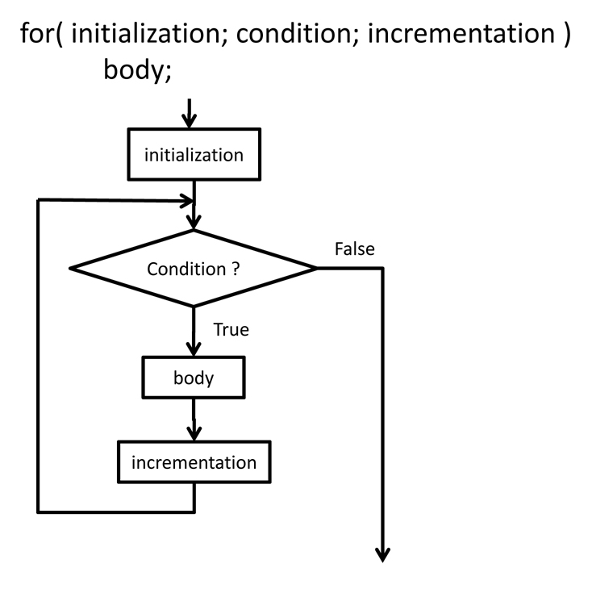

where again the body can be either a single statement or a block of statements within { curly braces }.
- Details:
  - The initialization step occurs one time only, before the loop begins.
  - The condition is tested at the beginning of each iteration of the loop.
    - If the condition is true ( non-zero ), then the body of the loop is executed next.
    - If the condition is false ( zero ), then the body is not executed, and execution continues with the code following the loop.
  - The incrementation happens AFTER the execution of the body, and only when the body is executed.
- Example:
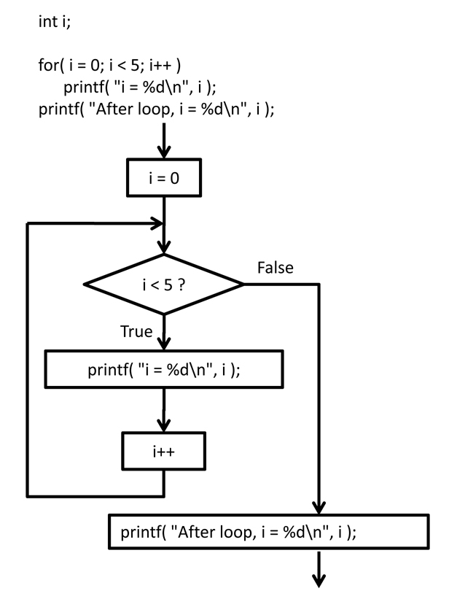
- Special Notes:
  - The third part of the loop is labeled "incrementation", because it usually takes the form of "i++" or something similar. However it can be any legal C/C++ statement, such as "N += 3" or "counter = base + delta".
  - In the example above, the variable i is declared before the loop, and continues to exist after the loop has completed. You will also see occasions where the loop variable is declared as part of the for loop, ( in C99 ), in which case the variable exists only within the body of the loop, and is no longer valid when the loop completes:
for( int i = 0; i < 5; i++ )
printf( "i = %d\n", i );
printf( "After loop, i is no longer valid\n" );

Arrays a kind of data structure that can store a fixed-size sequential collection of elements of the same type. An array is used to store a collection of data, but it is often more useful to think of an array as a collection of variables of the same type.
Instead of declaring individual variables, such as number0, number1, ..., and number99, you declare one array variable such as numbers and use numbers[0], numbers[1], and ..., numbers[99] to represent individual variables. A specific element in an array is accessed by an index.
All arrays consist of contiguous memory locations. The lowest address corresponds to the first element and the highest address to the last element.
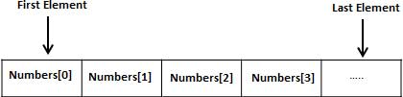

Declaring Arrays
To declare an array in C, a programmer specifies the type of the elements and the number of elements required by an array as follows −
type arrayName [ arraySize ];
This is called a single-dimensional array. The arraySize must be an integer constant greater than zero and type can be any valid C data type. For example, to declare a 10-element array called balance of type double, use this statement −
double balance[10];
Here balance is a variable array which is sufficient to hold up to 10 double numbers.

Initializing Arrays
You can initialize an array in C either one by one or using a single statement as follows −
double balance[5] = {1000.0, 2.0, 3.4, 7.0, 50.0};
The number of values between braces { } cannot be larger than the number of elements that we declare for the array between square brackets [ ].
If you omit the size of the array, an array just big enough to hold the initialization is created. Therefore, if you write −
double balance[] = {1000.0, 2.0, 3.4, 7.0, 50.0};
You will create exactly the same array as you did in the previous example. Following is an example to assign a single element of the array −
balance[4] = 50.0;
The above statement assigns the 5th element in the array with a value of 50.0. All arrays have 0 as the index of their first element which is also called the base index and the last index of an array will be total size of the array minus 1. Shown below is the pictorial representation of the array we discussed above −
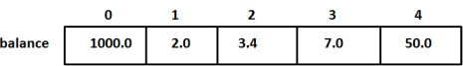

Accessing Array Elements
An element is accessed by indexing the array name. This is done by placing the index of the element within square brackets after the name of the array. For example −
double salary = balance[9];
The above statement will take the 10th element from the array and assign the value to salary variable. The following example Shows how to use all the three above mentioned concepts viz. declaration, assignment, and accessing arrays −
#include <stdio.h>

int main () {

int n[ 10 ]; /* n is an array of 10 integers */
int i,j;

/* initialize elements of array n to 0 */
for ( i = 0; i < 10; i++ ) {
n[ i ] = i + 100; /* set element at location i to i + 100 */
}

/* output each array element's value */
for (j = 0; j < 10; j++ ) {
printf("Element[%d] = %d\n", j, n[j] );
}

return 0;
}
When the above code is compiled and executed, it produces the following result −
Element[0] = 100
Element[1] = 101
Element[2] = 102
Element[3] = 103
Element[4] = 104
Element[5] = 105
Element[6] = 106
Element[7] = 107
Element[8] = 108
Element[9] = 109

There are following types of arrays in the C programming language –
- One – dimensional arrays
- Two – dimensional arrays
- Multidimensional arrays

1D Arrays in C language – A list of items can be given one variable name using only one subscript and such a variable is called single sub-scripted variable or one dimensional array.

Declaration of 1D Arrays –
Like any other variable, arrays must be declared before they are used so that the compiler can allocate space for them in the memory. The syntax form of array declaration is –
type variable-name[size];
Ex -
float height[50];
int groupt[10];
char name[10]
The type specifies the type of the element that will be contained in the array, such as int, float, or char and the size indicates the maximum number of elements that can be stored inside the array. Also the C programming language treats character strings simply as arrays of characters.
Now as we declare a array
int number[5];
Then the computer reserves five storage locations as the size of the array is 5 as shown below –
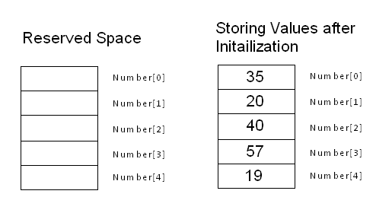

Initialization of 1D Array
After an array is declared, it’s elements must be initialized. In C programming an array can be initialized at either of the following stages:
- At compile time
- At run time

Compile Time initialization
We can initialize the elements of arrays in the same was as the ordinary variables when they are declared. The general form of initialization of array is:
type array-name[size] = { list of values };
The values in the list are separated by commas. For ex, the statement
int number[3] = { 0,5,4 };
will declare the variable’ number’ as an array of size 3 and will assign the values to each element. If the number of values in the list is less than the number of elements, then only that many elements will be initialized. The remaining elements will be set to zero automatically.
Remember, if we have more initializers than the declared size, the compiler will produce an error.

Run time Initialization
An array can also be explicitly initialized at run time. For ex – consider the following segment of a C program.
for(i=0;i<10;i++)
{
scanf(" %d ", &x[i] );
}
Above example will initialize array elements with the values entered through the keyboard. In the run time initialization of the arrays looping statements are almost compulsory. Looping statements are used to initialize the values of the arrays one by one by using assignment operator or through the keyboard by the user.

Sample Array Program
/* Simple C program to store the elements in the array and to print them from the array */
#include<stdio.h>
void main()
{
int array[5],i;

printf("Enter 5 numbers to store them in array \n");
for(i=0;i<5;i++)
{
scanf("%d",&array[i]);
}
printf("Element in the array are - \n \n");
for(i=0;i<5;i++)
{
printf("Element stored at a[%d] = %d \n",i,array[i]);
}
getch();
}
Input – Enter 5 elements in the array – 23 45 32 25 45
Output – Elements in the array are –
Element stored at a[0]-23
Element stored at a[0]-45
Element stored at a[0]-32
Element stored at a[0]-25
Element stored at a[0]-45

Two-dimensional array :-
Two-dimensional array are those type of array, which has finite number of rows and finite number of columns. The declaration form of 2-dimensional array is
Data_type Array_name [row size][column size];
The type may be any valid type supported by C. The rule for giving the array name is same as the ordinary variable. The row size and column size should be an individual constant.
The following declares a two-dimensional 3 by 3 array of integers and sets the first and last elements to be 10.
int matrix [3][3];
matrix[0][0] = 10;
matrix[2][2] = 10;
The following Figure illustrates a two dimensional array, matrix. The array contains three rows and tree columns, so it is said to be a 3-by-3 array. In general, an array with m rows and n columns is called an m-by-n array.
 | [0] | [1] | [2]
[0] | 10
[1]
[2] |  |  | 10
Every element in array matrix is identified by an element name of the form matrix[ i ][ j ]; matrix is the name of the array, and i and j are the subscripts that uniquely identify each element in matrix . Notice that the names of the elements in the first row all have a first subscript of 0; the names of the elements in the third column all have a second subscript of 2.
In the case of Two-dimensional array, during declaration the maximum number of rows and maximum number of column should be specified for processing all array elements.
The implementation of the array stores all the elements in a single contiguous block of memory. The other possible implementation would be a combination of several distinct one-dimensional arrays. That’s not how C does it. In memory, the array is arranged with the elements of the rightmost index next to each other. In other words, matrix[1][1] comes right before matrix[1][2] in memory.
The following array:
 | [0] | [1] | [2]
[0] | 1 | 2 | 3
[1] | 4 | 5 | 6
[2] | 7 | 8 | 9
would be stored:
1 | 2 | 3 | 4 | 5 | 6 | 7 | 8 | 9
Example:
