Computer is an electronic device used for information processing. It accepts the data and instructions from the user, stores in its memory and processes and gives the results for the user. The term computer is derived from the Latin word compute which means to calculate or manipulate. Therefore computer is a calculating machine.

Capabilities of computer
A computer is capable of performing the following task
- Huge storage
A computer can store a huge amount of data and instructions in its memory. The computers storage is just like a human brain where information is stored and retrieved from
- Input and output
It receives data and instructions from the use and displays after excecution
- Processing
It processes the data input by the user. Processing means performing necessary operations such as arithmetic operations or logical operations on the data

Characterstics of computer

- High speed
A computer is a fast information processing device. It carries out all sorts of computations within a fractions of second. It excecutes millions of instructions per second.
- Accuracy
It gives accurate results for correct input data. Here accuracy means correctness of data. If the input data is errorneous , then the output will not be correct
- Reliability
It gives consistent results, even though working on electrical connections and electronic circuits, which are prone to errors.
- Versatility
Its role is versatile. It is used for scientific calculations, business processing, computer games, teaching, training,simulations, music fine-art etc
- Diligence
It does not fell tired. It can be used for hours. It can also be used for a number of days or months without non-stop. It will work satisfactory without fatigue

BLOCK DIAGRAM OF A COMPUTER

A computer is a programmable device and has its own architecture.The architecuture consists of various components.These components are interconnected to form a system.A system is nothing but a meaningful combination of components or units which cooperate and coordinates for a specific operation.The basic structure or system logical organization of a computer is shown below
There are three basic units. They are
1.input 2. system unit 3. output unit

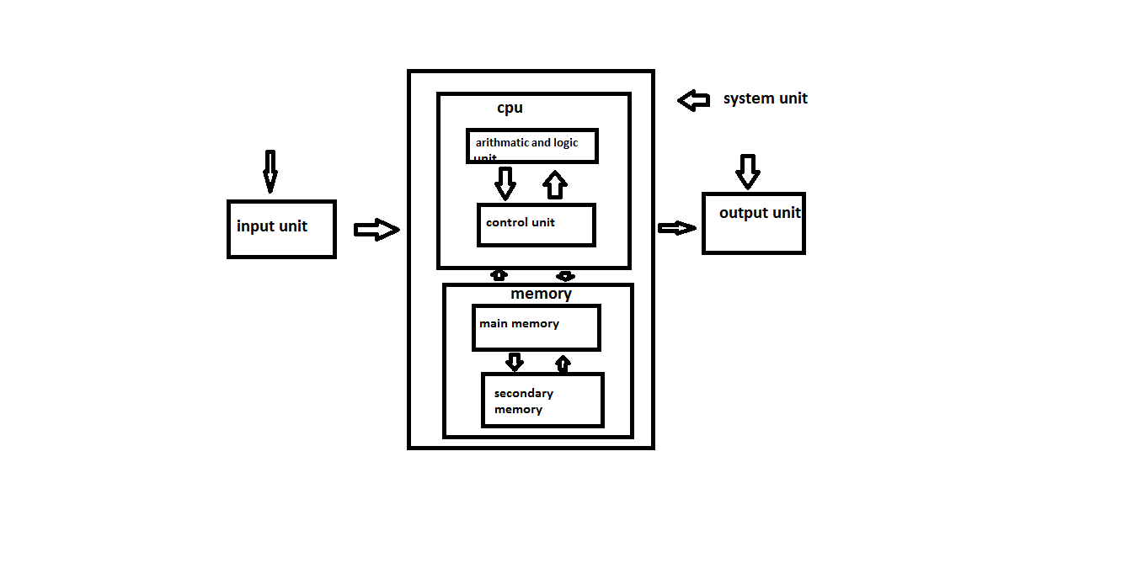Block diagram of a computer or simple model of computer

INPUT UNIT

Input unit is an external device that is connected to the cpu.This unit is used to read the data and instructions from the user.There are many input devices are there in a computer they are
1.key board 2.mouse 3.mouse stick

SYSTEM UNIT
Once the data and instruction are received from the user they are stored and processed in this unit. it consists of two subunits
They are 1.central processing unit
2.memory unit
Central processing unit:
it is generally called CPU. once the data and instructions are received from the input device, they are to be processed in this unit.so it can be called as heart and brain of the computer system.further,the cpu consists of two important functional units
1.Control unit
2.Arithmatic and Logical unit

Control unit
It is an important unit in a computer. It controls and coordinates all the activities of all the units of a computer system. It acts as a supervisor in a computer system. It sends controls and timing signals to various units to coordinate for the specific operation.The following are some of the functions performed by the control unit

- Fetching a data and instructions from main memory
- Controlling the transfer of data and instructions to and main memory
- Control input and output devices

Arithmatic and logical unit
All calculations are carried out in arithmetic and logical unit. It is generally called ALU. An ALU consist of electronic circuitry which performs basic arithmetic operations such as addition ,substration, and multiplication and division. It also consists of logic circuitry which performs logical operations.

Memory unit
It is a storage device. The memory unit is a device where the data and instructions fed by the user are stored. It is like a rack in which items are put.Yet you can also assume it as a page of note book where you write to and read from. The memory of a computer is measured in terms of bytes and bits. A bit is binary digit either 0 or 1.A byte is basic unit of memory and is defined as sequence of 8 bits.
The computer memory classified into
- Main memory
- Secondary memory
Main memory
it is the place where the data and instructions supplied by the input devices are stored. This is temporary memory because the data and instructions stored here are erased when the power goes off. This is also referred as primary memory. It is a secondary memory. It consists of RAM and ROM main memories

Secondary memory
This is a permanent memory. It keeps data when the power goes off. It is a magnetic memory. There are many secondary devices namely
- Floppy disk
- Hard disks
- CD-ROM

