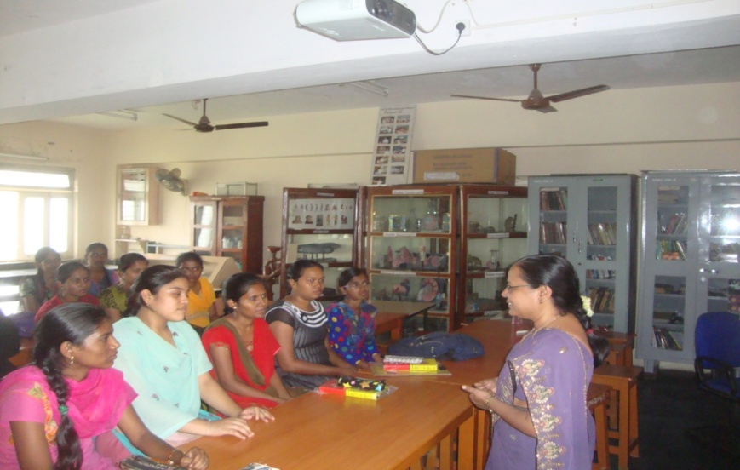
A Special lecture on ‘Importance of Biodiversity’ by Dr Chandrakala Patil, Associate Professor in Zoology, Smt. V.G. Women’s College, Kalaburgi, was organised on 14-04-2015 was organized for B.Sc. CBZ Students. In her lecture, she explained present status of Indian Biodiversity and importance to mankind and also their role in food security, medicines etc.
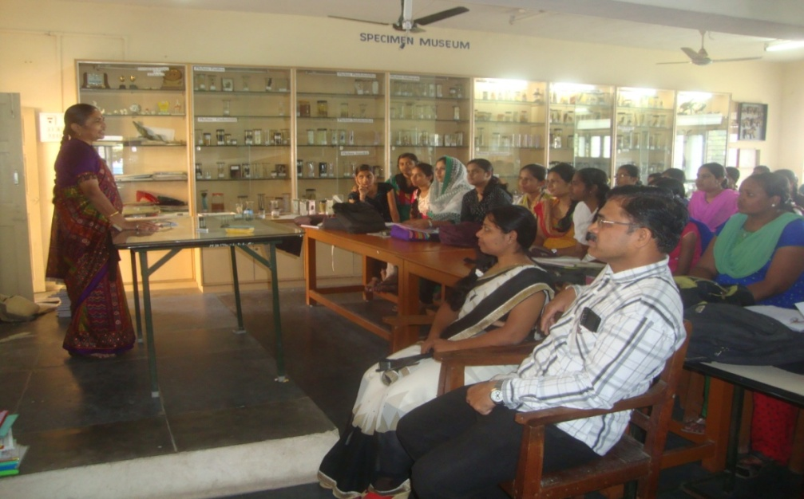
A Special lecture on ‘Wetland Biodiversity’ by Dr. Veenakumari, Associate Professor in Zoology AMMM Vidyalaya, Bidar was organised on 10-02-2016 for B.Sc. CBZ Students. She explained about wetland ecology and fauna of Wetlands with special reference to north Karnataka. They also explained about Ramsar convention on Wetland protection.
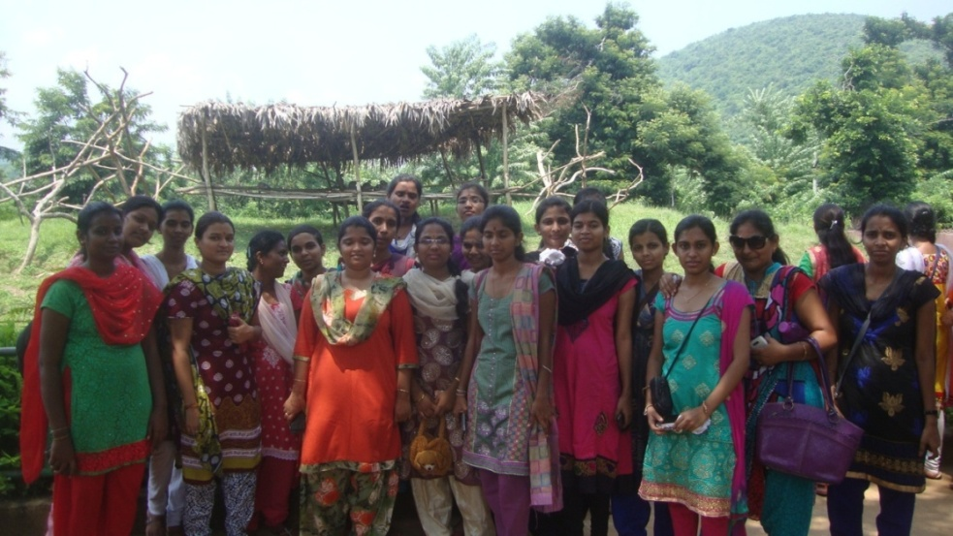
The students of B.Sc final year visited Aruku vally near Vishakapatnam as Part of study tour. Aruku Is located in easternghats it known for diverse diversity of life. During this study tour students gained much practical knowledge on different ecological systems of the Aruku On 27-09-2015.

