VISUAL BASIC 6.0

Visual Basic is initiated by using the Programs option > Microsoft Visual Basic 6.0 > Visual Basic 6.0. Clicking the Visual Basic icon, we can view a copyright screen enlisting the details of the license holder of the copy of Visual Basic 6.0. Then it opens in to a new screen as shown in figure 1 below, with the interface elements Such as MenuBar, ToolBar, The New Project dialog box. These elements permit the user to buid different types of Visual Basic applications.

The Integrated Development Environment:
One of the most significant changes in Visual Basic 6.0 is the Integrated Development Environment (IDE). IDE is a term commonly used in the programming world to describe the interface and environment that we use to create our applications. It is called integrated because we can access virtually all of the development tools that we need from one screen called an interface. The IDE is also commonly referred to as the design environment, or the program.
Tha Visual Basic IDE is made up of a number of components
- Menu Bar
- Tool Bar
- Project Explorer
- Properties window
- Form Layout Window
- Toolbox
- Form Designer
- Object Browser
In previous versions of Visual Basic, the IDE was designed as a Single Document Interface (SDI). In a Single Document Interface, each window is a free-floating window that is contained within a main window and can move anywhere on the screen as long as Visual Basic is the current application. But, in Visual Basic 6.0, the IDE is in a Multiple Document Interface (MDI) format. In this format, the windows associated with the project will stay within a single container known as the parent. Code and form-based windows will stay within the main container form.
Figure 1 The Visual Basic startup dialog box
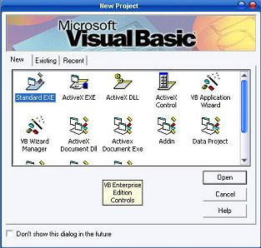

Menu Bar
This Menu Bar displays the commands that are required to build an application. The main menu items have sub menu items that can be chosen when needed. The toolbars in the menu bar provide quick access to the commonly used commands and a button in the toolbar is clicked once to carry out the action represented by it.

Toolbox
The Toolbox contains a set of controls that are used to place on a Form at design time thereby creating the user interface area. Additional controls can be included in the toolbox by using the Components menu item on the Project menu. A Toolbox is represented in figure 2 shown below.
Figure 2 Toolbox window with its controls available commonly.
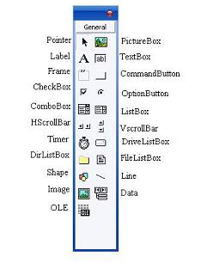
Control | Description
Pointer | Provides a way to move and resize the controls form
PictureBox | Displays icons/bitmaps and metafiles. It displays text or acts as a visual container for other controls.
TextBox | Used to display message and enter text.
Frame | Serves as a visual and functional container for controls
CommandButton | Used to carry out the specified action when the user chooses it.
CheckBox | Displays a True/False or Yes/No option.
OptionButton | OptionButton control which is a part of an option group allows the user to select only one option even it displays mulitiple choices.
ListBox | Displays a list of items from which a user can select one.
ComboBox | Contains a TextBox and a ListBox. This allows the user to select an ietm from the dropdown ListBox, or to type in a selection in the TextBox.
HScrollBar and VScrollBar | These controls allow the user to select a value within the specified range of values
Timer | Executes the timer events at specified intervals of time
DriveListBox | Displays the valid disk drives and allows the user to select one of them.
DirListBox | Allows the user to select the directories and paths, which are displayed.
FileListBox | Displays a set of files from which a user can select the desired one.
Shape | Used to add shape (rectangle, square or circle) to a Form
Line | Used to draw straight line to the Form
Image | used to display images such as icons, bitmaps and metafiles. But less capability than the PictureBox
Data | Enables the use to connect to an existing database and display information from it.
OLE | Used to link or embed an object, display and manipulate data from other windows based applications.
Label | Displays a text that the user cannot modify or interact with.

Project Explorer
Docked on the right side of the screen, just under the tollbar, is the Project Explorer window. The Project Explorer as shown in in figure servres as a quick reference to the various elements of a project namely form, classes and modules. All of the object that make up the application are packed in a project. A simple project will typically contain one form, which is a window that is designed as part of a program's interface. It is possible to develop any number of forms for use in a program, although a program may consist of a single form. In addition to forms, the Project Explorer window also lists code modules and classes.
Figure 3 Project Explorer
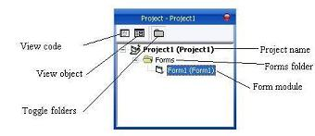

Properties Window
The Properties Window is docked under the Project Explorer window. The Properties Window exposes the various characteristics of selected objects. Each and every form in an application is considered an object. Now, each object in Visual Basic has characteristics such as color and size. Other characteristics affect not just the appearance of the object but the way it behaves too. All these characteristics of an object are called its properties. Thus, a form has properties and any controls placed on it will have propeties too. All of these properties are displayed in the Properties Window.

Object Browser
The Object Browser allows us to browse through the various properties, events and methods that are made available to us. It is accessed by selecting Object Browser from the View menu or pressing the key F2. The left column of the Object Browser lists the objects and classes that are available in the projects that are opened and the controls that have been referenced in them. It is possible for us to scroll through the list and select the object or class that we wish to inspect. After an object is picked up from the Classes list, we can see its members (properties, methods and events) in the right column.
A property is represented by a small icon that has a hand holding a piece of paper. Methods are denoted by little green blocks, while events are denoted by yellow lightning bolt icon.
Object naming conversions of controls (prefix)
Form -frm
Label-lbl
TextBox-txt
CommandButton-cmd
CheckBox -chk
OptionButton -opt
ComboBox -cbo
ListBox-lst
Frame-fme
PictureBox -pic
Image-img
Shape-shp
Line -lin
HScrollBar -hsb
VScrollBar –vsb

Control Structures in Visual Basic 6.0

Control Statements are used to control the flow of program's execution. Visual Basic supports control structures such as if... Then, if...Then ...Else, Select...Case, and Loop structures such as Do While...Loop, While...Wend, For...Next etc method.

If...Then selection structure
The If...Then selection structure performs an indicated action only when the condition is True; otherwise the action is skipped.
Syntax of the If...Then selection
If <condition> Then
statement
End If
e.g.: If average>75 Then
txtGrade.Text = "A"
End If

If...Then...Else selection structure
The If...Then...Else selection structure allows the programmer to specify that a different action is to be performed when the condition is True than when the condition is False.
Syntax of the If...Then...Else selection
If <condition > Then
statements
Else
statements
End If
e.g.: If average>50 Then
txtGrade.Text = "Pass"
Else
txtGrade.Text = "Fail"
End If

Nested If...Then...Else selection structure
Nested If...Then...Else selection structures test for multiple cases by placing If...Then...Else selection structures inside If...Then...Else structures.
Syntax of the Nested If...Then...Else selection structure
You can use Nested If either of the methods as shown above
Method 1
If < condition 1 > Then
statements
ElseIf < condition 2 > Then
statements
ElseIf < condition 3 > Then
statements
Else
Statements
End If
Method 2
If < condition 1 > Then
statements
Else
If < condition 2 > Then
statements
Else
If < condition 3 > Then
statements
Else
Statements
End If
End If
EndIf
e.g.: Assume you have to find the grade using nested if and display in a text box
If average > 75 Then
txtGrade.Text = "A"
ElseIf average > 65 Then
txtGrade.Text = "B"
ElseIf average > 55 Then
txtGrade.text = "C"
ElseIf average > 45 Then
txtGrade.Text = "S"
Else
txtGrade.Text = "F"
End If

Select...Case selection structure
Select...Case structure is an alternative to If...Then...ElseIf for selectively executing a single block of statements from among multiple block of statements. Select...case is more convenient to use than the If...Else...End If. The following program block illustrate the working of Select...Case.
Syntax of the Select...Case selection structure
Select Case Index
Case 0
Statements
Case 1
Statements
End Select
e.g.: Assume you have to find the grade using select...case and display in the text box
Dim average as Integer
average = txtAverage.Text
Select Case average
Case 100 To 75
txtGrade.Text ="A"
Case 74 To 65
txtGrade.Text ="B"
Case 64 To 55
txtGrade.Text ="C"
Case 54 To 45
txtGrade.Text ="S"
Case 44 To 0
txtGrade.Text ="F"
Case Else
MsgBox "Invalid average marks"
End Select

LOOPING STRUCTURES :
A repetition structure allows the programmer to that an action is to be repeated until given condition is true.

Do While... Loop Statement
The Do While...Loop is used to execute statements until a certain condition is met. The following Do Loop counts from 1 to 100.
Dim number As Integer
number = 1
Do While number <= 100
number = number + 1
Loop
A variable number is initialized to 1 and then the Do While Loop starts. First, the condition is tested; if condition is True, then the statements are executed. When it gets to the Loop it goes back to the Do and tests condition again. If condition is False on the first pass, the statements are never executed.

While... Wend Statement
A While...Wend statement behaves like the Do While...Loop statement. The following While...Wend counts from 1 to 100
Dim number As Integer
number = 1
While number <=100
number = number + 1
Wend

Do...Loop While Statement
The Do...Loop While statement first executes the statements and then test the condition after each execution. The following program block illustrates the structure:
Dim number As Long
number = 0
Do
number = number + 1
Loop While number < 201
The programs executes the statements between Do and Loop While structure in any case. Then it determines whether the counter is less than 501. If so, the program again executes the statements between Do and Loop While else exits the Loop.

Do Until...Loop Statement
Unlike the Do While...Loop and While...Wend repetition structures, the Do Until... Loop structure tests a condition for falsity. Statements in the body of a Do Until...Loop are executed repeatedly as long as the loop-continuation test evaluates to False.
An example for Do Until...Loop statement. The coding is typed inside the click event of the command button
Dim number As Long
number=0
Do Until number > 1000
number = number + 1
Print number
Loop
Numbers between 1 to 1000 will be displayed on the form as soon as you click on the command button.

The For...Next Loop
The For...Next Loop is another way to make loops in Visual Basic. For...Next repetition structure handles all the details of counter-controlled repetition. The following loop counts the numbers from 1 to 100:
Dim x As Integer
For x = 1 To 50
Print x
Next
In order to count the numbers from 1 yo 50 in steps of 2, the following loop can be used
For x = 1 To 50 Step 2
Print x
Next
The following loop counts numbers as 1, 3, 5, 7..etc
The above coding will display numbers vertically on the form. In order to display numbers horizontally the following method can be used.
For x = 1 To 50
Print x & Space$ (2);
Next
To increase the space between the numbers increase the value inside the brackets after the & Space$.
Following example is a For...Next repetition structure which is with the If condition used.
Dim number As Integer
For number = 1 To 10
If number = 4 Then
Print "This is number 4"
Else
Print number
End If
Next
In the output instead of number 4 you will get the "This is number 4".

INUTBOX FUNCTION :
Displays a prompt in a dialog box, waits for the user to input text or click a button, and returns a String containing the contents of the text box.
Following is an expanded InputBox
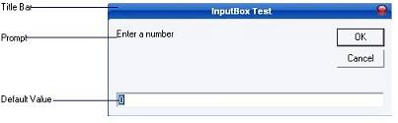
Syntax :
memory_variable = InputBox (prompt[,title][,default])
memory_variable is a variant data type but typically it is declared as string, which accept the message input by the users. The arguments are explained as follows:
- Prompt - String expression displayed as the message in the dialog box. If prompt consists of more than one line, you can separate the lines using the vbCrLf constant
- Title - String expression displayed in the title bar of the dialog box. If you omit the title, the application name is displayed in the title bar
- default-text - The default text that appears in the input field where users can use it as his intended input or he may change to the message he wish to key in.
- x-position and y-position - the position or the coordinate of the input box.
Following example demonstrates the use of InputBox function
* Open a new project and save the Form as InputBox.frm and save the Project as InputBox.vbp
* Design the application as shown below.
Object | Property | Setting
Form | Caption  Name | InputBox test  frmInputBox
Label | Caption  Name | You entered  lbl1
Label | Caption  Name  BorderStyle | ( empty)  lbl2  1-Fixed Single
CommandButton | Caption  Name | OK  cmdOK
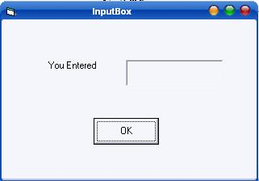
Following code is entered in cmdOK_Click ( ) event
Private Sub cmdok_Click()
Dim ans As String
ans = InputBox("Enter something to be displayed in the label", "Testing", 0)
If ans = "" Then
lbl2.Caption = "No message"
Else
lbl2.Caption = ans
End If
End Sub
Save and run the application. As soon as you click the OK button you will get the following InputBox
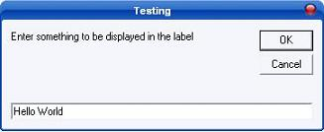
Here I have entered "Hello World" in text field. As soon as you click OK the output is shown as shown below
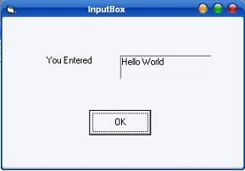

COMMAND BUTTION FUNCTION :
Displays a message in a dialog box and wait for the user to click a button, and returns an integer indicating which button the user clicked.
Following is an expanded MessageBox
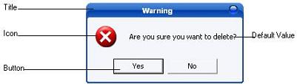
Syntax :
MsgBox ( Prompt [,icons+buttons ] [,title ] )
memory_variable = MsgBox ( prompt [, icons+ buttons] [,title] )
Prompt : String expressions displayed as the message in the dialog box. If prompt consist of more than one line, you can separate the lines using the vbrCrLf constant.
Icons + Buttons : Numeric expression that is the sum of values specifying the number and type of buttons and icon to display.
Title : String expression displayed in the title bar of the dialog box. If you omit title, the application name is placed in the title bar.
Icons
Constant | Value | Description
vbCritical | 16 | Display Critical message icon
vbQuestion | 32 | Display Warning Query icon
vbExclamation | 48 | Display Warning message icon
vbInformation | 64 | Display information icon
Buttons
Constant | Value | Description
vbOkOnly | 0 | Display OK button only
vbOkCancel | 1 | Display OK and Cancel buttons
vbAbortRetryIgnore | 2 | Display Abort, Retry and Ignore buttons
vbYesNoCancel | 3 | Display Yes, No and Cancel buttons
vbYesNo | 4 | Display Yes and No buttons
vbRetryCancel | 5 | Display Retry and Cancel buttons
Return Values
Constant | Value | Description
vbOk | 1 | Ok Button
vbCancel | 2 | Cancel Button
vbAbort | 3 | Abort Button
vbRetry | 4 | Retry Button
vbIgnore | 5 | Ignore Button
vbYes | 6 | Yes Button
vbNo | 7 | No Button
Following is an example illustrates the use of message boxes
* Open a new Project and save the Form as messageboxdemo.frm and save the Project as messageboxdemo.vbp
* Design the application as shown below.
Object | Property | Setting
Form | Caption  Name | MessageBoxDemo  frmMessageBoxDemo
Label | Caption  Name | lblName  Name
TextBox | Name  Text | txtName  ( empty )
ListBox | Name | lstName
CommandButton | Caption  Name | Add  cmdAdd
CommandButton | Caption  Name | Delete  cmdDelete
CommandButton | Caption  Name | Exit  cmdExit
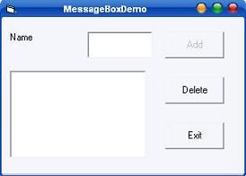
Following code is entered in the txtName_Change ( ) event
Private Sub txtName_Change()
If Len(txtName.Text) > 0 Then
cmdAdd.Enabled = True
End If
End Sub
Following code has to be entered in the cmdAdd_Click ( ) event
Private Sub cmdAdd_Click()
answer = MsgBox("Do you want to add this name to the list box?", vbExclamation + vbYesNo,
"Add Confirm")
If answer = vbYes Then
lstName.AddItem txtName.Text
txtName.Text = ""
txtName.SetFocus
cmdAdd.Enabled = False
End If
End Sub
Following code is entered in the cmdDelete_Click ( ) event
Private Sub cmdDelete_Click()
Dim remove As Integer
remove = lstName.ListIndex
If remove < 0 Then
MsgBox "No names is selected", vbInformation, "Error"
Else
answer = MsgBox("Are you sure you want to delete " & vbCrLf & "the selected name?",_
vbCritical + vbYesNo, "Warning")
If answer = vbYes Then
If remove >= 0 Then
lstName.RemoveItem remove
txtName.SetFocus
MsgBox "Selected name was deleted", vbInformation, "Delete Confirm"
End If
End If
End If
End Sub
Following code is entered in the cmdExit_Click ( ) event
Private Sub cmdExit_Click()
answer = MsgBox("Do you want to quit?", vbExclamation + vbYesNo, "Confirm")
If answer = vbYes Then
End
Else
MsgBox "Action canceled", vbInformation, "Confirm"
End If
End Sub

