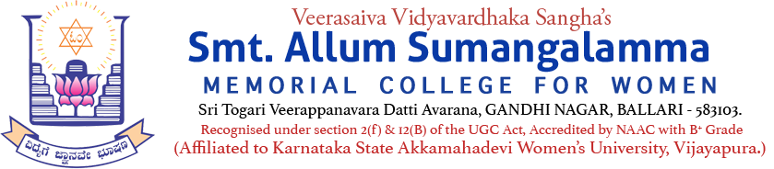
Internal Quality Assurance Cell (IQAC)
Youth Red Cross Wing Activity
Programme: UG & PG Departments: All
Name of the Programme | Red Cross Wing Day – 2025
Category | Knowledge Oriented & Awareness Programme
Venue, Date & Time | 08.05.2025, 10.30am, Seminar Hall
Target Audience &  Students and Staff Participated | UG & PG Students & College Staff  (Attendance Sheet Copy Enclosed)
Objective & Theme | World Red Cross and Red Crescent Day 2025: The theme "Keeping Humanity Alive" is the official theme for World Red Cross and Red Crescent Day in 2025. The theme of dedication of the Red Cross and the Red Crescent staff, who provide relief where it is most needed, is reflected in this theme.
Brief Report on activity | Youth Red Cross Wing (YRCW) MoU Activity - A Special Awareness Programme organized and observed Red Cross Wing Day (i.e., World Red Cross Day)-2025 on 08.05.2025 @ Seminar Hall. Indian Red Cross Society Chief Guest, College Principal, IQAC Coordinator, IQAC Co-Coordinator, Convener & Members of YRCW, Staff & Students participated on the occasion.
Geo Tagged Photos Social Media Web link | https://www.facebook.com/share/p/16UmNsY6Mt/  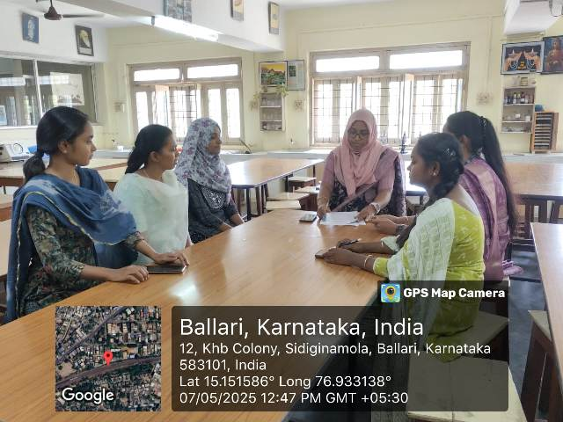
HEI web link of the Event | Youth Red Cross Wing MoU Activity - A Special Awareness Programme
