UNIT-2 : Data Models:

Data Models
Data Model is the modeling of the data description, data semantics, and consistency constraints of the data. It provides the conceptual tools for describing the design of a database at each level of data abstraction. Therefore, there are following four data models used for understanding the structure of the database:
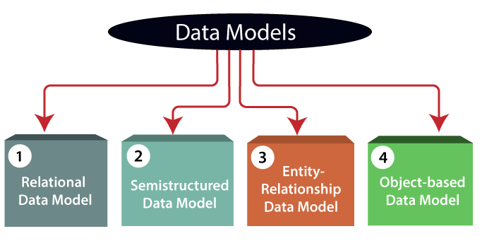
1) Relational Data Model: This type of model designs the data in the form of rows and columns within a table. Thus, a relational model uses tables for representing data and in-between relationships. Tables are also called relations. This model was initially described by Edgar F. Codd, in 1969. The relational data model is the widely used model which is primarily used by commercial data processing applications.
2) Entity-Relationship Data Model: An ER model is the logical representation of data as objects and relationships among them. These objects are known as entities, and relationship is an association among these entities. This model was designed by Peter Chen and published in 1976 papers. It was widely used in database designing. A set of attributes describe the entities. For example, student_name, student_id describes the 'student' entity. A set of the same type of entities is known as an 'Entity set', and the set of the same type of relationships is known as 'relationship set'.
3) Object-based Data Model: An extension of the ER model with notions of functions, encapsulation, and object identity, as well. This model supports a rich type system that includes structured and collection types. Thus, in 1980s, various database systems following the object-oriented approach were developed. Here, the objects are nothing but the data carrying its properties.
4) Semistructured Data Model: This type of data model is different from the other three data models (explained above). The semistructured data model allows the data specifications at places where the individual data items of the same type may have different attributes sets. The Extensible Markup Language, also known as XML, is widely used for representing the semistructured data. Although XML was initially designed for including the markup information to the text document, it gains importance because of its application in the exchange of data.

Data model Schema and Instance
- The data which is stored in the database at a particular moment of time is called an instance of the database.
- The overall design of a database is called schema.
- A database schema is the skeleton structure of the database. It represents the logical view of the entire database.
- A schema contains schema objects like table, foreign key, primary key, views, columns, data types, stored procedure, etc.
- A database schema can be represented by using the visual diagram. That diagram shows the database objects and relationship with each other.
- A database schema is designed by the database designers to help programmers whose software will interact with the database. The process of database creation is called data modeling.
A schema diagram can display only some aspects of a schema like the name of record type, data type, and constraints. Other aspects can't be specified through the schema diagram. For example, the given figure neither show the data type of each data item nor the relationship among various files.
In the database, actual data changes quite frequently. For example, in the given figure, the database changes whenever we add a new grade or add a student. The data at a particular moment of time is called the instance of the database.
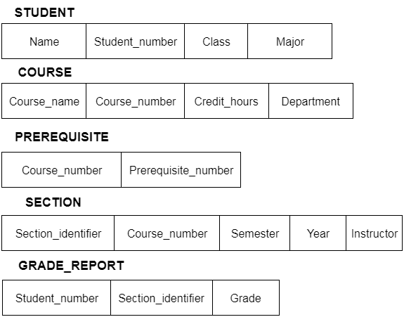

Three schema Architecture
- The three schema architecture is also called ANSI/SPARC architecture or three-level architecture.
- This framework is used to describe the structure of a specific database system.
- The three schema architecture is also used to separate the user applications and physical database.
- The three schema architecture contains three-levels. It breaks the database down into three different categories.

The three-schema architecture is as follows:
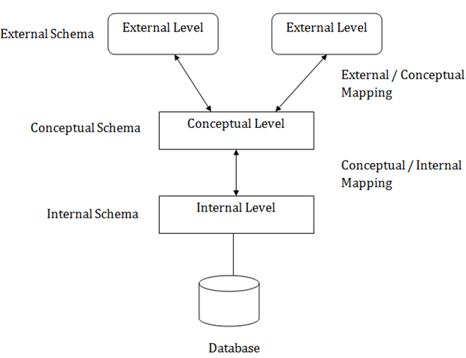
In the above diagram:
- It shows the DBMS architecture.
- Mapping is used to transform the request and response between various database levels of architecture.
- Mapping is not good for small DBMS because it takes more time.
- In External / Conceptual mapping, it is necessary to transform the request from external level to conceptual schema.
- In Conceptual / Internal mapping, DBMS transform the request from the conceptual to internal level.

Objectives of Three schema Architecture
The main objective of three level architecture is to enable multiple users to access the same data with a personalized view while storing the underlying data only once. Thus it separates the user's view from the physical structure of the database. This separation is desirable for the following reasons:
- Different users need different views of the same data.
- The approach in which a particular user needs to see the data may change over time.
- The users of the database should not worry about the physical implementation and internal workings of the database such as data compression and encryption techniques, hashing, optimization of the internal structures etc.
- All users should be able to access the same data according to their requirements.
- DBA should be able to change the conceptual structure of the database without affecting the user's
- Internal structure of the database should be unaffected by changes to physical aspects of the storage.

1. Internal Level
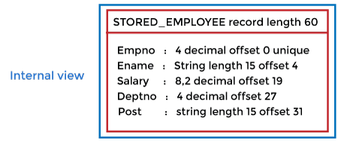
- The internal level has an internal schema which describes the physical storage structure of the database.
- The internal schema is also known as a physical schema.
- It uses the physical data model. It is used to define that how the data will be stored in a block.
- The physical level is used to describe complex low-level data structures in detail.
The internal level is generally is concerned with the following activities:
- Storage space allocations.
For Example: B-Trees, Hashing etc.
- Access paths.
For Example: Specification of primary and secondary keys, indexes, pointers and sequencing.
- Data compression and encryption techniques.
- Optimization of internal structures.
- Representation of stored fields.

2. Conceptual Level
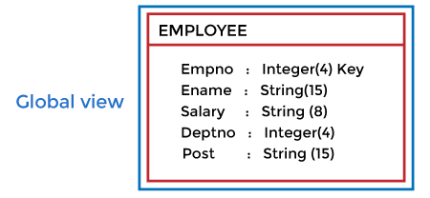
- The conceptual schema describes the design of a database at the conceptual level. Conceptual level is also known as logical level.
- The conceptual schema describes the structure of the whole database.
- The conceptual level describes what data are to be stored in the database and also describes what relationship exists among those data.
- In the conceptual level, internal details such as an implementation of the data structure are hidden.
- Programmers and database administrators work at this level.

3. External Level
- At the external level, a database contains several schemas that sometimes called as subschema. The subschema is used to describe the different view of the database.
- An external schema is also known as view schema.
- Each view schema describes the database part that a particular user group is interested and hides the remaining database from that user group.
- The view schema describes the end user interaction with database systems.

Mapping between Views
The three levels of DBMS architecture don't exist independently of each other. There must be correspondence between the three levels i.e. how they actually correspond with each other. DBMS is responsible for correspondence between the three types of schema. This correspondence is called Mapping.

There are basically two types of mapping in the database architecture:
- Conceptual/ Internal Mapping
- External / Conceptual Mapping
Conceptual/ Internal Mapping
The Conceptual/ Internal Mapping lies between the conceptual level and the internal level. Its role is to define the correspondence between the records and fields of the conceptual level and files and data structures of the internal level.
External/ Conceptual Mapping
The external/Conceptual Mapping lies between the external level and the Conceptual level. Its role is to define the correspondence between a particular external and the conceptual view.

Data Independence
- Data independence can be explained using the three-schema architecture.
- Data independence refers characteristic of being able to modify the schema at one level of the database system without altering the schema at the next higher level.
There are two types of data independence:

1. Logical Data Independence
- Logical data independence refers characteristic of being able to change the conceptual schema without having to change the external schema.
- Logical data independence is used to separate the external level from the conceptual view.
- If we do any changes in the conceptual view of the data, then the user view of the data would not be affected.
- Logical data independence occurs at the user interface level.

2. Physical Data Independence
- Physical data independence can be defined as the capacity to change the internal schema without having to change the conceptual schema.
- If we do any changes in the storage size of the database system server, then the Conceptual structure of the database will not be affected.
- Physical data independence is used to separate conceptual levels from the internal levels.
- Physical data independence occurs at the logical interface level.
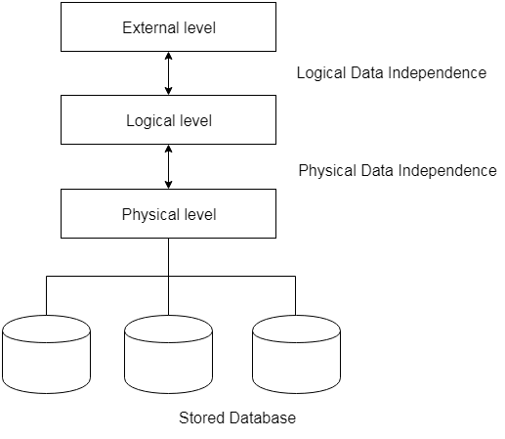
Fig: Data Independence

Database Languages in DBMS
- A DBMS has appropriate languages and interfaces to express database queries and updates.
- Database languages can be used to read, store and update the data in the database.

Types of Database Languages
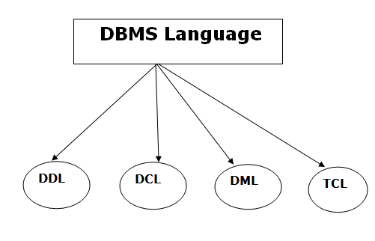

1. Data Definition Language (DDL)
- DDL stands for Data Definition Language. It is used to define database structure or pattern.
- It is used to create schema, tables, indexes, constraints, etc. in the database.
- Using the DDL statements, you can create the skeleton of the database.
- Data definition language is used to store the information of metadata like the number of tables and schemas, their names, indexes, columns in each table, constraints, etc.
Here are some tasks that come under DDL:
- Create: It is used to create objects in the database.
- Alter: It is used to alter the structure of the database.
- Drop: It is used to delete objects from the database.
- Truncate: It is used to remove all records from a table.
- Rename: It is used to rename an object.
- Comment: It is used to comment on the data dictionary.
These commands are used to update the database schema that's why they come under Data definition language.

2. Data Manipulation Language (DML)
DML stands for Data Manipulation Language. It is used for accessing and manipulating data in a database. It handles user requests.
Here are some tasks that come under DML:
- Select: It is used to retrieve data from a database.
- Insert: It is used to insert data into a table.
- Update: It is used to update existing data within a table.
- Delete: It is used to delete all records from a table.
- Merge: It performs UPSERT operation, i.e., insert or update operations.
- Call: It is used to call a structured query language or a Java subprogram.
- Explain Plan: It has the parameter of explaining data.
- Lock Table: It controls concurrency.

3. Data Control Language (DCL)
- DCL stands for Data Control Language. It is used to retrieve the stored or saved data.
- The DCL execution is transactional. It also has rollback parameters.
(But in Oracle database, the execution of data control language does not have the feature of rolling back.)
Here are some tasks that come under DCL:
- Grant: It is used to give user access privileges to a database.
- Revoke: It is used to take back permissions from the user.
There are the following operations which have the authorization of Revoke:
CONNECT, INSERT, USAGE, EXECUTE, DELETE, UPDATE and SELECT.

4. Transaction Control Language (TCL)
TCL is used to run the changes made by the DML statement. TCL can be grouped into a logical transaction.
Here are some tasks that come under TCL:
- Commit: It is used to save the transaction on the database.
- Rollback: It is used to restore the database to original since the last Commit.
DATABASE INTERFACES :
The different user-friendly interfaces provided by the database management system (DBMS) are as follows −
- Menu-Based interfaces.
- Forms-based interfaces.
- Graphical user interfaces.
- Natural language interfaces.
- Speech input and output interfaces.
- Interfaces for parametric users.
- Interfaces for the database administrator (DBA).

User friendly interfaces
Let’s discuss the user-friendly interfaces provided by the DBMS in detail.

Menu-based interfaces
These interfaces contain the lists of options through which the user is able to send the request.
The Pull-down menus are a very popular technique in web-based user interfaces.
These types of interfaces are mainly used by the web browsing users and web clients.

Forms-based interfaces
These types of interfaces are displaying a form to each user. The user is able to fill the entries to insert new data.
These forms are usually designed and programmed by naïve users as interfaces for recorded transactions.
User who wants to submit the online information by filling and submitting the details are going to use this type of interface
To create accounts on a website, or enrolling into some institution etc are also preferred to use this interface.

Graphical user interfaces
A graphical user interface contains a diagrammatic form that comprises a schema to the user.
The user asks a query by manipulating the diagram. These interfaces use the mouse as a pointing device to pick certain parts of the diagram.
These types of interfaces are used by the users who use electronic gadgets like mobile phones and touch screens.

Natural language interfaces
These interfaces accept the request from the user and try to interpret it.
The natural languages interfaces have their own schema which is like the database conceptual schema.
The search engines these days are using natural language interfaces.
The user can use these search engines to accept the words and retrieve the related information.

Speech input and output interfaces
These types of interfaces accept speech as an input and output the speech as a result.
These types of interfaces are mostly used in the inquiry for telephone directory or to get the flight information over the smart gadgets etc.

Interfaces for parametric users
Parametric users like bank tellers have a small set of operations that they must perform repeatedly.
These interfaces contain some commands to perform a request with minimum keystrokes.
These interfaces can be used in bank transactions to deposit or withdraw of money.

Interfaces for DBA
These interfaces contain some commands for creating accounts, to manipulate the database to perform some operations on the database.
These interfaces are specially used by the database administrators.
The types of user friendly interfaces provided by the DBMS are shown below in the diagram −
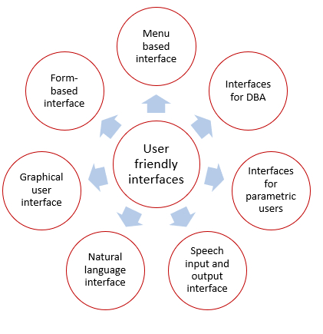

Components of DBMS
DBMS stands for DataBase Management System. DBMS is a type of software by which we can save and retrieve the user's data with the security process. DBMS can manipulate the database with the help of a group of programs. The DBMS can accept the request from the operating system to supply the data. The DBMS also can accept the request to retrieve a large amount of data through the user and third-party software.
DBMS also give permission to the user to use the data according to their needs. The word "DBMS" contains information regarding the database program and the users. It also provides an interface between the user and the software. In this topic, we are going to discuss the various types of DBMS.

Components of DBMS/ Database System Environment :
There are many components available in the DBMS. Each component has a significant task in the DBMS. A database environment is a collection of components that regulates the use of data, management, and a group of data. These components consist of people, the technique of Handel the database, data, hardware, software, etc. there are several components available for the DBMS. We are going to explain five main topics of the database below.
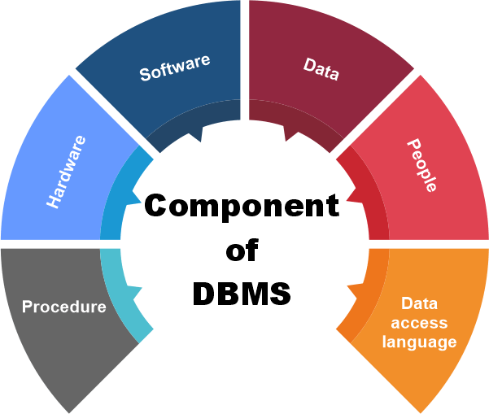

1. Hardware
- Here the hardware means the physical part of the DBMS. Here the hardware includes output devices like a printer, monitor, etc., and storage devices like a hard disk.
- In DBMS, information hardware is the most important visible part. The equipment which is used for the visibility of the data is the printer, computer, scanner, etc. This equipment is used to capture the data and present the output to the user.
- With the help of hardware, the DBMS can access and update the database.
- The server can store a large amount of data, which can be shared with the help of the user's own system.
- The database can be run in any system that ranges from microcomputers to mainframe computers. And this database also provides an interface between the real worlds to the database.
- When we try to run any database software like MySQL, we can type any commands with the help of our keyboards, and RAM, ROM, and processor are part of our computer system.

2. Software
- Software is the main component of the DBMS.
- Software is defined as the collection of programs that are used to instruct the computer about its work. The software consists of a set of procedures, programs, and routines associated with the computer system's operation and performance. Also, we can say that computer software is a set of instructions that is used to instruct the computer hardware for the operation of the computers.
- The software includes so many software like network software and operating software. The database software is used to access the database, and the database application performs the task.
- This software has the ability to understand the database accessing language and then convert these languages to real database commands and then execute the database.
- This is the main component as the total database operation works on a software or application. We can also be called as database software the wrapper of the whole physical database, which provides an easy interface for the user to store, update and delete the data from the database.
- Some examples of DBMS software include MySQL, Oracle, SQL Server, dBase, FileMaker, Clipper, Foxpro, Microsoft Access, etc.

3. Data
- The term data means the collection of any raw fact stored in the database. Here the data are any type of raw material from which meaningful information is generated.
- The database can store any form of data, such as structural data, non-structural data, and logical data.
- The structured data are highly specific in the database and have a structured format. But in the case of non-structural data, it is a collection of different types of data, and these data are stored in their native format.
- We also call the database the structure of the DBMS. With the help of the database, we can create and construct the DBMS. After the creation of the database, we can create, access, and update that database.
- The main reason behind discovering the database is to create and manage the data within the database.
- Data is the most important part of the DBMS. Here the database contains the actual data and metadata. Here metadata means data about data.
- For example, when the user stores the data in a database, some data, such as the size of the data, the name of the data, and some data related to the user, are stored within the database. These data are called metadata.

4. Procedures
- The procedure is a type of general instruction or guidelines for the use of DBMS. This instruction includes how to set up the database, how to install the database, how to log in and log out of the database, how to manage the database, how to take a backup of the database, and how to generate the report of the database.
- In DBMS, with the help of procedure, we can validate the data, control the access and reduce the traffic between the server and the clients. The DBMS can offer better performance to extensive or complex business logic when the user follows all the procedures correctly.
- The main purpose of the procedure is to guide the user during the management and operation of the database.
- The procedure of the databases is so similar to the function of the database. The major difference between the database procedure and database function is that the database function acts the same as the SQL statement. In contrast, the database procedure is invoked using the CALL statement of the DBMS.
- Database procedures can be created in two ways in enterprise architecture. These two ways are as below.
- The individual object or the default object.
- The operations in a container.
- CREATE [OR REPLACE] PROCEDURE procedure_name (<Argument> {IN, OUT, IN OUT}
- <Datatype>,...)
- IS
- Declaration section<variable, constant> ;
- BEGIN
- Execution section
- EXCEPTION
- Exception section
- END

5. Database Access Language
- Database Access Language is a simple language that allows users to write commands to perform the desired operations on the data that is stored in the database.
- Database Access Language is a language used to write commands to access, upsert, and delete data stored in a database.
- Users can write commands or query the database using Database Access Language before submitting them to the database for execution.
- Through utilizing the language, users can create new databases and tables, insert data and delete data.
- Examples of database languages are SQL (structured query language), My Access, Oracle, etc. A database language is comprised of two languages.
1. Data Definition Language(DDL):It is used to construct a database. DDL implements database schema at the physical, logical, and external levels.
The following commands serve as the base for all DDL commands:
- ALTER<object>
- COMMENT
- CREATE<object>
- DESCRIBE<object>
- DROP<object>
- SHOW<object>
- USE<object>
2. Data Manipulation Language(DML): It is used to access a database. The DML provides the statements to retrieve, modify, insert and delete the data from the database.
The following commands serve as the base for all DML commands:
- INSERT
- UPDATE
- DELETE
- LOCK
- CALL
- EXPLAIN PLAN

6. People
- The people who control and manage the databases and perform different types of operations on the database in the DBMS.
- The people include database administrator, software developer, and End-user.
- Database administrator-database administrator is the one who manages the complete database management system. DBA takes care of the security of the DBMS, its availability, managing the license keys, managing user accounts and access, etc.
- Software developer- theThis user group is involved in developing and designing the parts of DBMS. They can handle massive quantities of data, modify and edit databases, design and develop new databases, and troubleshoot database issues.
- End user - These days, all modern web or mobile applications store user data. How do you think they do it? Yes, applications are programmed in such a way that they collect user data and store the data on a DBMS system running on their server. End users are the ones who store, retrieve, update and delete data.
- The users of the database can be classified into different groups.
  - Native Users
  - Online Users
  - Sophisticated Users
  - Specialized Users
  - Application Users
  - DBA - Database Administrator

Centralized and Client Server Architecture for DBMS

Centralized Architecture of DBMS:
Architectures for DBMSs have generally followed trends seen in architectures for larger computer systems. The primary processing for all system functions, including user application programs, user interface programs, and all DBMS capabilities, was handled by mainframe computers in earlier systems. The primary cause of this was that the majority of users accessed such systems using computer terminals with limited processing power and merely display capabilities. Only display data and controls were delivered from the computer system to the display terminals, which were connected to the central node by a variety of communications networks, while all processing was done remotely on the computer system.
The majority of users switched from terminals to PCs and workstations as hardware prices decreased. Initially, Database Systems operated on these computers in a manner akin to how they had operated display terminals. As a result, the DBMS itself continued to operate as a centralized DBMS, where all DBMS functionality, application program execution, and UI processing were done on a single computer. The physical elements of a centralized architecture Client/server DBMS designs emerged as DBMS systems gradually began to take advantage of the user side's computing capability.
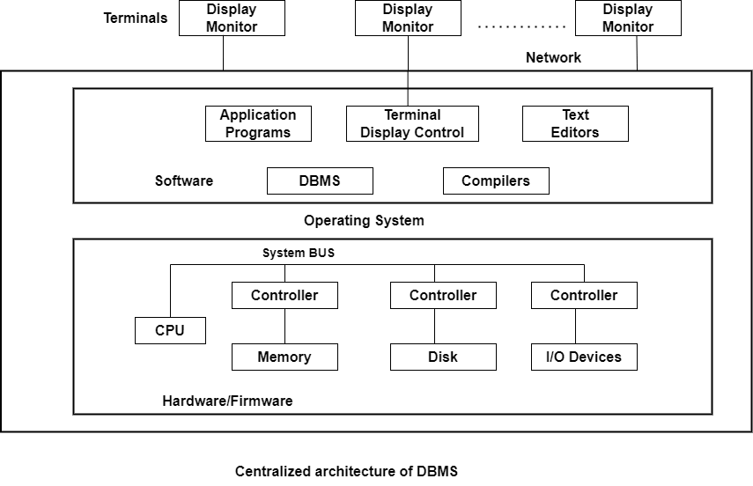

Client-server Architecture of DBMS:
We first talk about client/server architecture in general, and then we look at how DBMSs use it. In order to handle computing settings with a high number of PCs, workstations, file servers, printers, database servers, etc., the client/server architecture was designed.
A network connects various pieces of software and hardware, including email and web server software. To define specialized servers with a particular functionality is the aim. For instance, it is feasible to link a number of PCs or compact workstations to a file server that manages the client machines' files as clients. By having connections to numerous printers, different devices can be designated as a printer server; all print requests from clients are then directed to this machine. The category of specialized servers also includes web servers and email servers. Many client machines can utilize the resources offered by specialized servers. The user is given the proper user interfaces for these servers as well as local processing power to run local applications on the client devices. This idea can be applied to various types of software, where specialist applications, like a CAD (computer-aided design) package, are kept on particular server computers and made available to a variety of clients. Some devices (such as workstations or PCs with discs that only have client software installed) would only be client sites.
The idea of client/server architecture presupposes an underpinning structure made up of several PCs and workstations as well as fewer mainframe computers connected via LANs as well as other types of computer networks. In this system, a client is often a user machine that offers local processing and user interface capabilities. When a client needs access to extra features-like database access-that are not available on that system, it connects to a server that offers those features. A server is a computer system that includes both hardware and software that can offer client computer services like file access, printing, archiving, or database access. Generally speaking, some workstations install both client and server software, while others just install client software. Client and server software, however, typically run on separate workstations, which is more typical. On this underlying client/server framework, Two-tier and Three-tier fundamental DBMS architectures were developed.

Two-Tier Client Server Architecture:
Here, the term "two-tier" refers to our architecture's two layers-the Client layer and the Data layer. There are a number of client computers in the client layer that can contact the database server. The API on the client computer will use JDBC or some other method to link the computer to the database server. This is due to the possibility of various physical locations for clients and database servers.

Three-Tier Client-Server Architecture:
The Business Logic Layer is an additional layer that serves as a link between the Client layer and the Data layer in this instance. The layer where the application programs are processed is the business logic layer, unlike a Two-tier architecture, where queries are performed in the database server. Here, the application programs are processed in the application server itself.
Classification of DBMS:
DBMS is a collection of programs used for managing data and simultaneously it supports different types of users to create, manage, retrieve, update and store information.

Types of DBMS
The types of DBMS based on data model are as follows −
- Relational database.
- Object oriented database.
- Hierarchical database.
- Network database.

Relation Database
A relational database management system (RDBMS) is a system where data is organized in two-dimensional tables using rows and columns.
This is one of the most popular data models which is used in industries. It is based on SQL.
Every table in a database has a key field which uniquely identifies each record.
This type of system is the most widely used DBMS.
Relational database management system software is available for personal computers, workstation and large mainframe systems.
For example − Oracle Database, MySQL, Microsoft SQL Server etc.
Std ID | Name | City
201 | Bob | Hyderabad
204 | Lucky | Chennai
205 | Pinky | Bangalore
In the above student table Std ID, Name and city are called as attributes and their values. Std ID is a primary key attribute which uniquely identifies each record in the student table.

Object Oriented Database
It is a system where information or data is represented in the form of objects which is used in object-oriented programming.
- It is a combination of relational database concepts and object-oriented principles.
- Relational database concepts are concurrency control, transactions, etc.
- OOPs principles are data encapsulation, inheritance, and polymorphism.
- It requires less code and is easy to maintain.
For example − Object DB software.
The object oriented database is represented in diagram format below −
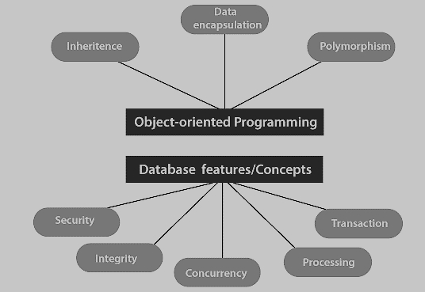

Hierarchical Database
It is a system where the data elements have a one to many relationship (1: N). Here data is organized like a tree which is similar to a folder structure in your computer system.
- The hierarchy starts from the root node, connecting all the child nodes to the parent node.
- It is used in industry on mainframe platforms.
For example− IMS(IBM), Windows registry (Microsoft).
An example of a hierarchical database is given below −
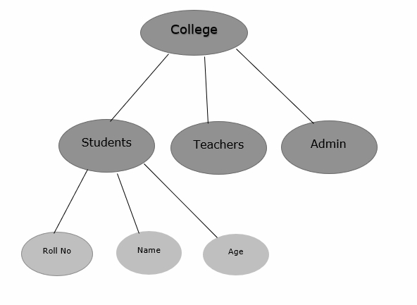

Network database
A Network database management system is a system where the data elements maintain one to one relationship (1: 1) or many to many relationship (N: N).
It also has a hierarchical structure, but the data is organized like a graph and it is allowed to have more than one parent for one child record.
Example
Teachers can teach in multiple departments. This is shown below −
