V. V.Sangha's
Smt. A.S.M. College for Women, Ballari. (Estd.:1969)
(Affiliated to Karnataka State Akkamahadevi Women’s University, Vijayapura.)
AISHE CODE: C-8690, NAAC TRACK ID-KACOGN11970
Recognized under sections 2(f) and 12(B) of the UGC Act 1956
(Accredited by NAAC in IV Cycle)
Internal Quality Assurance Cell (IQAC) - Placement & Career Guidance Cell activity -
One Week Skill Based Training Programme for the Degree Final Year Students
(i.e. from 21.07.2025, Monday to 26.07.2025, Saturday.)
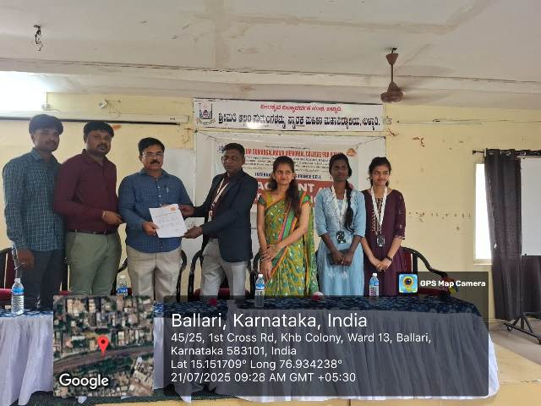
Magic Bus India Foundation & Reliance Foundation MoU activity: One-week skill-based training program conducted for the degree final-year students (i.e., from 21.07.2025 Monday to 26.07.2025 Saturday) @ Seminar Hall.
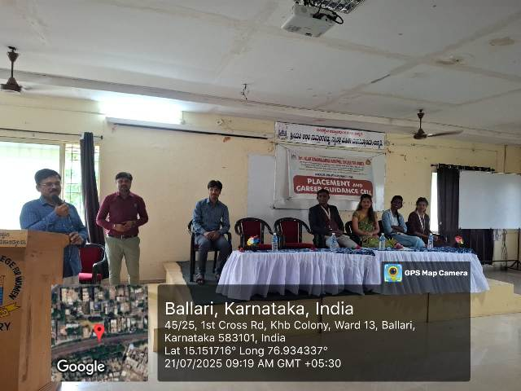
Inaugural Program organized on 21.07.2025 @ Seminar Hall. The Principal, Placement Cell Officer, Trainers, Staff and Students participated on occasion.

