VeerasaivaVidyavardhaka Sangha’s,
SMT. ALLUM SUMANGALAMMA MEMORIAL COLLEGE FOR WOMEN,
Sri Togari Veerappanavara Datti Avarana, GANDHI NAGAR, BALLARI-583103.
Recognized under section 2(f) and 12(B) of the UGC, Accredited by NAAC with B⁺ Grade
(Affiliated to Karnataka State Akkamahadevi Women’s University, Vijayapura)
Website: www.smtasmc.org Email: smtasmc@gmail.com,Ph.: 08392-256756
========================================================================================
DEPARTMENT P.G Studies in Commerce - M.Com
"Math Mixed Mania”
Date:22/11/2025

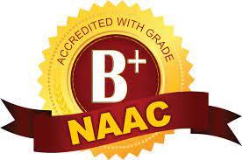



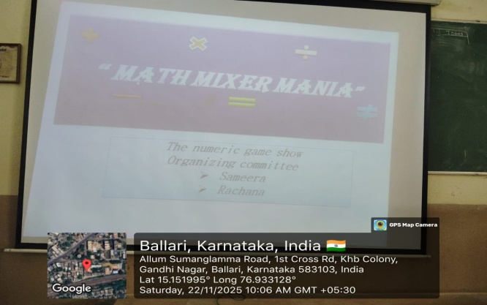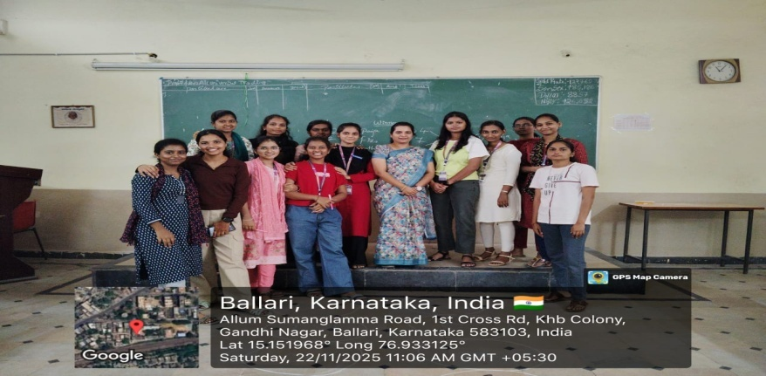
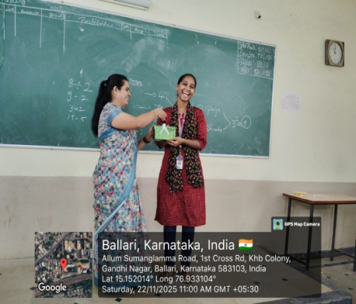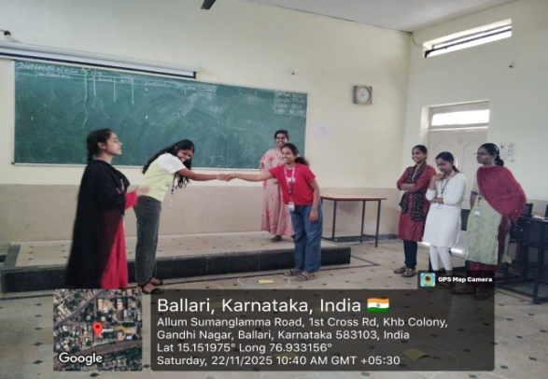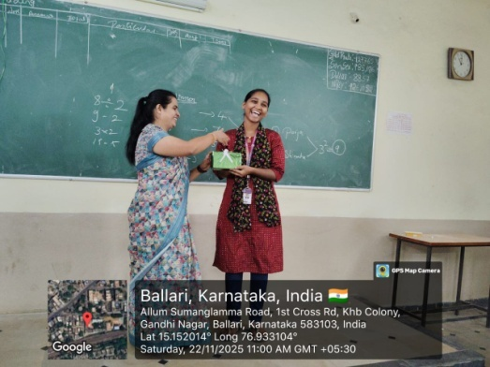
"Math Mixed Mania" is an umbrella term for various educational activities designed to enhance mathematical skills through engagement and fun. The activities and their outcomes generally focus on cognitive development, skill development, and fostering positive attitudes towards mathematics.

The key outcomes of participating in these types of activities extend beyond just computational skills, impacting overall cognitive and academic development.
