
Internal Quality Assurance Cell (IQAC)
Programme: UG Department: English
Name of the Programme | A Special Lecture / Talk
Category | Knowledge Oriented
Venue, Date & Time | 09.05.2025, 09.00am, Seminar Hall
Target Audience &  Students and Staff Participated | UG Students & Staff  (Attendance Sheet Copy Enclosed)
Brief Report on activity | The Department of English had organized a special talk on careers in the wake of journalism and mass communication today in the BBA Seminar Hall. Renowned journalist Shri. Murali Krishna Maddikeri was the chief guest and resource person. He spoke about the prospects and significance of journalism. He concluded that journalism is the most independent, powerful profession that exposes the irregularities and abnormalities in the society in spite of giving the news. Principal Dr. Dupam Satheesh presided over the event. HoD of the English Department Shree K. Vijayendra Ranga Prasad introduced the chief guest. Ms. Sahana carried out the event. Faculty of English Mr. Sharmas Vali proposed the vote of thanks.
Geo Tagged Photos Social Media Web link | https://www.facebook.com/share/p/1GpU9MgY7b/  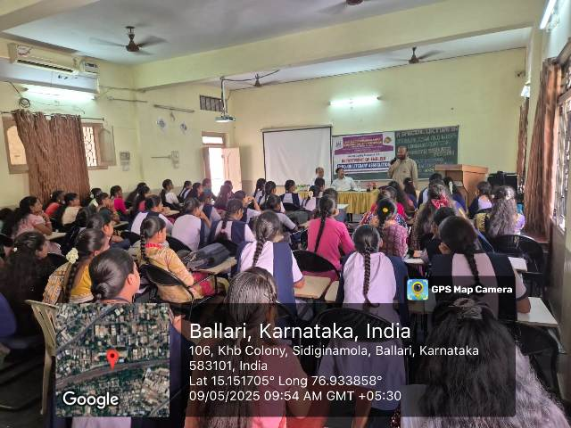
HEI Web link of the Event | https://www.smtasmc.org/index.php/latest-news-home-left/english-department-activity-a-special-lecture-programme-organized
