V. V.Sangha's
Smt. A.S.M. College for Women, Ballari. (Estd.:1969)
(Affiliated to Karnataka State Akkamahadevi Women’s University, Vijayapura.)
AISHE CODE: C-8690, NAAC TRACK ID-KACOGN11970
Recognized under sections 2(f) and 12(B) of the UGC Act 1956
(Accredited by NAAC in IV Cycle)
Internal Quality Assurance Cell (IQAC)
Anti-Ragging Committee activity held on 19.07.2025
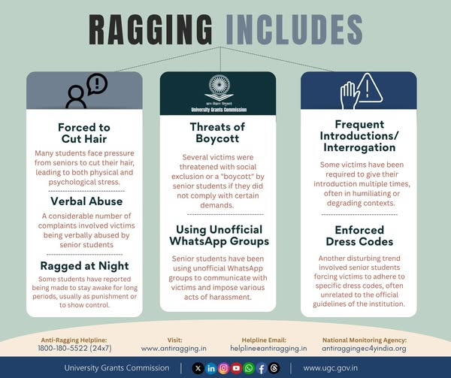
Say No To Ragging! A message for a ragging-free campus. Smt. ASM College for Women, Ballari, requested to ensure strict compliance with the UGC Advisory on Anti-Ragging and fill out the compliance on www.antiragging.in. Call 24x7 National Anti-Ragging Helpline No. 1800-180-5522.

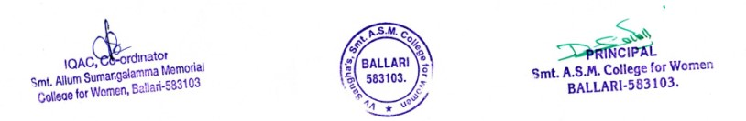

Geo Tagged Photos

