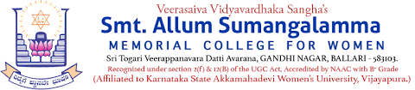
Internal Quality Assurance Cell (IQAC)

Programme: UG Department: Physical Education
Name of the Programme | ABVP Throw Ball Competition
Category | Games & Sports
Venue, Date & Time | 09.04.2025, BPS College, Ballari.
Staff & Students Participated | Attendance Sheet Copy Enclosed
HoD | Sri.G.Ashok, Physical Education Director
Brief Report on Activity | Very happy to inform that Smt.ASM College for Women, Ballari, has won the SilverMedal i.e. Second Place in Throw ball event organized by ABVP at BPSC PU College on 09-04-2025.  Hearty Congratulation to the Winners  - VVS Management, Chairperson, CGC Members, Principal, Staff & Students.
Geo Tagged Photos & HEI Web link | https://www.smtasmc.org/index.php/latest-news-home-left/physical-education-department-activity-hearty-congratulations-to-the-winners  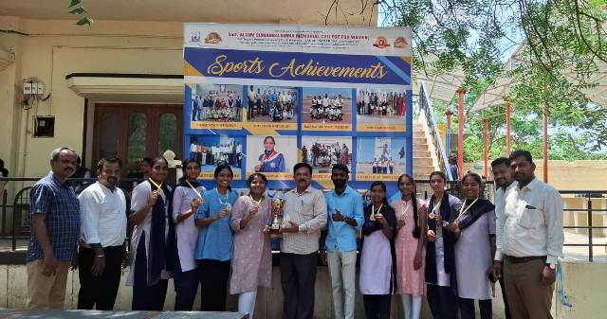

Sports & Games - 2025
