V.V.Sangha’s
Smt.Allum Sumangalamma Memorial College for Women, Ballari
Department Of Management Studies
A brief report on the education study visits during
the academic year - March 2017

Education study visits are very important for the overall development of a student. It gives them an opportunity to learn from their own experiences and from the experience of others.
When a student visits a historic place and learns about the history of that place, it feels as if she is seeing the historic events from her own eyes. They also learn from the mistakes that were done by historic characters.
From Kashmir valley to Kanyakumari and from Kutch to Kalimpong in the east, our country provides hundreds of places known for architecture, climate, scenery, environment, history, development, industry, culture, music, dance, religion a fauna. Then, there are seats of learning, which one may like to visit.
Simply reading books on science, commerce, arts, medicine, management, computers, education, law, engineering, history, architecture, etc. produces only book worms. For having enlightened citizen for a better world-order, we here encourage educational tours in our colleges and thus develop the personalities of the young girls.
An education tour gives us pleasures too. It breaks the monotony of life and fills the mind with joy. Moreover, travelling teaches it’s to bear hardship, and this is a good training for success in the struggle of life.
During the academic year 2017 the Department of Management has organized the education tour to Kerala, the details of visits are as follows:-
- Guruvayur
- Athirappilly Waterfalls
- Munnar
- Alleppey
- Thiruvanthapuram & Kovalam Beach
- Ernakulum & Kochin (Lulu International Mall)
As the part of academic curriculum, department of management has organized an education study visits for its students from March 20 2017 to March 28 2017. Accordingly the department has taken permission from the college governing body and the V.V.Sangha office. Later the department has contacted the tour agent and the tour was organized with pre plans. Students were escorted by four teaching faculties and one office staff.
The HOD of department of management Prof.Channappa Kowtal, The HOD of Department of Economics Dr.G.Shashikiran, The faculties of BCA department Ms.Sharvani & Ms.Savitha and the office staff Sri.Rajakumar Gogi were in the escort team.
Accordingly the escort team with 34 students and the tour agent team first assembled at the ballari railway station at 11pm on 20/03/2017. The team left ballari to thrissur Via Guntakal & Bangalore.
Team arrived thrissur at 8:30pm on 21/03/2017 everyone had dinner and then travelled to Guruvayur which was about 30klm from thrissur and night halt was arranged at hotel Madvan Inn Guruvayur.

22/03/2017 – Guruvayur & Athirappilly Falls
The day morning ie on 22/03/2017 all had their breakfast and later visited the famous Lord Krishna temple at Guruvayur and taken blessing from lord Krishna.
Guruvayur Sri Krishna Temple is a Hindu temple dedicated to the god Krishna (an avatar of the god Vishnu), located in the town of Guruvayur in Kerala, India.
It is one of the most important places of worship for Hindus of Kerala and is often referred to as "Bhuloka Vaikunta" which translates to the "Holy Abode of Vishnu on Earth".
The presiding deity of the Guruvayur Temple is Vishnu, worshipped in the form of Krishna. The central icon is a four-armed standing Krishna carrying the conch Panchajanya, the discus Sudarshana Chakra, the mace Kaumodaki and a lotus with a Holy basil garland.
Lord Krishna idol represents the majestic form of Vishnu as revealed to Krishna's parents Vasudeva and Devaki around the time of Krishna's birth; hence Guruvayur is also known as "Dwarka of South India".
He is currently worshipped according to routines laid down by Adi Shankara and later written formally in the Tantric way, the inter-religious spiritual movement that arose in medieval India, by Cennas Narayanan Nambudiri (born in 1427). The Cennas Nambudiris are the hereditary tantris (high priest) of the Guruvayur Temple.
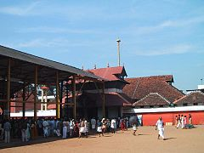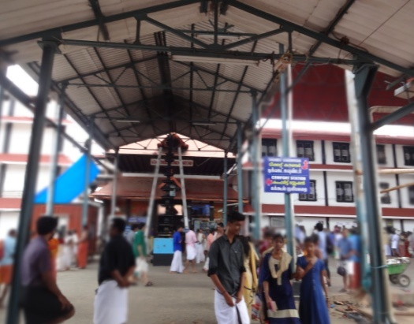
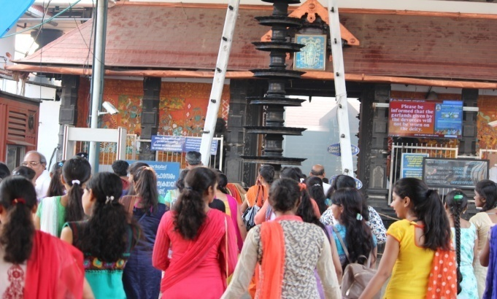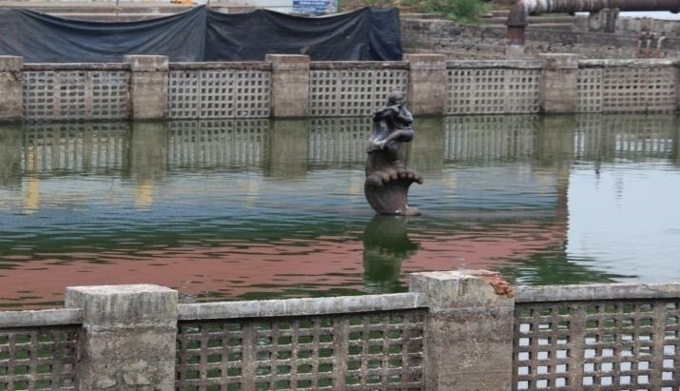
After the blessings taken from lord Krishna our team travelled to Athirappilly Falls, our team reached Athirappilly falls at 12 noon.

Athirappilly Falls
Athirappilly Falls is situated on the border of Athirappilly panchayath, Chalakudy Taluk of Thrissur district and Ayyampuzha panchayath, Aluva Taluk of Ernakulam district, Kerala on the southwest coast of India. Located on the west-flowing Chalakudy River near the Vazhachal Forest Division and the Sholayar ranges, this 24-metre (80 ft) waterfall and the nearby Vazhachal Falls are popular tourist destinations. There is another waterfall on the way from Athirappilly to Vazhachal Falls, in close proximity to the road and is locally called “Charpa Falls”. Our team has visited only Athirappilly falls because of the time constraint and Athirappilly Falls is the largest waterfall in Kerala and is nicknamed "The Niagara of India". Controversy about a state-proposed hydroelectric dam on the Chalakudy River above the waterfalls began in the 1990s and has continued through 2011.
Athirappilly Falls is one of the famous water falls in Kerala and is known as the Niagara of India. Even in summer the flow of water is heavy here in the falls. Our team spent about 6hours here and rejoiced each and every moment and carried wonderful memories from that place.
Athirappilly Falls is also known for film making spot, many films were shot here like the recent blockbuster movie Bahubali, Bahubali2, Janatha Garrage, etc…
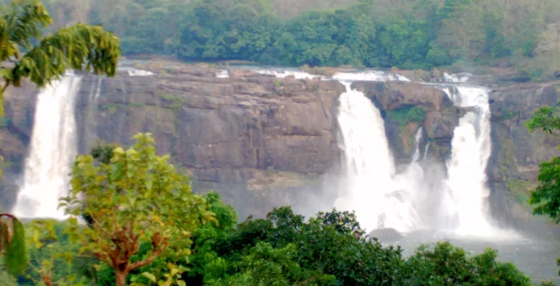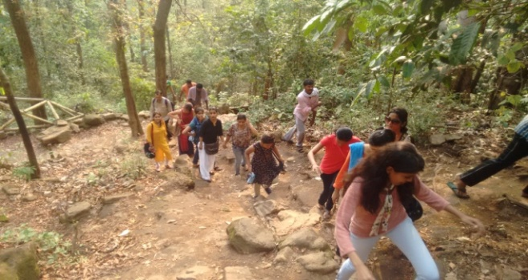
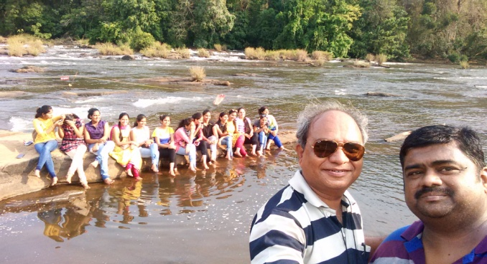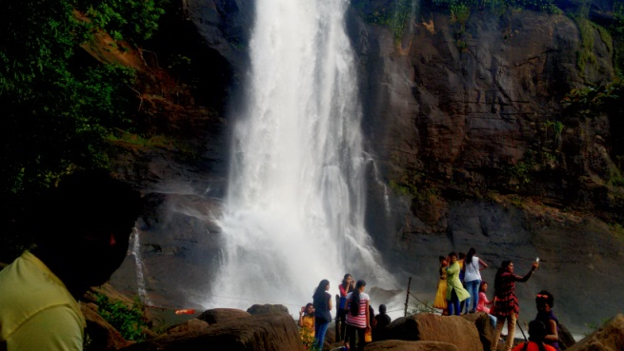
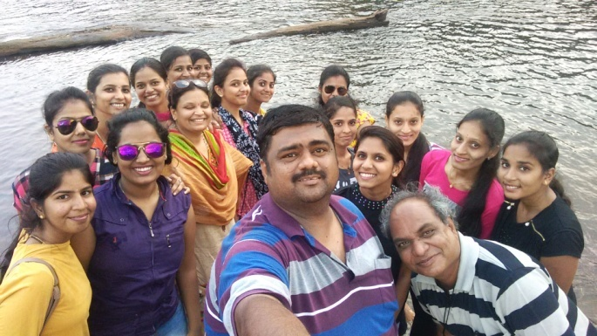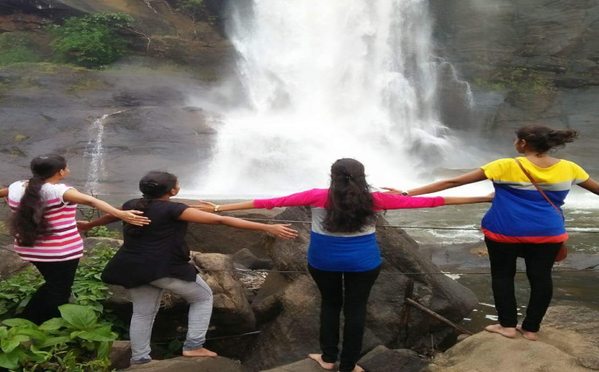

23/03/2017 – Munnar
Team reached Munnar at 10pm on 22/03/2017 and had dinner, halted in hotel regional regim. Later next day morning had wonderful breakfast ie ballari famous Vaggarni Mirchi and started our journey.
During the day we have visited the famous Rose Garden (Floriculture Centre), Elephant Ride, Mattupetty Dam, Tata Tea Factory & Museum and the Echo Point.
Munnar is situated at the confluence of three mountain streams - Mudrapuzha, Nallathanni and Kundala. 1,600 m above sea level, this hill station was once the summer resort of the erstwhile British Government in South India.
Sprawling tea plantations, picture-book towns, winding lanes and holiday facilities make this a popular resort town. Among the exotic flora found in the forests and grasslands here is the Neelakurinji. This flower which bathes the hills in blue once in every twelve years will bloom next in 2018.
Munnar also has the highest peak in South India, Anamudi, which towers over 2,695 m. Anamudi is an ideal spot for trekking. Munnar town is situated on the Kannan Devan Hills village in Devikulam taluk and is the largest panchayat in the Idukki district covering an area of nearly 557 square kilometres (215 sq mi).
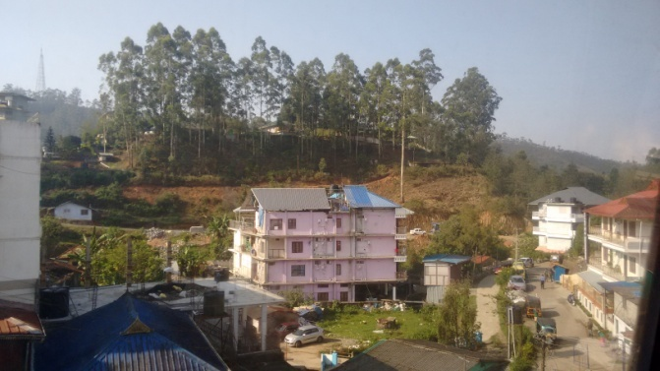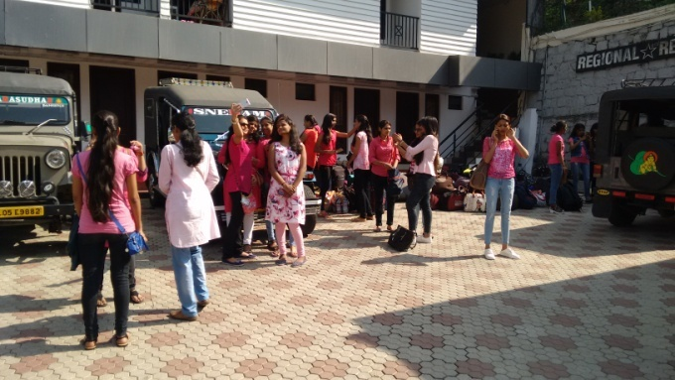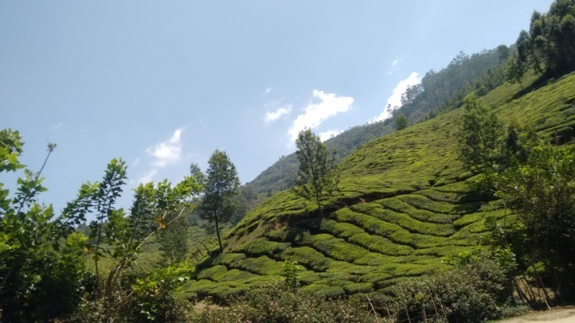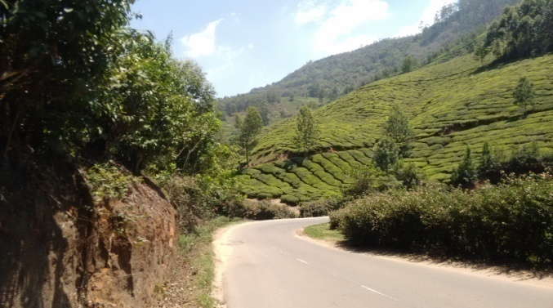

Mattupetty (Maddupetty Dam)
Another place of interest, located about 13 km from Munnar Town, is Mattupetty. Situated at a height of 1700 m above sea level, Mattupetty is known for its storage masonry dam and the beautiful lake, which offers pleasurable boat rides, enabling one to enjoy the surrounding hills and landscape. Mattupetty's fame is also attributed to the dairy farm run by the Indo-Swiss Livestock Project, where one would come across different high yielding breeds of cows.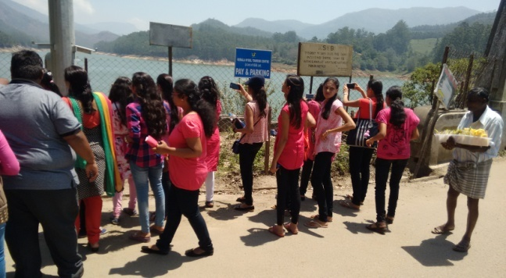 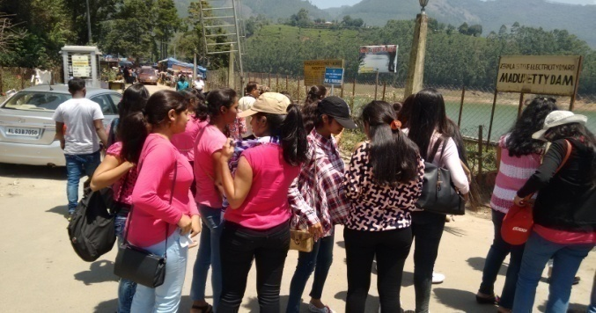
- Munnar has its own Tea Museum & Tata Tea Factory

(Industry Interaction)
Munnar has a legacy of its own when it comes to the origins and evolution of tea plantations. Taking account of this legacy and to preserve and showcase some of the exquisite and interesting aspects on the genesis and growth of tea plantations in Kerala's high ranges, a museum exclusively for tea was opened some years ago by Tata Tea in Munnar. This Tea Museum houses curios, photographs and machineries; all of which have a story to tell on the origins and growth of tea plantations in Munnar. The museum is located at the Nallathanni Estate of Tata Tea in Munnar and is worth a visit.
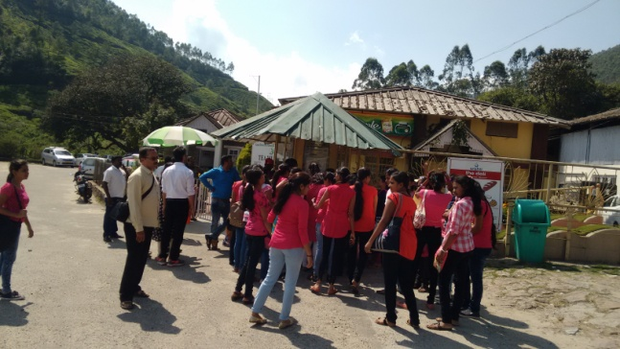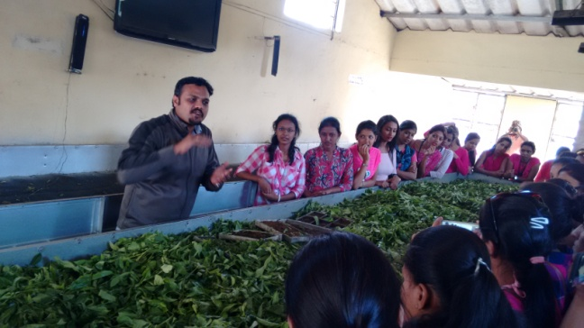
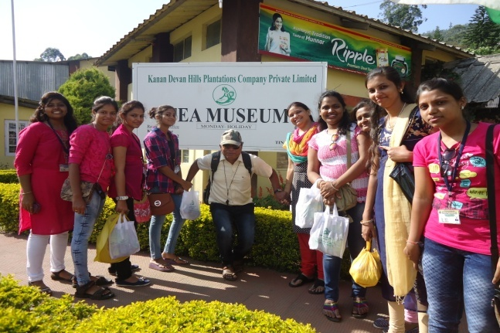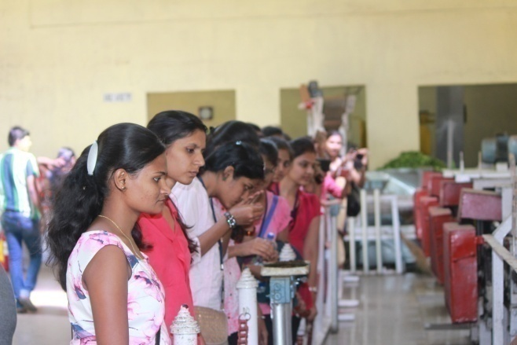

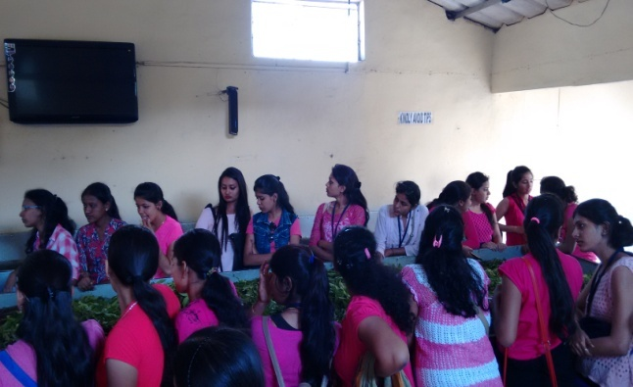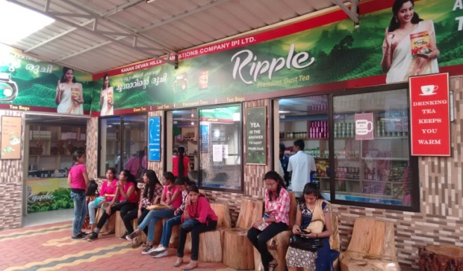

Students have taken maximum practical knowledge and experiences by visiting the Tata tea factory. Students were enlightened with the knowledge of how the tea plantation are grown and how the tea powder are been manufactured. Students have also come to know the purpose for drinking tea and the process of how the tea is prepared. Our team has also visited the famous tea museum.

- Munnar Rose Garden (Floriculture Centre) - a treat for the eyes
Munnar Floriculture Centre, popularly known as Munnar Rose Garden, is a beautiful garden with hundreds of rare varieties of flowers and herbal plants. With large tea plantations in the background, this is place is definitely worth a visit for everyone who enjoy flowers.
Munnar Floriculture Centre is operated by Kerala Forest Developerment Centre (KFDC), a Govt. of Kerala undertaking. Spread across a few acres of land and located along the Munnar - Mattupetty road, this place has an amenity centre for tourists and a sales outlet, in addition to hundreds of rare varieties of flowers, cactus, shrubs, creepers and herbal plants. The amenity centre inside the garden has toilets, shop, snacks, coffee etc.
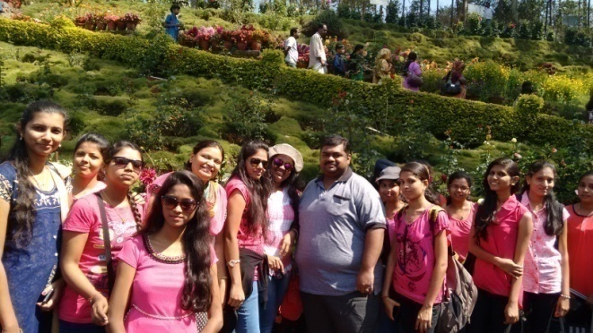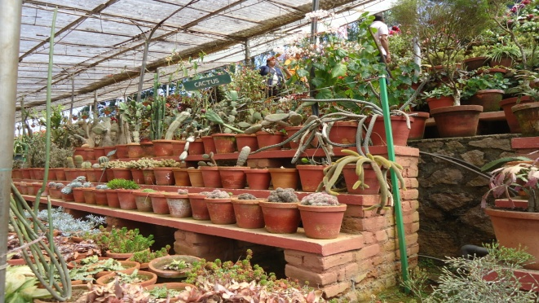
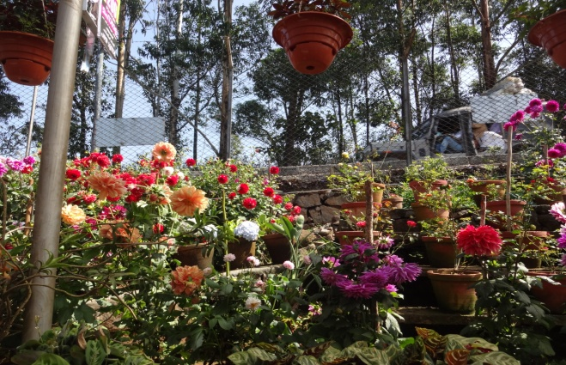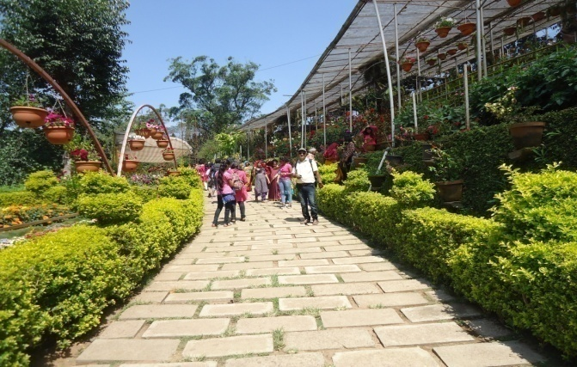
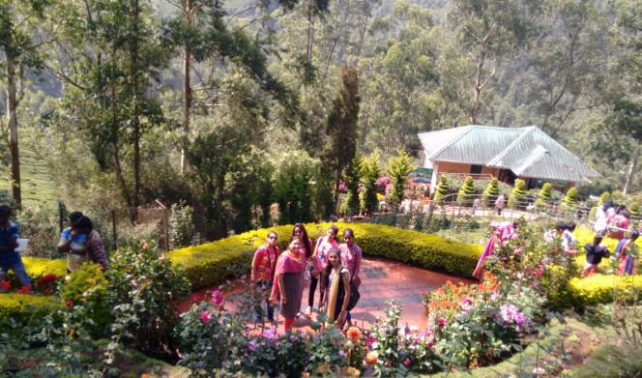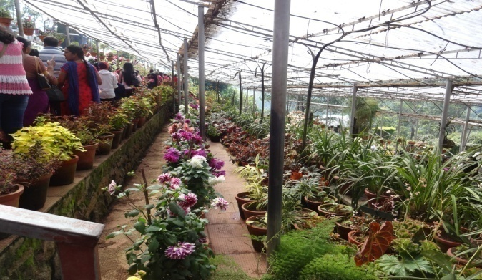
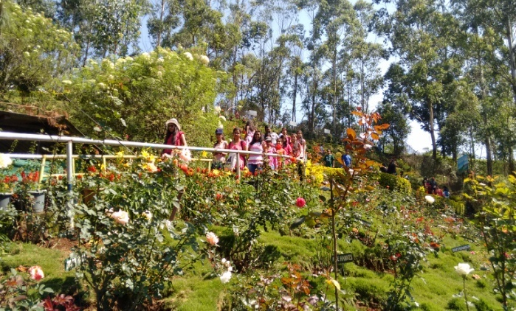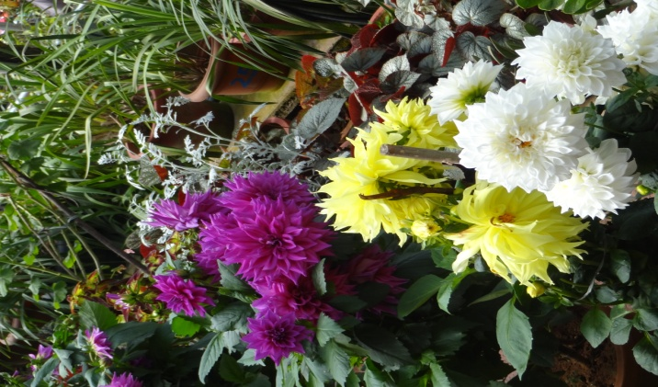
- Carmelagiri Elephant Park
Enjoy a ride on the back of an elephant at the Carmelagiri Elephant Park in Munnar. The elephant safari will take you through the rugged terrain and deep valleys of the misty Munnar forests. Because of the time constraint and heavy ride booking at elephant park our team could not enjoy the elephant ride.
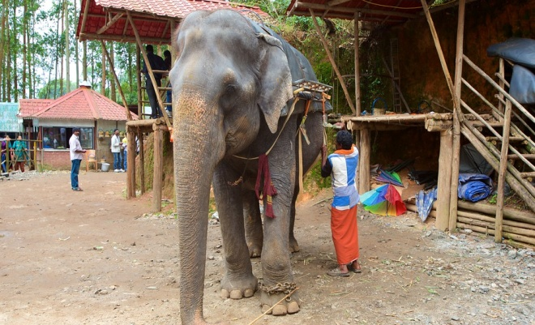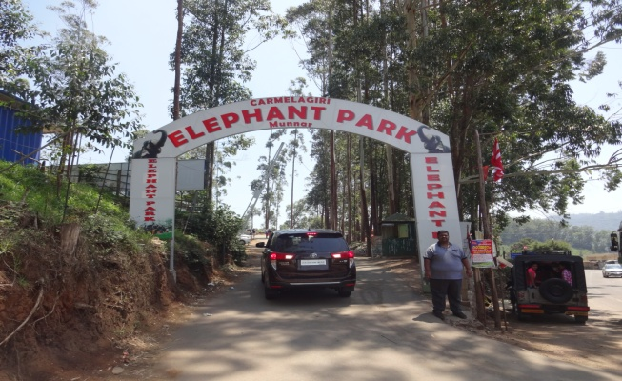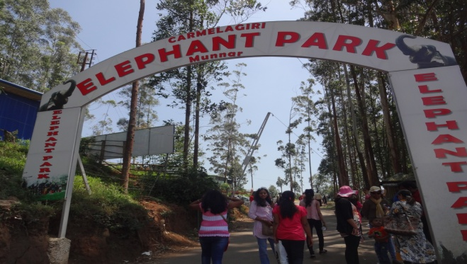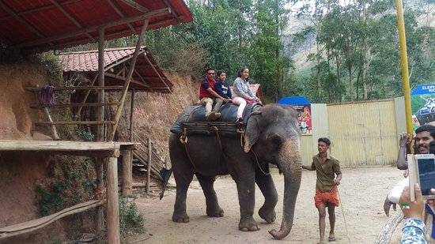
- Echo Point
This scenic place gets its name from the natural echo phenomenon here. Echo Point, situated on the way to Top Station from Munnar is a stopover for tourists visiting Top Station - the highest point in Munnar and the rare Neelakurinji (Strobilanthus) blooms here.
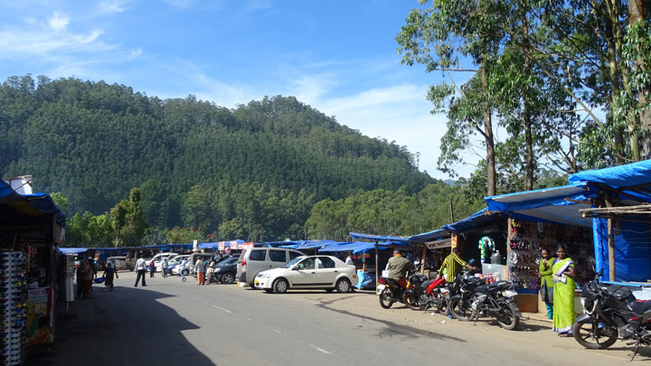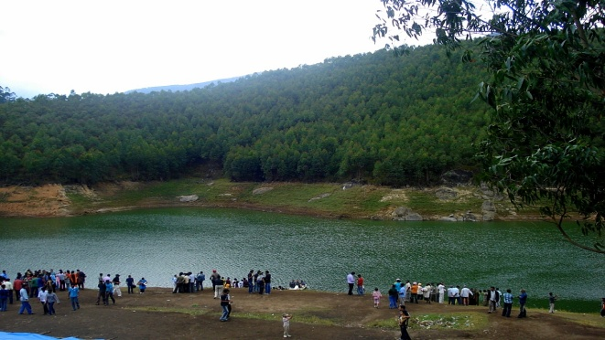
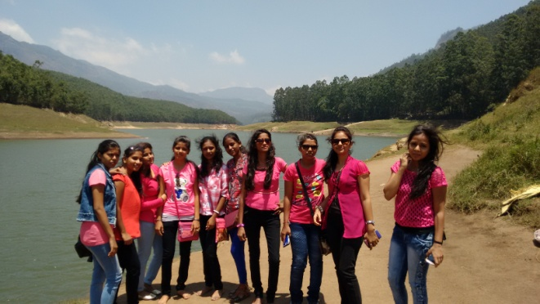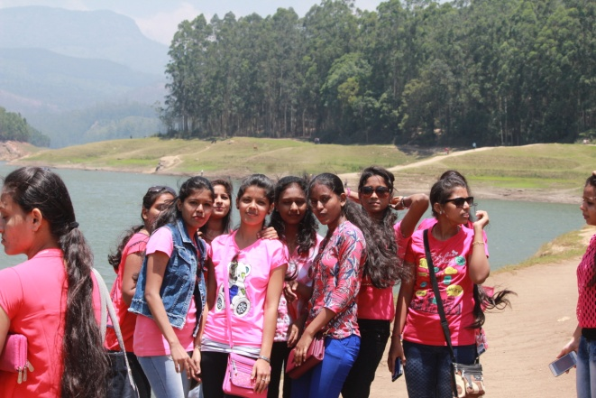
24/03/2017 – Alleppey (Alappuzha)
After a hectic journey from Munnar in the evening reached Alleppey at 10pm on 23/03/2017 and the halt & dinner was arranged in an air-conditioned boathouse.
In God’s Own Country, Alleppey is the most beautiful county – Backwaters still as mirrors, alluring beaches, shimmering canals, luscious greenery and much more.
Alappuzha (or Alleppey) is a city on the Laccadive Sea in the southern Indian state of Kerala. It's best known for houseboat cruises along the rustic Kerala backwaters, a network of tranquil canals and lagoons. Alappuzha Beach is the site of the 19th-century Alappuzha Lighthouse. The city's Mullakkal Temple features a traditional design. Punnamada Lake's snake boat races are a well-known annual event.
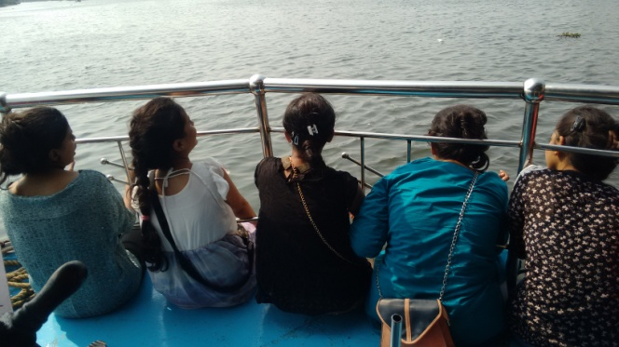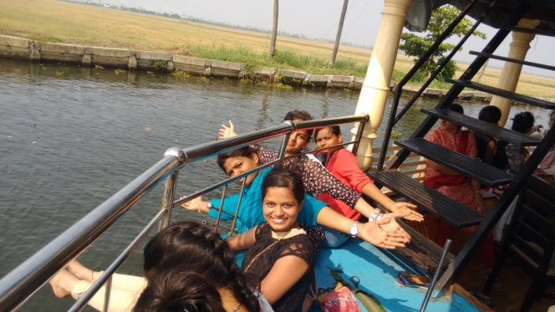
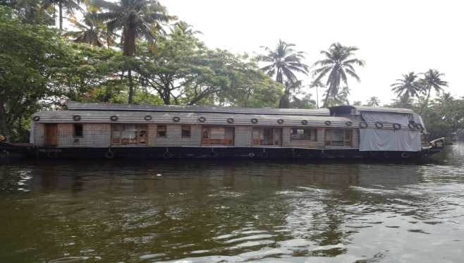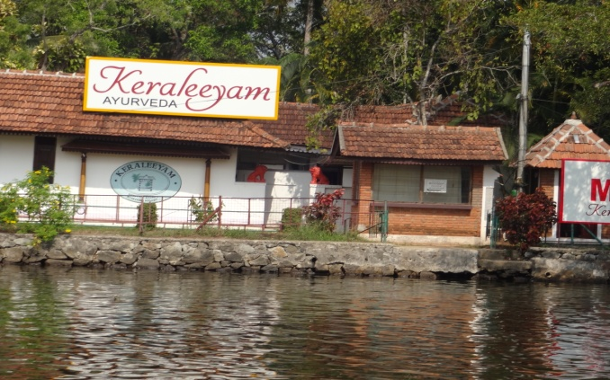
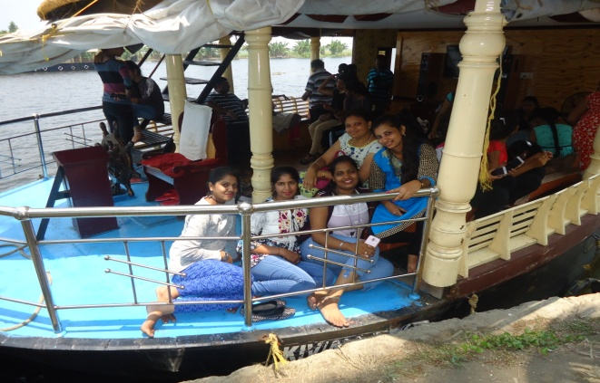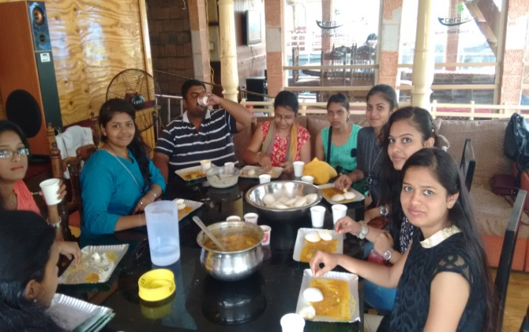
Alleppey is a famous place in Kerala; the temperature is about 29 C – 30 C. which is also known as city of backwaters and the city has the sea shore and it has the deepest beaches across its place.
Our team travelled in the boathouse for about 45klms in the backwaters. Our team was soo excited as most of the team members had their first backwaters boathouse experiences.
After the daylong enjoyment in boathouse the journey got an end at 5pm with wonderful snaks and tea at boathouse.
After the sightseeing at Alleppey the team left to thiruvananthapuram and reached our destination around 10pm, dinner and halt was arranged at hotel thriva.
25/03/2017 – Thiruvananthapuram & Kovalam Beach
Morning 7am everyone got ready and reached the famous “Padmanaba Swamy Temple” and took blessing from the lord Padmanaba Swamy. Later a guide from the temple explained the importance of visiting “Padmanaba Swamy Temple” and how the dharshan to be made at temple and the guide also explained the history of the temple. After the temple visit our team left to Kovalam Beach where our students enjoyed in beach. Later in the evening our team left to Ernakulam.
Thiruvananthapuram, formerly known as Trivandrum, is the capital and the largest city of the Indian state of Kerala. It is located on the west coast of India near the extreme south of the mainland. Referred to by Mahatma Gandhi as the "Evergreen city of India" it is classified as a Tier-II city by the Government of India.
Thiruvananthapuram was a trading post for spices, sandalwood and ivory. The city was ruled by the Ays and was captured by the rulers of Venad in tenth century A.D. In 1729, Marthanda Varma founded the princely state of Thiruvithamkoor and made Thiruvananthapuram the capital in 1745. It remained as a princely state ruled by Travancore under the loose governance of the British before joining the Indian Union in 1948.
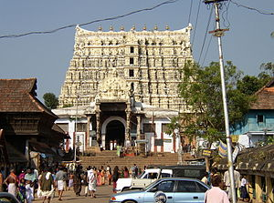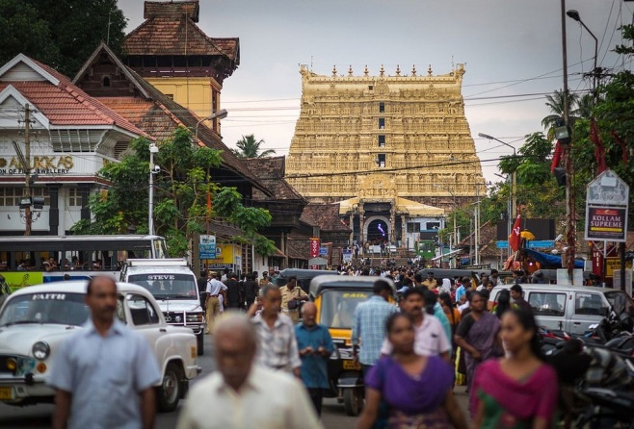
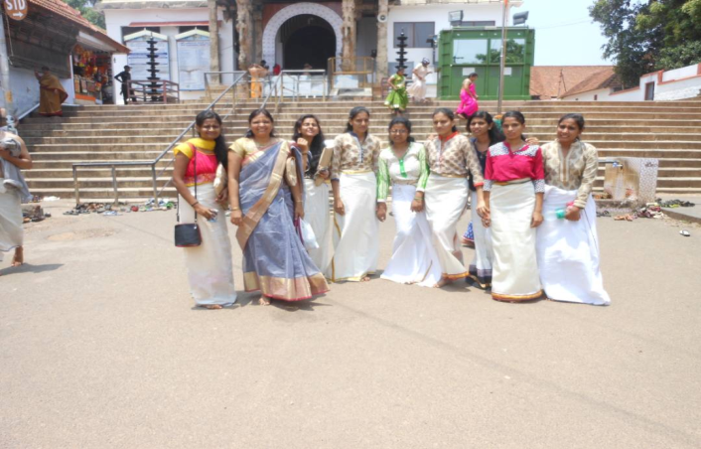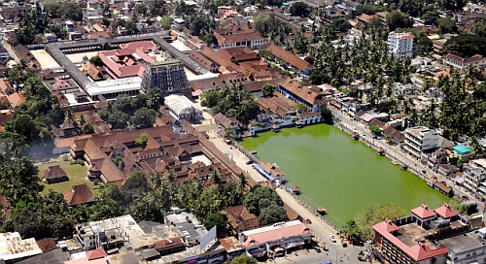
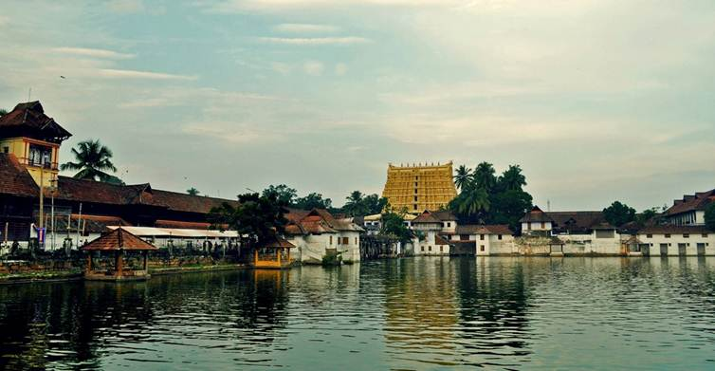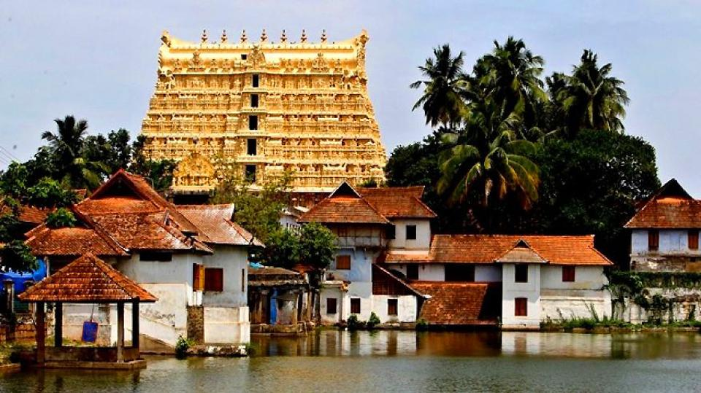

Kovalam Beach
Kovalam is a beach town by the Arabian Sea in Thiruvananthapuram city, Kerala, India, located around 16 km south of the city center. Kovalam means a grove of coconut trees and true to its name the village offers an endless sight of coconut trees.
Kovalam first received attention when the Regent Maharani Sethu Lakshmi Bayi of Travancore constructed her beach resort, Halcyon Castle, here towards the end of the 1920s. Thereafter the place was brought to the public eye by her nephew the Maharaja of Travancore.^{[2]} The European guests of the then Travancore kingdom discovered the potentiality of Kovalam beach as a tourist destination in the 1930s. However, Kovalam shot into limelight in the early seventies with arrivals of the masses of hippies on their way to Ceylon in the Hippie Trail. This exodus started the transformation of a casual fishing village of Kerala into one of the most important tourist destinations in all India.
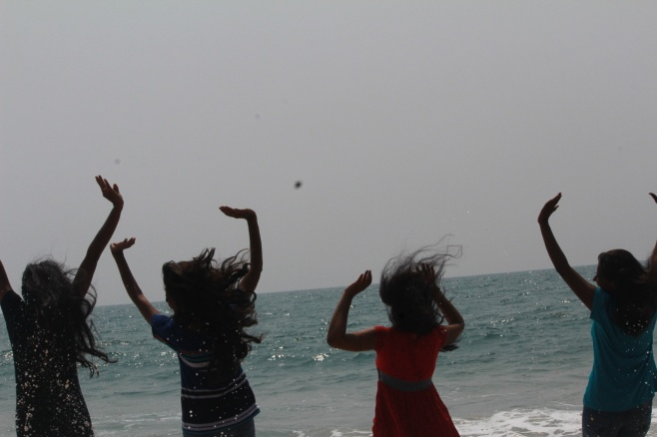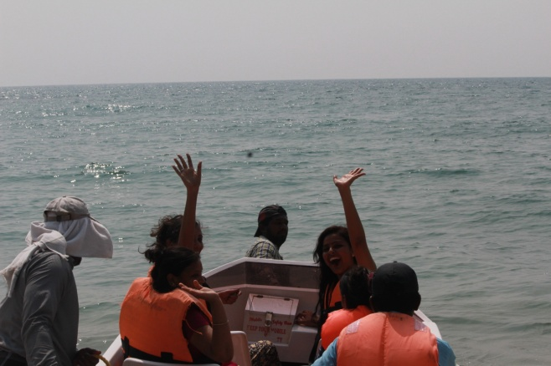
26/03/2017 - Ernakulam
After a beautiful breakfast our team as visited an IT company by name “Chips Software System” and interacted with the IT people during the secession IT officials enlightened our students with the soft skills on IT and audio visual presentation and other computer topics. At the end of the secession “Chips Software System” handed over a certificate to our team for our visit.
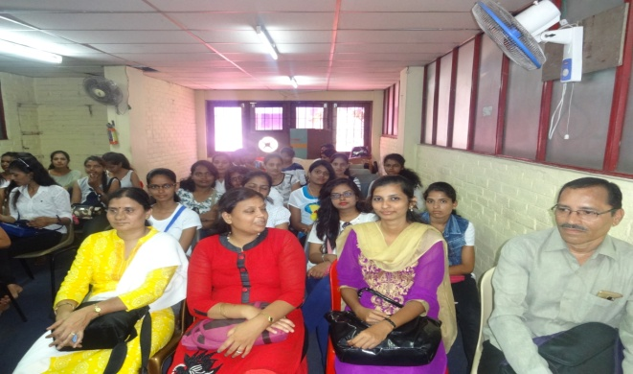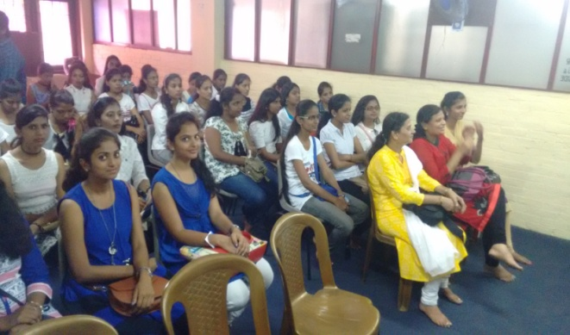
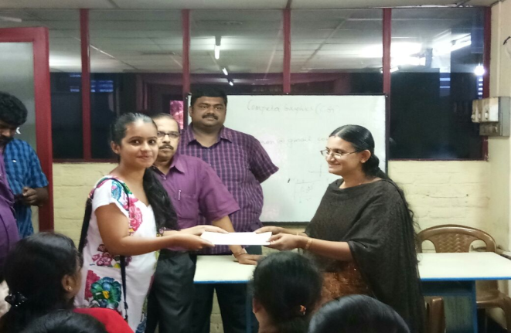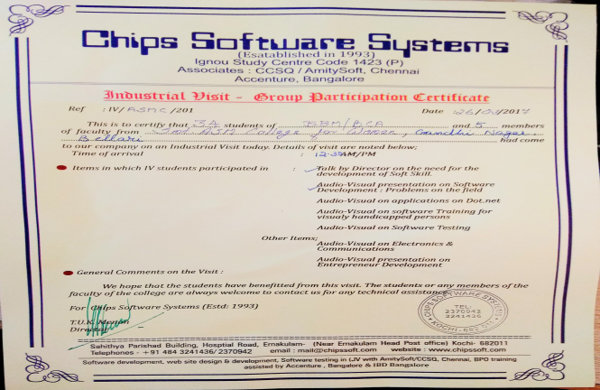

Lulu International Shopping Mall
After the IT industry visit our team left to Kochin, in Kochin our students visited the famous Lulu International Mall.
Lulu Mall, in the city of Kochi, Kerala, is the largest shopping mall in India. It is one of the most visited places in Kerala. Spanning 17 acres and with a total built up area of 2.5 million square feet, it is the 89th-largest shopping mall in the world and the largest in India with 1.7 million square feet area of retail space. The mall was opened in March 2013.
It contains more than 215 outlets, including food courts, restaurants, family entertainment zones, a multiplex, ice skating rink and bowling alley. The estimated cost for this project is more than ₹16 billion or US$250 million.
The property is owned and managed by Lulu Group, which has extensive business in retail, hospitality, real estate etc. Lulu Mall in Kochi was their maiden retail venture in India.
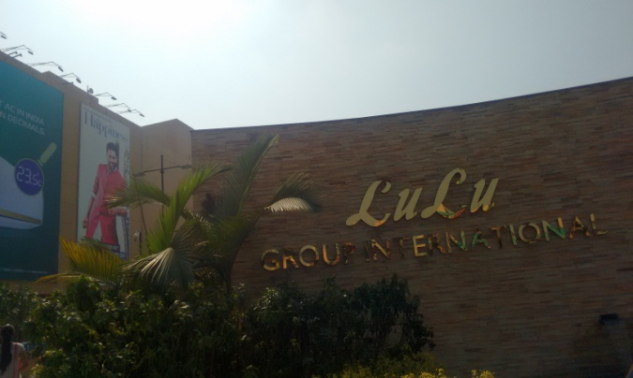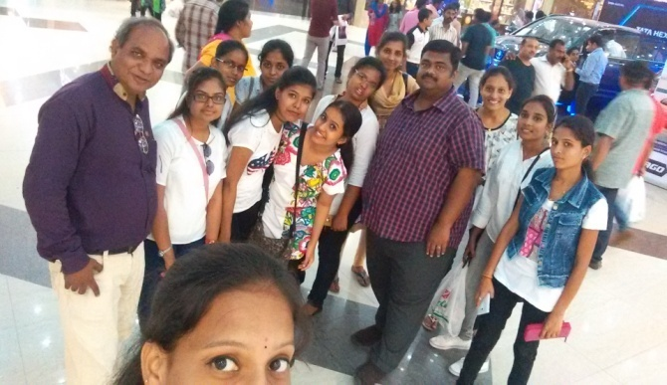

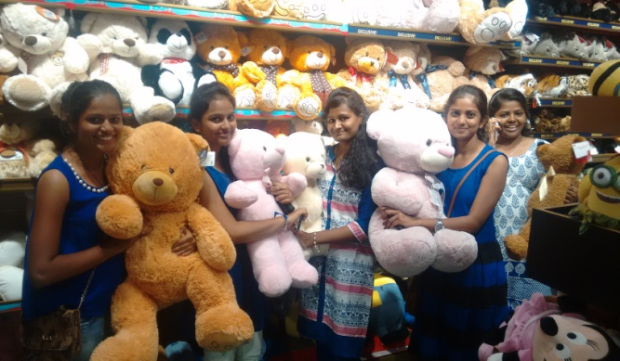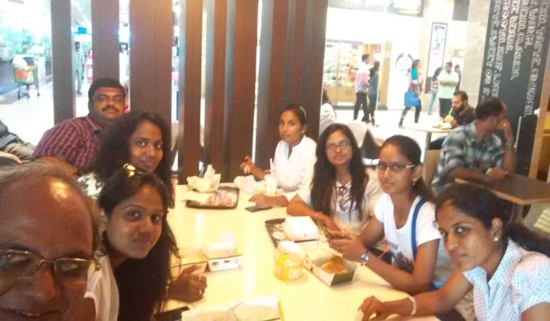
27/03/2017
Our team started return journey from Ernakulam south railway station in morning 9am through Ernakulam – Bangalore express train and reached Bangalore at 8pm, Again need to change the train for our further journey. At 10pm we started our journey through Hampi express and reached ballari in the morning 7am on 28/03/2017.
All the students’ parents were arrived in the morning 7am to receive their daughters and dispersed from ballari railway station.

