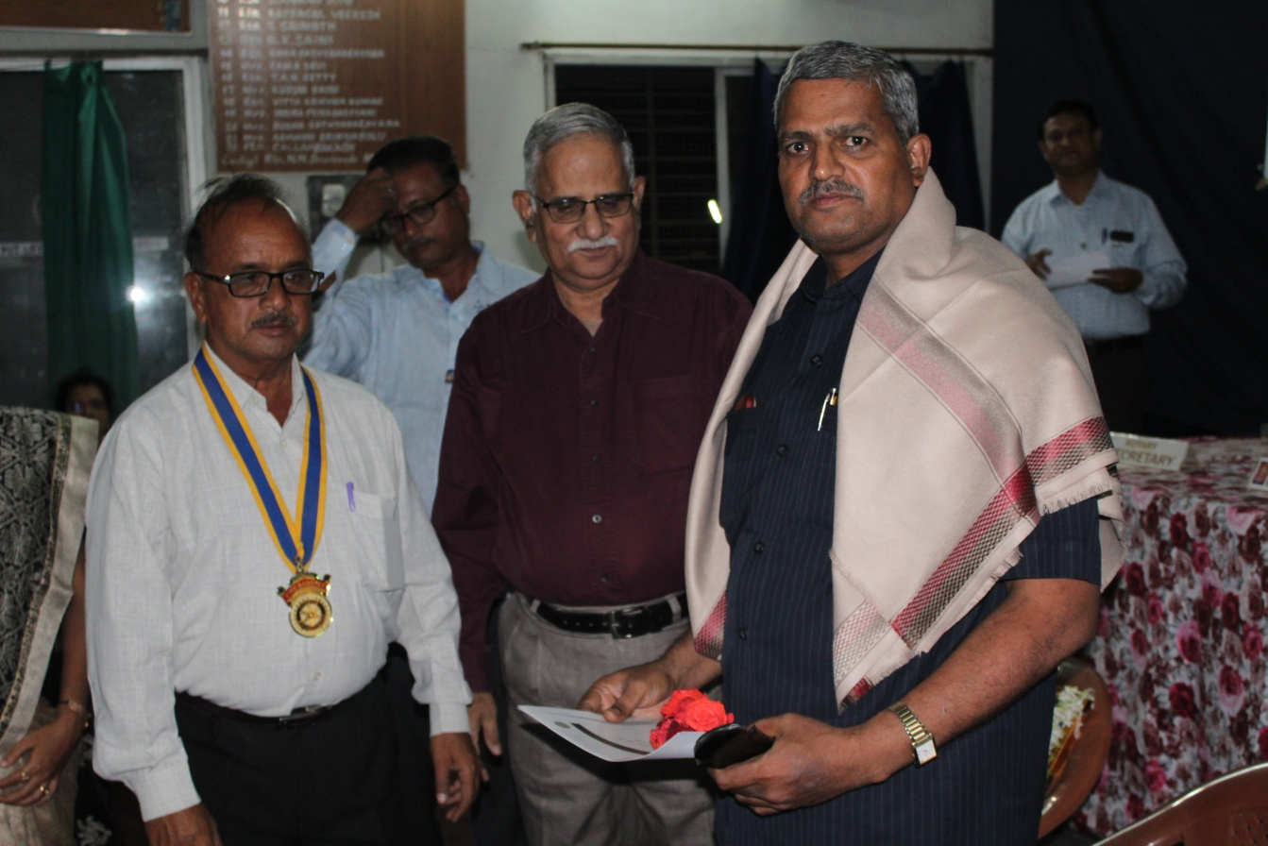
Rotary Nation Builder Award awarded to Dr.V.S.Prabhaiah, Associate Professor of Mathematics,
Smt. A.S.M. College for Women, Ballari.
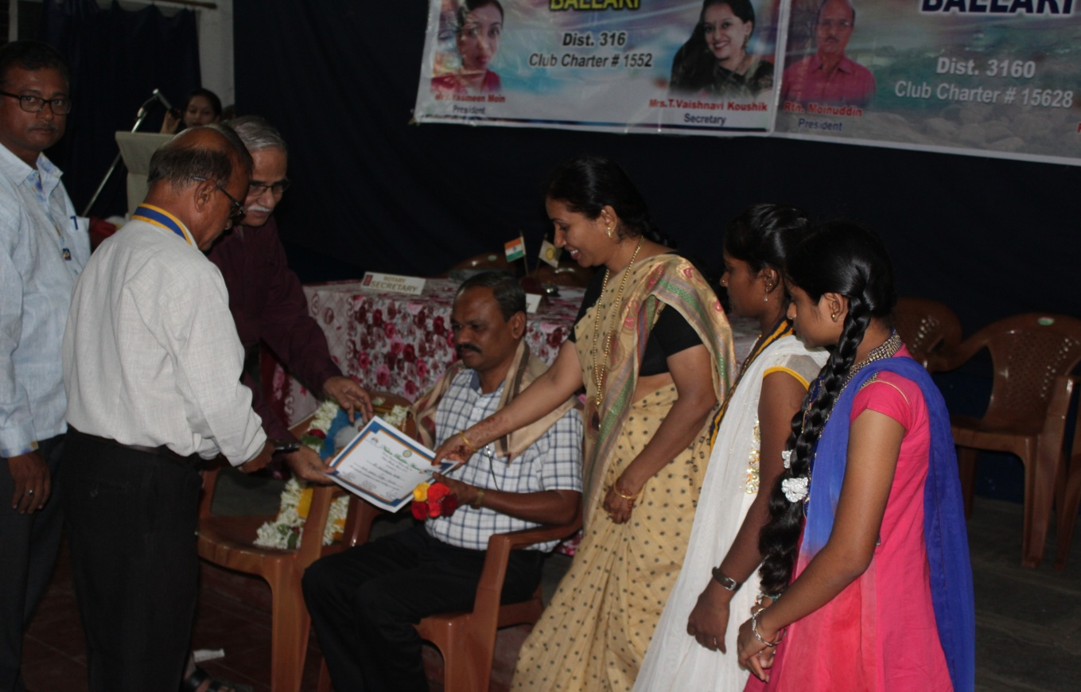
Rotary Nation Builder Award awarded to Dr.Gavisiddappa Gadag, Associate Professor of Commerce,
Smt. A.S.M. College for Women, Ballari.

