
Internal Quality Assurance Cell (IQAC_
Smt.Allum Sumngalmma Rangers Unit
Programme : UG Departments: Kannada & History & NSS Units
Name of the Programme | Celebration of Matha Poojya Shree Akkamahadevi Birth Anniversary
Category | Knowledge Oriented
Venue, Date & Time | 12th April, 2025 @ 10.40am in the Botany Lab
Objective & Report | Akka Mahadevi's Jayanti, birth anniversary, is celebrated on April 10th, 2025, as it is a significant day to commemorate the contributions of this influential Kannada poet and mystic. Time Period: She lived in the 12th century. Literary Contribution: She wrote "Vachanas," a type of poetry that aimed to make complex religious ideas accessible to the common people through simple language. Inspiration: She is seen as an inspirational woman in Kannada literature and in the history of Karnataka. Husband: She considered the god Shiva ("Chenna Mallikarjuna") as her husband. Legacy: Akkamahadevi's work and life have had a lasting impact on Kannada literature and culture.
Target Audience | Rangers & UG Students  Attendance Sheet Enclosed
Geo Tagged Photo | 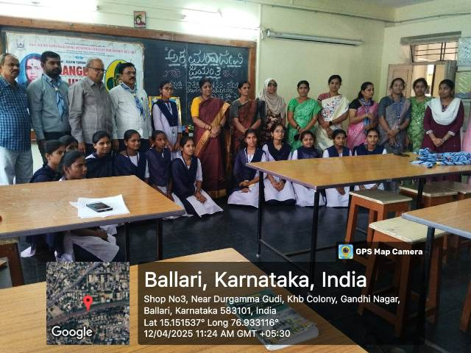
HEI web link of the Event | https://www.smtasmc.org/index.php/latest-news-home-left/celebration-of-akkamahadevi-birth-anniversary-april-2025
..2(P.T.O.)

-2-
Report on the Event
On 12.04.2025, Smt.Allum Sumangalamma Memorial Women's College, Ballari, Ranger Unit celebrated the blessed Akkamahadevi Jayanthi in collaboration with Kannada, History and NSS units. The program was presided over by Mrs. Kathyayini M. Maridevaiah, Chairperson of the College Governing Council. The Principal of the College, Dr. Dupam Sateesh was the chief guest. Durgamma H., a ranger student, BA Fourth Semester, who spoke about the life and achievement of Akkamahadevi. Mrs. Kathyayini M. Maridevaiah said through his presidential remarks that the life story of Akkamahadevi and his ideas in his vows would also be applied to the present time. The program began with prayer. The prayer was sung by Ms.KM Chaitanya, who was guests of the event. Ms.Anusha was welcomed. Ms.K. Shweta performed the salutation. The program was hosted by Ms.L. Sahan, the captain of the Ranger unit. The officers of the ranger unit, Dr.MANGALA BOJA BN, IQAC Coordinator Dr. P.J BINDU, co-coordinator Dr. SYEDA K TANVEER, Head of Kannada Department and NSS Unit Officer Dr. Suvarnamma .D., Head of History, Sri Ramalinga T, NSS Unit Officers Dr. Basavarajeshwari. H. And the heads of all departments, lecturers and rangers were present in the event.

