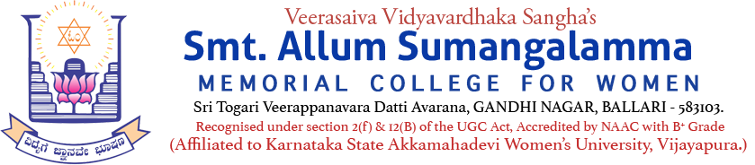
Internal Quality Assurance Cell (IQAC)
Health Centre & Youth Red Cross Wing MoU Activity
Programmes: UG & PG Departments: All & YRCW
Name of the Programme | National Voluntarily Blood Donors Day-2025  Blood Grouping & Voluntarily Blood Donation Camp
Category | Institution Social Responsibility MoU activity  Knowledge Oriented & Importance of Day
Venue, Date & Time | College Auditorium, 11.10.2025, 10.00am
Resource Person | Invitation Copy Enclosed
Target Audience &  Participation of Students and Staff | UG, PG Students, Staff & Public  (Attendance Sheet Copy Enclosed)
Brief Report on activity | Report Copy Enclosed below
Geo Tagged Photos Social Media Web links | https://www.facebook.com/share/p/1Bi2t4reCy/  https://www.facebook.com/share/1ZDHS2c1kp/
HEI Web link of the Event | Youth Red Cross Wing (YRCW) MoU activity—Blood Grouping & Voluntary Blood Donation Camp held on 11.10.2025 at the Auditorium of Smt. ASM College for Women, Ballari
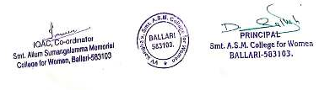

V.V.Sangha's
Smt. A.S.M. College for Women, Ballari (Estd.: 1969)
(Affiliated to Karnataka State Akkamahadevi Women’s University, Vijayapura.)
AISHE CODE: C-8690, NAAC TRACK ID-KACOGN11970
Recognized under sections 2(f) and 12(B) of the UGC Act 1956
(Accredited by NAAC in IV Cycle)
Internal Quality Assurance Cell (IQAC)
Date: 11.10.2025
Youth Red Cross Wing (YRCW) activity—Blood Grouping & Voluntary Blood Donation
Camp held on 11.10.2025 at the Auditorium of Smt. ASM College for Women, Ballari.
Social Media Web link --> https://www.facebook.com/share/1ZDHS2c1kp/

Report on the Blood Donation Camp held on 11.10.2025 @ Auditorium

Youth Red Cross Wing of Smt.ASM College for Women, Ballari, in association with Indian Red Cross Society, Ballari & Ballari Medical College & Research Centre had organized “Blood Group Checkup & Blood Donation Camp” in the main auditorium of the College on 11.10.2025. The College Governing Council Chairperson Smt.KATHYAYINI.M.MARIDEVAIAH, presided over the event. Chief Guest Sri.Md.Haris Sumer, I.A.S., Chief Executive Officer, Zilla Panchayat, Ballari, and Vice-President of IRCS, Dr.V.Indrani, DAPCU Officer, Dr.Bindu, Blood Bank Officer, BMC & RC, Ballari, Dr.S.J.V. Mahipal, Vice-Chairman, IRCS, Ballari, Sri.S.Devanna, Director, Blood Donation Sub Committee IRCS & Sri. Kuppagal Veeresh, Retired Principal of RYME College, Ballari, inaugurated the vent by watering the Plant. Dr. Indrani delivered the keynote address. Chief Guest Md. Haris Sumer, IAS, in his inaugural address briefed out the significance of blood donation. He advised the students and gathering to donate the blood that could save many lives.
..2

-2-
Dr.S.J.V.Mahipal, Vice-Chairman, IRCS, Ballari, spoke on the occasion that every drop of blood is precious. He advised the students to eat nutritious food that will improve the quality and quantity of blood in the body. Principal Dr.Dupam Satheesh also spoke about the various aspects of Blood donation and its process. The College Governing Council Chairperson Smt.KATHYAYINI.M.MARIDEVAIAH, in her presidential remarks lauded the effors of YRCW of the College for organizing Blood Donation Camp and also thanked BMC & RC, IRCS for collaborating with the college for the noble cause. Shri.Md.Haris Sumer, Dr.Indrani & Dr.Bindu, Dr.S.J.V.Mahipal & Sri.Devanna were felicitated on the occasion. The College IQAC Coordinator & Convener of YRCW Dr.SYEDA.K.TANVEER, carried out the event. The College faculty of Chemistry Smt.ROHINAZ welcomed the guests and gathering. Ms.AMRUTHA, of B Sc-III Semester invocated the event. Faculty of Zoology Ms.VINSHNU PRIYA proposed the vote of thanks. Volunteers of The Bharat Scouts & Guides Rangers Unit involved and assisted the YRCW in the Blood Donation event. The College Staff & Students witnessed the event. In all donated the blood on the camp.
