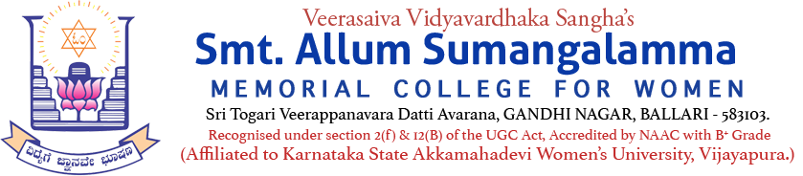
Internal Quality Assurance Cell (IQAC)
Botany & Zoology Departments
Programmes: UG & PG Departments: All
Name of the Programme | A One-day National Conference in Hybrid Mode on the topic "FRONTIER'S IN AGRICULTURE, MEDICAL & ENVIRONMENTAL SCIENCE (FAMES-2K25)"
Category | National Conference (RDC)
Venue, Date & Time | Seminar Hall, 28.11.2025, 09.00am to 06.00pm
Resource Person | Brochure Enclosed
Target Audience &  Participation of Students and Staff | Delegates, Participants, UG, PG Students & Staff  (Attendance Sheet Copy Enclosed)  Hybrid Mode
Brief Report on activity | Report Copy Enclosed
Geo Tagged Photos Social Media Web link | https://www.facebook.com/share/p/16DVrMGb6e/  https://www.facebook.com/share/p/14P1a8Tvifk/  https://www.facebook.com/share/p/19x4NZGoBY/
HEI Web links of the Event | https://www.smtasmc.org/index.php/latest-news-home-left/a-one-day-national-conference-in-hybrid-mode-on-the-topic-frontiers-in-agriculture-medical-environmental-science-fames-2k25-on-28-11-2025-at-seminar-hall
 | https://www.smtasmc.org/index.php/latest-news-home-left/department-s-of-botany-zoology-are-going-to-organize-a-one-day-national-conference-in-hybrid-mode-on-the-topic-frontiers-in-agriculture-medical-environmental-science-fames-2k25-on-28-11-2025
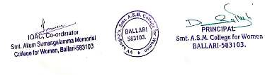

Date: 28.11.2025
Internal Quality Assurance Cell (IQAC)
Zoology & Botany Department(s)
A One-day National Conference in Hybrid Mode on the topic "FRONTIERS IN AGRICULTURE, MEDICAL & ENVIRONMENTAL SCIENCE (FAMES-2K25)" on 28.11.2025 at College Seminar Hall.
Report on the National Conference organized on 28.11.2025 at Seminar Hall
Press Note
A One Day National Level Conference on “Frontiers in Agriculture Medical and Environmental Science FAMES2K25” was organized by the Departments of Botany & Zoology of V.V.Sangha’s Smt.ASM College for Women, Ballari, on 28th November, 2025. College Governing Council Chairperson Smt.KATHYAYINI.M.MARIDEVAIAH, Chief Guest Dr.Sasidar.B.S., Principal Scientist, National Institute of Interdisciplinary Science & Technology, Thiruvanantapuram, Resource Persons Dr.Sreenivasa Nayaka from Karnataka University, Dharwad, Dr.Nagabhushan.V.Charantimath from VSK University, Ballari, Principal Dr.Dupam Satheesh, HoD of Botany Dr.Bheemanagounda.N.Patil, Former HoD of Botany Dr.M.G.Nadagouda inaugurated the event by lighting the lamp. After the inauguration the dignitaries released the souvenir of the Conference.
The Chief Guest Dr.Sasidar.B.S. in his inaugural address spoke on the topic “Interdisciplinary Approach to Healthcare, Agro technologies; Harnessing Nature for global well being.” He briefed out the various aspects like ‘Centre for Sustainable Energy Technologies”, the environmental science concerned to technology, sustainable energy technology and other various aspects and its applications.
..2 (P.T.O.)

-2-
Principal Dr.Dupam Satheesh spoke about the purpose of organizing the One Day National Level Conference. He said that the participation in the seminars and conferences will enable the participants to resolve the various challenges and issues faced by the field of agriculture, medical and Environmental Sciences.
CGC Chairperson Smt.KATHYAYINI.M.MARIDEVAIAH in her presidential remarks appreciated the topic opted for the National Level Conference. She advised the delegates and participants to execute the knowledge for the well being of the mankind. She lauded the efforts of the departments of Botany & Zoology for organizing this conference. The Convener & Coordinator of IQAC Dr.SYEDA.K.TANVEER compered the event, HoD of Chemistry Dr.P.J.BINDU welcomed the guests and gathering. Ms.PREMA of BCA III Semester invocated, Ms.DEEPTHI, Ms.KANCHANA & Ms. SAHANA recited the “Nada Geethe” HoD of English Shree Karanam Vijayendra Ranga Prasad, proposed the vote of thanks and Organizing Secretary Dr.BASAVARAJESHWARI introduced the Chief Guest.
Dr.G.Manohar, HoD of Zoology, Veerasaiva College, Ballari & Dr.B.UMA REDDY, Assistant Professor & Chairman of Botany Department, VSK University, Ballari, were the Rapporteurs of the Conference.
Former Principal Dr.V.S.Prabhaiah, former HoD of Botany Dr.M.G.Nadagouda, delegates from various colleges across the country, participants and students witnessed the event.

