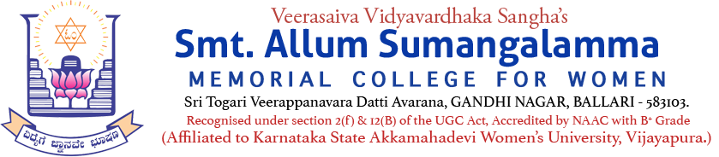
Internal Quality Assurance Cell (IQAC)
Programme: UG Departments: Botany & Zoology
Report on Inauguration of Two Days Regional Level Workshop
Name of the Programme | Regional Level Two Days Workshop
Category | Knowledge Oriented Workshop (RDC)
Venue, Date & Time | 20th & 21st May, 2025, Seminar Hall.
Target Audience &  Students and Staff Participated | V.V.Sangha’s Institution Faculty Members of Botany & Zoology Departments (Copy Enclosed)
Workshop Topic | Recent Developments & Innovations in Life Sciences
Chief Guests & Resource Persons | Brochure Copy Enclosed
Brief Report on activity | A Regional Level Workshop has been organized on the topic "Recent Developments and Innovations in Life Sciences" by Botany and Zoology Departments at Smt.Allum Sumangalamma Memorial College for Women, Ballari, for two days i.e. from 20-05-2025 to 21-05-2025. The program was presided over by Smt. Kathyayini M. Maridevaiah, Chairperson of our College Governing Council. The program was inaugurated by the Vice-Chancellor of the Hassan University, Dr.TC Taranath, and all the dignitaries of the Workshop. After the inauguration, Dr.TC Taranath said that life science is very important, and informed us, importance of every living creature living in the environment and also explained the role in enhancing the quality of mankind. Dr. Dupam Sateesh, Principal of the College, spoke about the workshop. Smt.Kathyayini.M.Marideviah, in her presidency speech, said that the organizing such workshops would help teachers to engage in the latest developments. Dr. Bheenagouda Patil, Head of the Botany Department, introduced the dignitaries on the dais. Head of the Department of Zoology & IQAC Co-Coordinator Dr.Syeda.K.Tanveer, welcomed the guests and gathering of the workshop. Mrs.Anjana and Mrs.Rohinaz, Faculty members of Department of Chemistry, prayed the prayer song. The Head of the Department of Commerce, Dr. Gavisiddappa Gadag, was honored the Resource Persons and Chief Guests of the Workshop. The program was narrated by Dr.Basavarajeshwari, Assistant Professor of Botany.
Geo Tagged Photos Social Media Web links | https://www.facebook.com/share/p/16e9ww1fNQ/  https://www.facebook.com/share/p/1BGPKZnELa/
HEI Web links of the Event | https://www.smtasmc.org/index.php/latest-news-home-left/botany-zoology-departments-activity-inauguration-of-two-days-workshop  https://www.smtasmc.org/index.php/latest-news-home-left/zoology-botany-departments-activity-self-funded-regional-level-two-days-workshop-on-20th-21st-may-2025
