NAAC PEER TEAM'S VISIT TO COLLEGE ON 04th & 05th August, 2017
for III Cycle Reaccreditation
NAAC Peer Team visited Smt. A.S.M. College for Women, Ballari on 04th & 05th August, 2017 to validate the Self Study Report (SSR) submitted by the College.
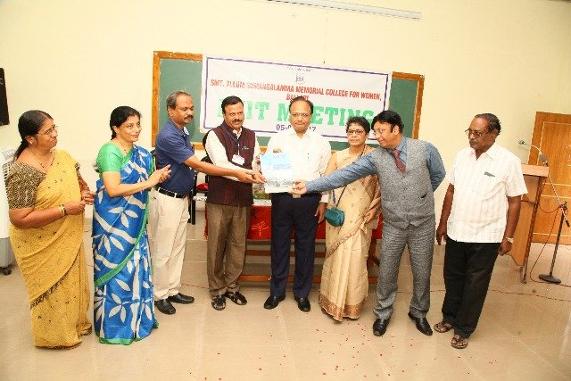
At the end of the visit, in the Exit Meeting, the Chairperson of the Peer Team Dr. Kailash Sodani, handed over the Peer Team Report (PTR) to the Principal of the College Dr. M.Pampapathi.
The other members of the Peer Team Dr. Maitreyee Bardhan Roy, NAAC Member Coordinator and Dr.Subhash Chand Arya, NAAC Member were present.
The result of declaration of third cycle grade is awaited.
NAAC Peer Team Visit Photos - 4th and 5th August, 2017.

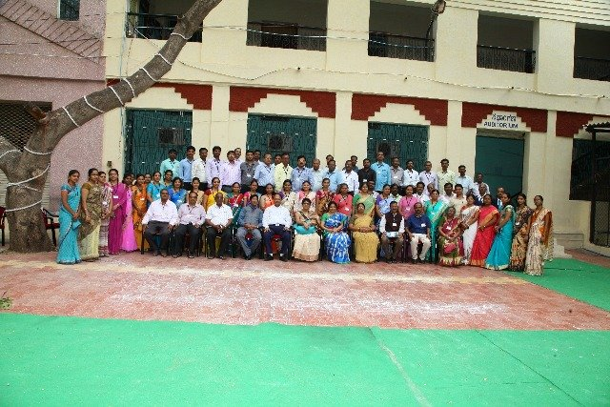
NAAC PEER TEAM WITH COLLGE GOVERNING COUNCIL & TEACHING STAFF
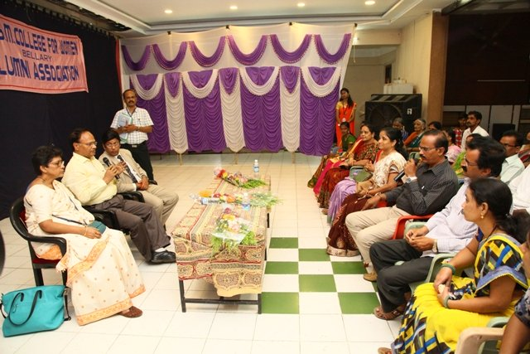
NAAC PEER TEAM MEETING WITH PARENTS
PEER TEAM VISIT
On 4th and 5th August, 2017, the honourable Chairperson Dr.Kailash Sodani, Vice-Chancellor, Guru Govind Tribal University, Banswara, Rajasthan, Dr.Maitrayee Bardhan Roy, Principal, Basantidevi College, Kolkatta as a Member Coordinator, Dr.Subash Chand Arya, Former Registrar, Vikram University, Ujjain, Madhya Pradesh as a member, being nominated by the National Assessment and Accreditation Council (NAAC), Bangalore visited the V.V.Sangha’s Smt. Allum Sumangalamma Memorial College for Women, Ballari for Third Cycle NAAC Reaccreditation and had series of interaction with the Management, Principal, Staff, Students, Alumni, Parents and assessed the infrastructure & support services available in the College.

The NAAC Exit Meeting was held on 5th August 2017, the Peer Team Report was handed over to the Principal of the College Dr.M.Pampapathi. Sri.Mundasada Muppanna, Treasurer, V.V.Sangha, the College Governing Council Chairperson Dr.Bhagyalakshmi, CGC Member Smt.Kuppagal Girija, IQAC Coordinator Dr.Gavisiddappa Gadag, All Teaching and Non-Teaching Staff were present.

