
Internal Quality Assurance Cell (IQAC)
Programme: UG Departments: Botany, Zoology & NSS
Name of the Programme | Seed Sowing Programme
Category | Experiential Learning
Venue, Date & Time | Mincheri Field Trip visit on 24.05.2025 from 10am to 04pm.
Target Audience &  Students and Staff Participated | UG Students, NSS Volunteers & Staff  (Attendance Sheet Copy Enclosed)
Brief Report on activity | Smt. ASM College for Women, Ballari, Staff and Students visited Mincheri Hills on 24.05.2025. NSS, Department of Botany and Department of History jointly organised "Seed Sowing Programme" at Mincheri Hills Forest Area. Around 54 students and 6 staff members participated and involved in seed sowing activity and covered about 5 acres of land by sowing about 5000 seeds in association with Ballari Range Forest Department on 25/05/2025 from 10am to 4pm.
Geo Tagged Photos Social Media Web link | https://www.facebook.com/share/p/1Ftu4u3m2p/  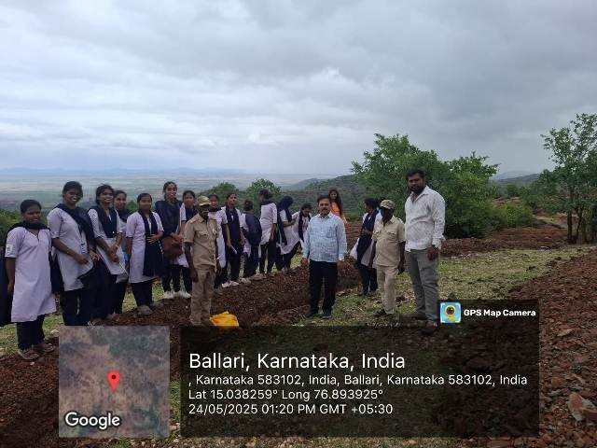
HEI Web link of the Event | https://www.smtasmc.org/index.php/latest-news-home-left/field-trip-activity-by-zoology-botany-nss-units-on-24-05-2025
