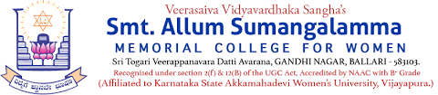
Internal Quality Assurance Cell (IQAC)

Programme: BA Department: History
Name of the Programme | History Importance of Day
Category | Knowledge Oriented
Venue, Date & Time | 10.04.2025, BA Class Room, 10.00am
Objectives | - Celebration of Mahaveer Jayanthi – 2025
Chief Guest | Smt Kathyayini M Maridevaiah
Target Audience & Number of  Students present | BA History Students  (Attendance Sheet Copy Enclosed)
Programme coordinator | Sri. Ramalinga, Head, Department of History, Smt.ASM College for Women, Ballari.
Brief Report on Activity | Happy Mahaveer Jayanthi - 10.042025.  Department of History celebrated Mahaveer Jayanthi on 10.04.2025. Head Sri.Ramalinga, Department Staff & Students participated on occasion. Wishing everyone a Happy Mahaveer Jayanti. ಧರ್ಮ, ಶಾಂತಿ ಮತ್ತು ಪ್ರೀತಿ ಪಸರಿಸುವ ಪವಿತ್ರ ಹಬ್ಬ. ನಮ್ಮೊಳಗಿನ ಧರ್ಮಬುದ್ಧಿ ಬೆಳೆಯಲಿ, ಪ್ರೀತಿ ಮತ್ತು ಶಾಂತಿಯನ್ನು ವಿಶ್ವಕ್ಕೆ ಹರಡೋಣ.
Geo Tagged Photos & HEI Web link | https://www.smtasmc.org/index.php/latest-news-home-left/history-department-activity-happy-mahaveer-jayanthi  