
DATE: 03/09/2025

To
Professor K.S. Lokesh,
Chairman of PG Studies in Chemistry,
Vijayanagara Sri Krishnadevaraaya University,
Ballari.

Sub: Invitation to deliver a Special Lecture on “SPECTROSCOPY” on 13/09/2025.
* * *

Respected Sir,

With the reference to the above cited subject, we are happy to extend our invitation to you to deliver a Special lecture on “SPECTROSCOPY” for BSc. V & III Semester Students on 13/09/2025, at Smt.ASM College for Women, Sir Kindly acknowledge and we look forward to your presence.

Yours faithfully,

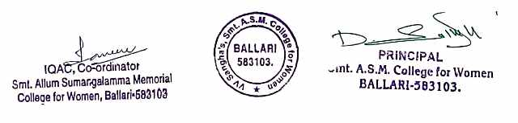

DATE: 13/09/2025

ATTENDANCE CERTIFICATE

This is to certify that Prof. K S Lokesh, Chairman of P.G. Studies in Chemistry, Vijayanagara Sri Krishna Devaraaya University, Ballari, has delivered a Special talk on “Spectroscopy” at Smt. A. S. M College for Women, Ballari, on 13/09/2025.

Date: 11/09/2025

CIRCULAR

Department of Chemistry will be conduct a Special Lecture on “Spectroscopy” by Prof. K S Lokesh, Chairman, Department of PG studies, VSKU, On 13th September 2025 for B.Sc. V & III semester students at 10:30 AM in Seminar Hall, Smt. A.S.M. College for women, Ballari. All the staff members and the students are here by informed to attend the program without fail.

DATE: 13/09/2025
DEPARTMENT OF CHEMISTRY
ACTIVITY: “SPECIAL LECTURE” ON “SPECTROSCOPY”
LIST OF FACULTIES WHO ATTENDED
SL.NO. | NAME | DESIGNATION | SIGNATURE

DATE: 13/09/2025

DEPARTMENT OF CHEMISTRY
ACTIVITY: “SPECIAL LECTURE” ON “SPECTROSCOPY”
LIST OF STUDENTS WHO ATTENDED

SL.NO. | NAME | SEMESTER | SIGNATURE

