Principle and Application of Electron microscope along with its types
PRINCIPLE OF ELECTRON MICROSCOPE:
A high voltage current is applied which results in the excitation of the electrons in the form of a continuous stream that is used as abeam light. The lens used in the electron microscope are magnetic coils
APPLICATIONS OF ELECTRON MICROSCOPE:
- Electron microscope is a technique for obtaining high resolution image of biological and non-biological specimens
- It is used in biomedical research for investigate the detail structure of tissues, cells, organelles and macro molecular complexes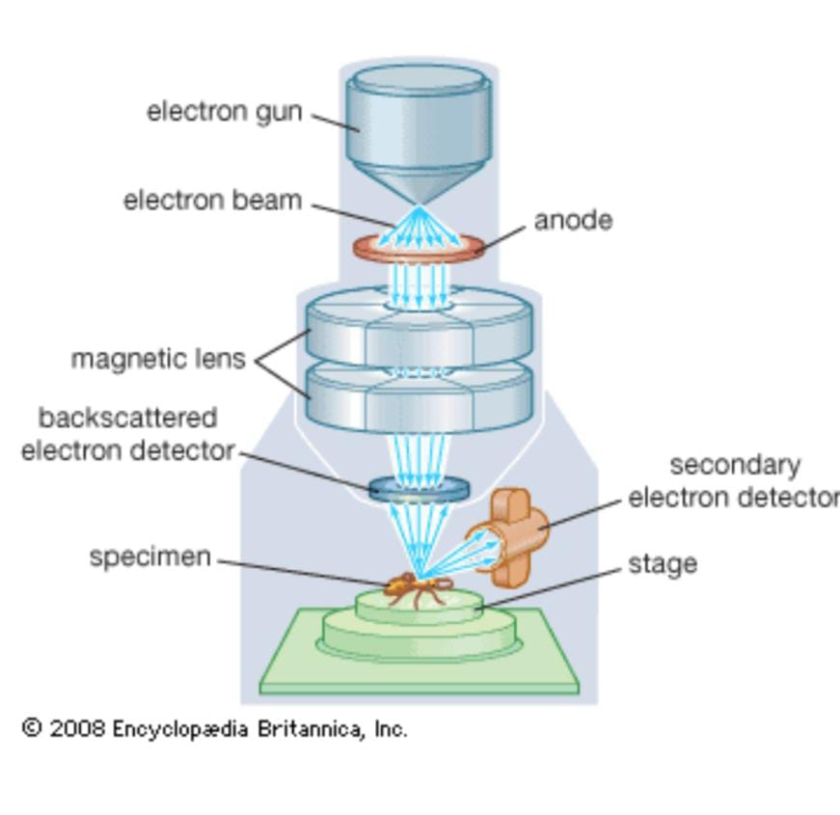

There are two types of electron microscope
- Transmission electron microscope(TEM)
- Scanning electron microscope (SEM)
TEM-Transmission electron microscope:
PRINCIPLE:
The TEM operates on the same basic principle as the light microscopes but uses electron instead of light because the wavelength of electron is much smaller than that of the optimal resolution attainable for tem images is many orders of magnitude better than that from a light microscope

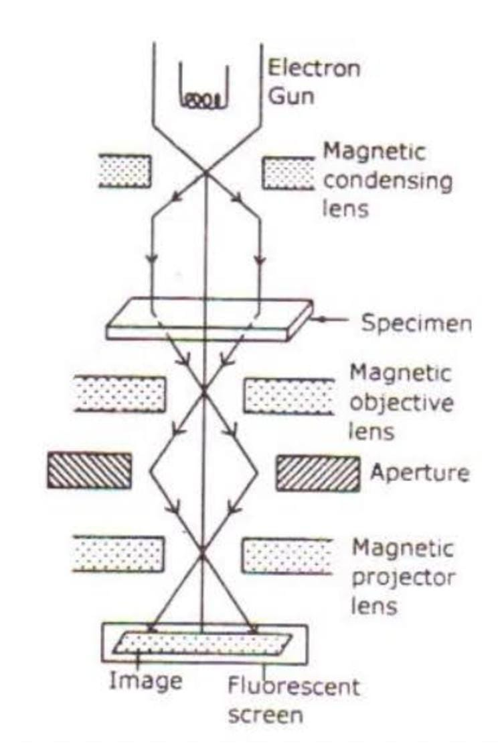
APPLICATIONS:
TEM is used in a wide variety of fields from biology, microbiology, forensic studies
- To visualize and study cell structures of bacteria, viruses and fungi
- To view the shape and size of micro cell organelles
- To view the bacteria flagella and plasmids
- To study and differentiate between plant and animal cells
- It also used in nanotechnology to study nanoparticles such as zno nanoparticles
- It is used to detect and identify fractures damaged micro particles which further enable repair mechanism of the particles
SEM-Scanning electron microscope:
PRINCIPLE:
Unlike the transmission electron microscope which uses transmitted electrons, the scanning electron microscope which uses emitted electrons. The scanning electron microscope works on the principle of applying kinetic energy to produce single on the interaction of the electrons. These electrons are secondary electrons back scattered electrons and diffracted electrons which are used to view crystallized elements and protons. Secondary and back scattered electrons are used to produce an image. The secondary electrons are emitted from the specimen play the primary role of detecting the morphology and topography of the specimen while the back scattered electrons shows contrast in the composition of the elements of the specimen

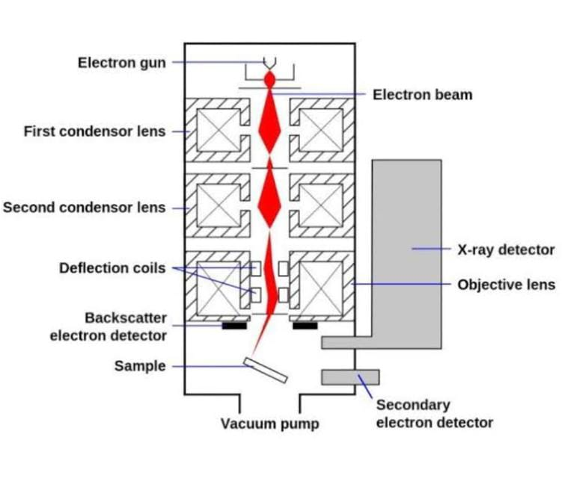
APPLICATIONS:
It is used in a Varity of fields including industrial uses, nanoscience studies, biomedical studies, microbiology
- Used for sport chemical analysis in energy dispersive x-ray
- Used in the analysis of cosmic components which are very tiny in size
- Used to study the filament structure of micro organisms
- Uses to study the topography of elements used in industries

