SEX DETERMINATION IN ANIMALS

The development of an organism into male or female is called sex determination.
Sex is a character. It has two alternatives, namely maleness and femaleness. The male produces
the sperm and the female produces the egg.
Sex is determined by the following factors:
1. Chromosomes2. Environment3. Hormone4. Metabolism
SEX DETERMINATION BY CHROMOSOMES
- MALE HETEROGAMETIC FEMALE HOMOGAMETIC TYPE
- XX- XY Method
The determination of sex by chromosomes is called chromosomal theory of sex determination. It was proposed by Mc Clung. The female has two X chromosomes and the male has one X chromosome and one Y chromosome. The female is homogametic and it produces only one type of eggs all carrying one X chromosome. The male is heterogametic and it produces two types of gametes; one type of sperm carries one X chromosome and the other type of sperm carries one Y chromosome. This phenomenon is called heterogamesis.In human beings, the sex is determined by the sperms. When a sperm carrying X chromosome fuses with the egg, the resulting baby is female. When a sperm carrying Y chromosome fuses with the egg, the resulting baby is male. Thus, father determines the sex of a baby
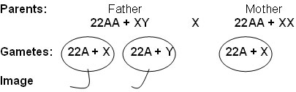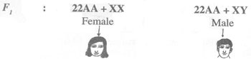
Sex Determination in Man
- XX – XO Type: Protenor Type
In certain insects belonging to orders Hemiptera (true bugs), Orthoptera (Grass Hoppers) and Dictyoptera (cockroaches), female has two ‘X’ chromosomes (XX) and are, thus homogametic, while male has only single ‘X’ chromosome (XO). The male being heterogametic sex produces two types of sperms, half with X chromosome and half without X chromosome in equal proportions. The sex of the offspring depends upon the sperm that fertilizes the egg, each of which carries a single X chromosome. Thus fertilization between male and female gametes always produced zygotes with one ‘X’chromosome from the female, but only 50% of the zygotes have an additional X chromosome from the male. In this way, ‘XO’ and ‘XX’ types would be formed in equal proportions, the former being males and the latter being females.
Sex Determination in GrasshopperIn grasshopper, sex is determined by chromosomes. The male is heterogametic and the female is homogametic.In grasshopper, the females have 11 pairs of autosomes and one pair of X chromosomes (11AA +XX).The males have 11 pairs of autosomes and only one X chromosome (11AA + XO). The female produce only one type of egg which carries 11 autosomes and one X (11A +X). But the male produces two types of sperms, one carrying 11 autosomes and one X chromosome (11A + X) and the other type carries only the autosomes (11A + O).Fertilization by a sperm of the first type (11A + X) results in a female and by a sperm of the second type (11A + O) results in a male.It is said to be evolved by the loss of Y chromosome.
II. FEMALE HETEROGAMETIC MALE HOMOGAMETIC TYPE
- MALE XX AND FEMALE XY TYPE OR ZZ - ZW TYPE
This system is found in certain insects (gypsy moth) and vertebrates such as fishes, reptiles and birds. In this system, the female is heterogametic and produces two types of gametes, one with ‘Z’ chromosome and the other with ‘W’ chromosome. On the other hand, male is homogametic and produces all sperms of same type carrying one ‘Z’ chromosome. The sex of the off spring depends on the kind of egg being fertilized. The ‘Z’ chromosome bearing eggs produce males, but the ‘W’ chromosome bearing eggs produces females
Sex Determination in Fowl
In fowl, sex is determined by chromosomes.
The male is homogametic and the female is heterogametic.
The chromosome number of fowl is 17 pairs. The male has two similar sex chromosomes , namely ZZ instead of XX.
The female has two dissimilar sex chromosomes, namely ZW.
Here Y is named as W.

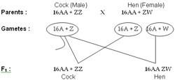

Sex Determination in Butterfly
In butterfly, chromosomes determine the sex. In butterfly male is homogametic sex. Female is heterogametic.Butterfly has 28 pairs of chromosomes. Of these 27 pairs are autosomes and one pair is allosomes.The male has 27 pairs of autosomes and one pair of sex chromosomes. The sex chromosomes are ‘XX’.The female has 27 pairs of autosomes and one pair of sex chromosomes. The sex chromosomes are ‘XY’

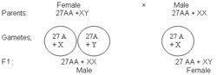

- ZO – ZZ or XO- XX - type Sex Determination in Fumea
In some members of Lepidopteran (Fumea) insects, the female has one X chromosome and the males has two X chromosomes. The females produce two types of ova. One type with X chromosome and the other type without X chromosome. The males produce only one type of sperm which carries one X chromosome. This mechanism is found in certain moths and butterflies. In this case, female possesses one single ‘Z’ chromosome and hence it heterogametic, producing two kinds of eggs half with Z chromosome and another half without any Z chromosome. Male possesses two Z chromosomes and thus homogametic, producing single type of sperms, each carries single Z chromosome. The sex of the off spring depends on the kind of egg.

- Haplo-Diploidy Type
Sex Determination in Honey Bee
In honey bee, sex is determined by parthenogenesis.
The males are haploid and the female are diploid.
The queen lays two types of eggs, namely fertilized eggs and unfertilized eggs.
The fertilized eggs develop into females. Hence they are diploid.
The unfertilized eggs develop parthenogenetically into males. Hence they are haploid.
As the males are haploid, the produce sperms by mitosis without reduction in chromosome number.It is a haploidy-diploidy mechanism of sex determination
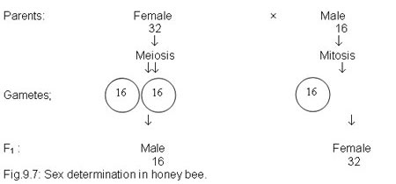

Genic Balance Theory
According to genic balance theory the sex is determined by the ratio between X chromosomes and autosomes.
This theory was formulated by Bridges. According to this theory, sex is determined by the relative number of X chromosomes and autosomes. It is actually the ratio between the X chromosomes and autosomes determines the sex.The X chromosomes carry female stimulating genes and the autosomes (A) seem to carry the male stimulating genes. There is no sex influencing genes in Y chromosomes. Haploid sets of autosomes are represented as n (A) and diploid sets of autosomes are represented as 2n(A). The sex of an animal is determined by the ratio between the number of X chromosomes and the number of haploid sets of autosomes. The ratio is the quantitative balance between X chromosomes and autosomes.
If the sex index is 1 the individual develops into female. If the sex index is 0.5, it develops into male. If the ratio is intermediate (0.67) between 1 and 0.5 the resulting individual is an intersex. If the ratio is above 1 (1.5) the sex is super female and if the ratio is below 0.5 (0.3), the sex is supermale.
In male Drosophila, there are 2 sets of autosomes 2n(A) and one X chromosome. Hence the ratio is X/2n(A)+1/2 = 0.5. In female, there are two sets of autosomes 2n(A) and two X
Bridges also explained the formation of supersexes and intersexes in Drosophila. He found some Drosophila females with triploid sets of chromosomes 3n(A) XXX. These triploid females are much like the normal diploid ones in appearance and are fertile. Bridges crossed this triploid female with normal diploid male. The diploid normal male produces two types of sperms. The triploid female produces four types of eggs. When the four types of eggs are fertilized by two types of sperms, eight sexually distinct kinds of offspring are produced as in the checker board.
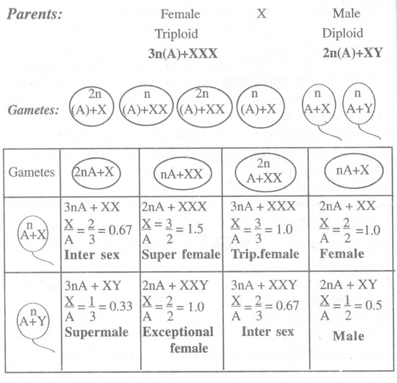
No. | Nature of the sex | Number of chromosomes | Number of sets of Autosomes | Sex Index RatioX/A
1. | Super female | 3X | 2n(A) | 3/2 = 1.5
2. | Triploid female | 3X | 3n(A) | 3/3 = 1
3. | Diploid female | 2X | 2n(A) | 2/2 = 1
4. | Intersex | 2X | 3n(A) | 2/3 = 0.67
5. | Intersex | 2XY | 3n(A) | 2/3 = 0.67
6. | Normal male | X | 2n(A) | 1/2 = 0.5
7. | Super male | X | 3n(A) | 1/3 = 0.33
8. | Exceptional female | 2XY | 2n(A) | 2/2 = 1
Table: Sexes and sex index of Drosophila.

Environmental Determination of Sex
In Bonellia, sex is determined by environmental factors. Bonellia is a marine echiuroid worm. It exhibits sexual dimorphism. The female is very large and is about 8cm with a proboscis of about one metre long. The male is very small and is about 1 to 3mm.
The female lives in a borrow at the sea bottom. The male lives as a parasite in the uterus of the adult female.
The larvae of Bonellia are alike and they have potentialities to develop into any sex. A larva settled on the proboscis of the female develops into male. A larva settled in the mud develops into a female.If the larva is detached from the proboscis of female before the completion of development, the larva develops into an intersex.CO₂ is the sex determining factor in Bonellia. In the proboscis of female, the amount of CO₂ is high because some amount of CO₂ is released in respiration. In sea water, comparatively the CO₂ content is less. So higher CO2 content determines the maleness and lower CO₂ content determines the femaleness
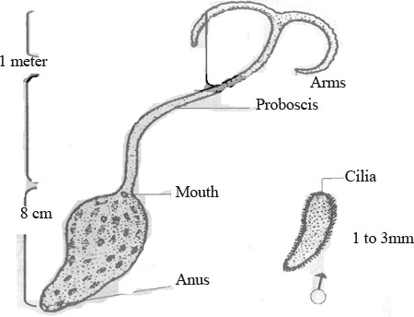
Hormonal Theory of Sex Determination
In higher animals, the endocrine glands secrete hormones. The hormones are distributed throughout the body through the blood stream. The ovary of the female animal secretes the ovarian hormone and testis of the male animal secretes the testicular hormone.
The hormones have some influence on the developing embryo. The removal of the testis or ovary in young animals prevents the expression of secondary sexual characters. Removal of ovaries form the female baby affects the normal development of mammary glands.
Removal of the testes of the male (man) before puberty induces the development of female characteristics in body form, voice, hair pattern, etc.
When the extract of the testes of a cock is injected into a hen, it develops a comb just like a cock.
Free Martin
In cattle, when twins of opposite sex (one female and other male) are born, the male is normal but the female is sterile with many male characteristics. Such sterile females are called free martins.
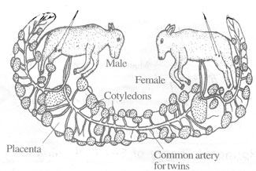
In cattle, twins occur frequently. If both the young ones are zygotically of the same sex, they develop normally; if however, one member is a male and the other female, then the development of the female is not normal. During development both the twins are connected by a common umbilical cord. The gonads of the male develop earlier than those of the female. So the male gonads produce male hormones earlier in development. These male hormones reach the female embryo and influence the development of male sex in the female embryo. This results in a sterile inter sex having female phenotype with sterile male gonads
GYNANDROMORPHS
Gynandromorphs are individuals which show male characters on some parts of the body and female characters on other parts of the body. They are also called gynanders. The gynandromorphs are sterile.
Gynanders are rare. They occur in Drosophila, butter flies, beetles, wasps, bees, silk worms, etc.
There are three types of gynanders. They are the following:
1. Bilateral Gynanders: These have male traits on one lateral side of the body and female traits on the other lateral side. Eg. Drosophila.
2. Anteroposterior-gynanders: They have features of one sex on the anterior half of the body and those of the other sex on the posterior half of the body. Eg. Beetles.
3. Sex pie balds: These are gynanders having a mixture of male and female tissues in the body.
Gynandromorphism is produced in two ways.One type is produced by the loss of one X chromosome in a blastomere. Another type is produced by a binucleate egg.
Supersexes
Supersexes are of two types and they are superfemales and supermales. The super females have a chromosome constitution 2n(A) XXX and the sex ratio is 1.5. Phenotypically these flies look like normal female flies with small differences, but are sterile. These flies are not superior to the normal females in any way, excepting the fact that they have an additional X chromosome. So such females are called metafemales. The supermales have a chromosome complement n(A)XY and the sex index is 0.33. Phenotypically these flies are like the normal male with slight changes and also are sterile. These are called supermales, just because these have an overdose set of autosomes than the normal males. So such males are called as meta males

Intersex
The cross between diploid male and a triploid female Drosophila produces some flies that are intermediate between normal males and females. Their chromosome constitution is either 3n(A)+XX or 3n(A)+XXY and the sex index is 0.67. Such flies are called intersexes. The intersexes are sterile individuals intermediate between females and males. Their reproductive organs are intermediate between testis and ovary and have a mixture of other male and female sex characters.

