
Internal Quality Assurance Cell (IQAC)
Programme: UG Department: Sociology
Name of the Programme | Gandhi Bharat
Category | Students Centric
Venue, Date & Time | 23.04.2025, 12.30pm, BA Class room.
Target Audience &  Students and Staff Participated | BA Sociology Students  (Attendance Sheet Copy Enclosed)
Competitions organized on the eve of GANDHI BHARAT | Quiz & Essay Competitions organized for BA Students
Geo Tagged Photos Social Media Web link | https://www.facebook.com/share/p/167NF3FE5R/
HEI web link of the Event | https://www.smtasmc.org/index.php/latest-news-home-left/sociology-department-activity-gandhi-bharat-events-winners
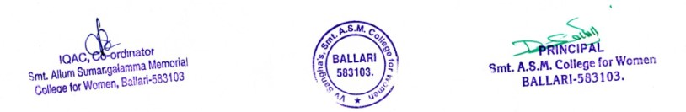

Internal Quality Assurance Cell (IQAC)
Programme: UG Department: Sociology
¢£ÁAPÀ:23.04.2025gÀAzÀÄ UÁA¢ü ¨sÁgÀvÀ PÁAiÀÄðPÀæªÀÄzÀ CAUÀªÁV ¸ÀªÀiÁd±Á¸ÀÛç «¨sÁUÀ¢AzÀ ©J «zÁåyð¤AiÀÄjUÉ gÀ¸À ¥Àæ±Éé ¸ÀàzsÉð ªÀÄvÀÄÛ ¥Àæ§AzsÀ ¸ÀàzsÉðUÀ¼À£ÀÄ DAiÉÆÃf¸À¯ÁVzÀÄÝ, F ¸ÀàzsÉðUÀ¼À°è «eÉÃvÀgÁvÀ ¥ÀnÖ F PÉÃ¼ÀV£ÀAwzÉ.
I] Quiz Competition Winners
I Prize – BA-VI Semester Students Team A
Ms. Mani, Ms. Yashodha.V., Ms. Sahana, Ms.Dhanalakshmi

II Prize – BA-IV Semester Students Team B
Ms. Sindhuja.H.M., Ms. Sindhu Hosamani, Ms. Sunkamma, Ms.Chandrika

III Prize – BA-VI Semester Students Team C
Ms.Radhika.S., Ms.Shanthi.D.S., Ms.Nandini, Ms.Shobha.C.

II] Essay Writing Competition Winners
I Prize
Ms. Sindhuja.H.M., B.A.-IV Semester
II Prize
Ms. Sindhu Hosamani, B.A.-IV Semester
III Prize
Ms. Sahana.L., B.A.-VI Semester

