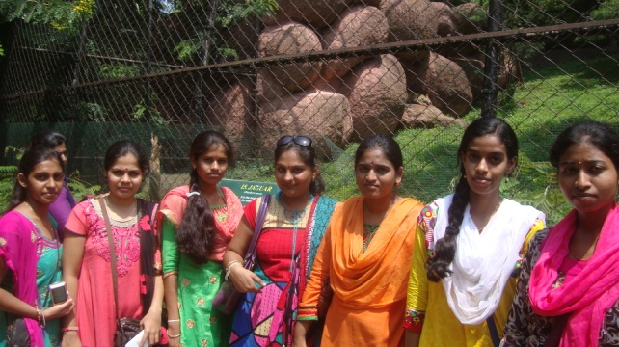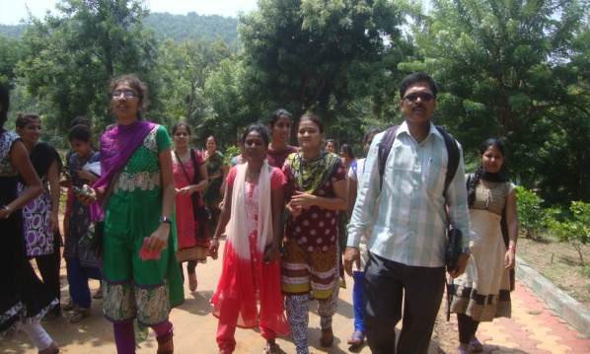
The students of B.Sc Final year Visited Zoological Park in Vijag, Andhra Paradesh. During this visit students got opprtunity to see differentst rare animals in the Zoo On 28-09-2015.
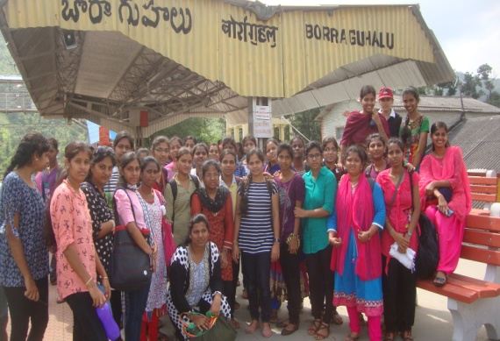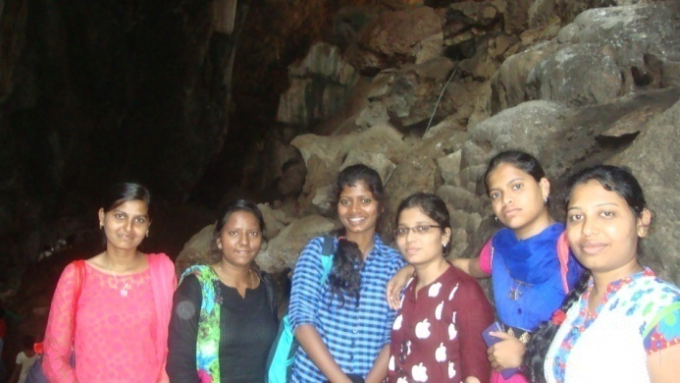
The students of B.Sc Final year Visited Bora Caves , Aruku, Andhra Paradesh. Bara caves are one of the imoprtant place in Aruku best known example for Cave ecosystem , the students practicaaly experined about cave ecosystem On 29-09-2015.
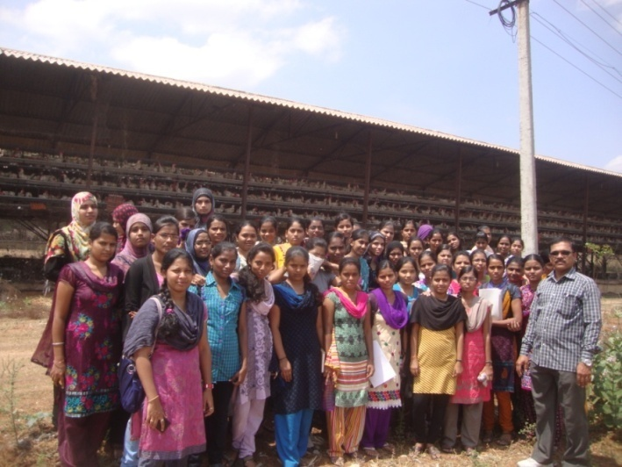
B.Sc. III Semester Students Visited poultry form near Havambhavi, Ballari as a Part practical study , The observed poultry form Management Practices of rearing poultry birds on 16-09-2015
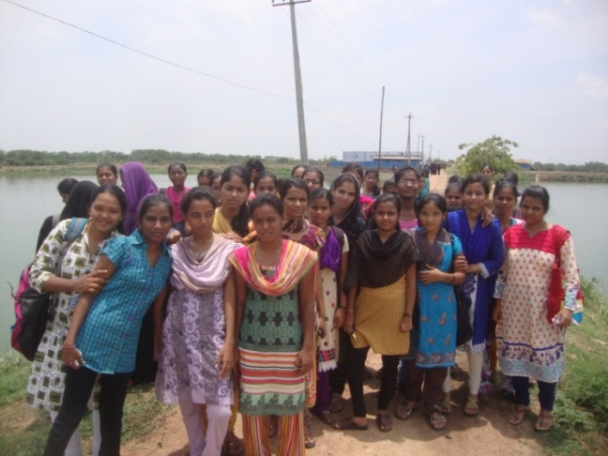
B.Sc.-III Semester Students Visited Aquaculture ponds near Srilakshmi Camp, Ballari as a part of practical study , The observed the Management Practices of rearing fishes on 16-09-2015.
* * *

