Smt. A.S.M. College for Women, Ballari.
Department Zoology - Events conducted from 2011to 2016
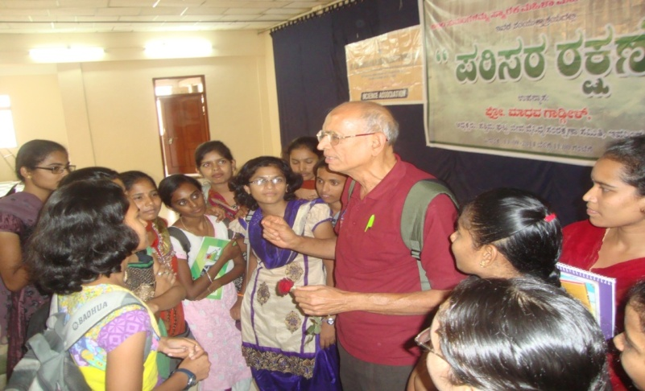
The interaction of Prof. Madhav Gadgil, II-Sc. with our College students when he visited our College on 13/09/2014 for addressing our students on ‘Protection of Environment’.
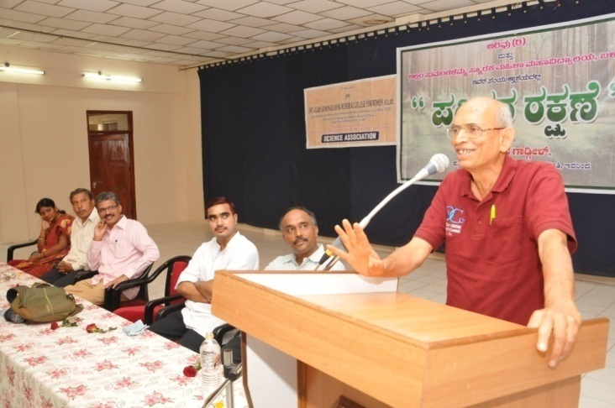
Prof. Madhav Gadgil, II-Sc. visited our College on 13/09/2014 for addressing our students on ‘Protection of Environment’. In his address he informed the role of Students in protection of Environment especially western Ghats. He gave detailed account on various laws which are enforced by Govt. of India for protection of Wild life and Environment.

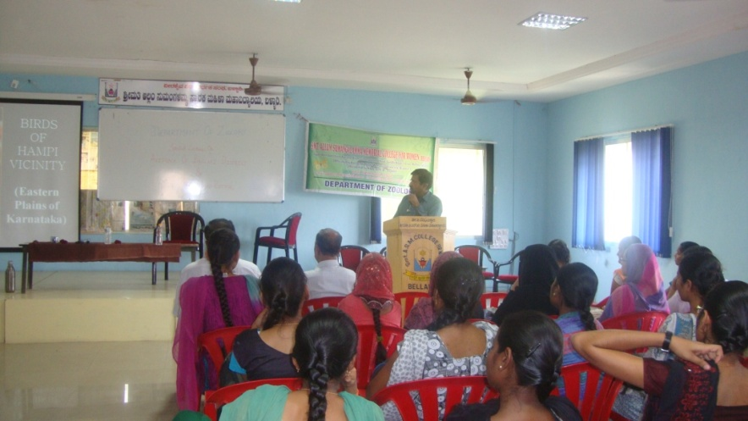
Dr. Samad Kottur, given special lecture on “Birds of Ballari district”. During his talk, he presented on occurrence of Avifauna in Ballari district. He emphasized on occurrence of Endangered Bustard in nearby places of Ballari. He gave detailed account on birding and had interaction with students on 23-03-2015.
* * *

