V. V.Sangha's
Smt. A.S.M. College for Women, Ballari. (Estd.:1969)
(Affiliated to Karnataka State Akkamahadevi Women’s University, Vijayapura.)
AISHE CODE: C-8690, NAAC TRACK ID-KACOGN11970
Recognized under sections 2(f) and 12(B) of the UGC Act 1956
(Accredited by NAAC in IV Cycle)
Internal Quality Assurance Cell (IQAC)
Department of Zoology Institution Social Responsibility (ISR) activity

Social Media Web link --> https://www.facebook.com/share/15oEXD2b6B/

ISR activity - Dr. SYEDA K.T., Head & Assistant Professor of Zoology, visited as a Chief Guest & Resource Person on 20.07.2025.
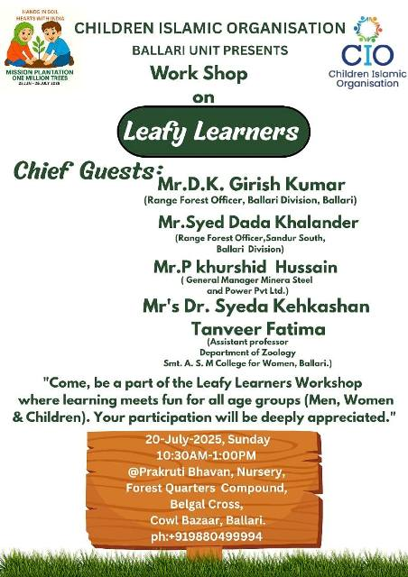
On 20.07.2025, Dr.SYEDA K.T., Head & Assistant Professor of Zoology, Smt.ASM College for Women, Ballari, was a Chief Guest and Resource Person at a program organized by Children Islamic Organization, Ballari.
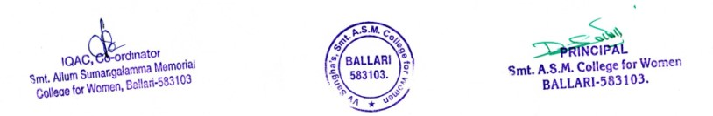

Geo Tagged Photos
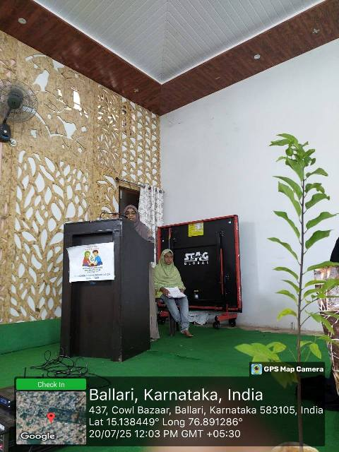

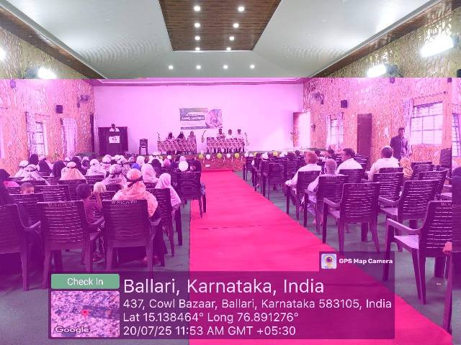

Website Hits as on 21.07.2025 - 1132649

Activities

