English Language Lab
A recently established English Language Lab caters to the enhancement of communicative skills and advance learning of English language to our students.

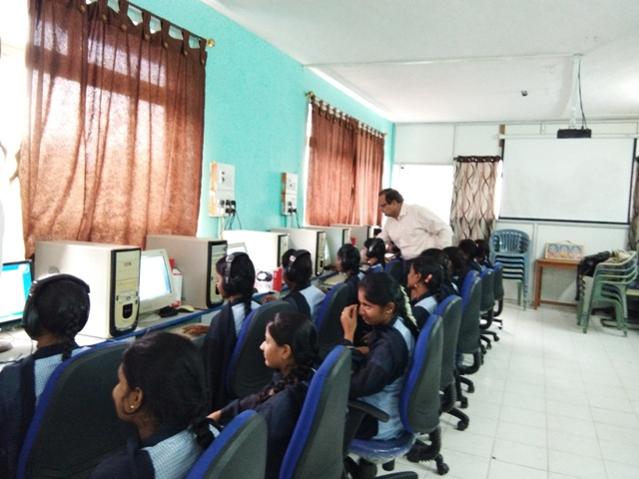
Students acquiring the verbal ability and practical knowledge about the continental language in the English Language Lab.

