Cost of Capital: Meaning, Importance and Measurement

Meaning of Cost of Capital:
An investor provides long-term funds (i.e., Equity shares, Preference Shares, Retained earnings, Debentures etc.) to a company and quite naturally he expects a good return on his investment.
In order to satisfy the investor’s expectations the company should be able to earn enough revenue. Thus, to the company, the cost of capital is the minimum rate of return that the company must earn on its investments to fulfill the expectations of the investors.
If a company can raise long-term funds from the market at 10%, then 10% can be used as cut-off rate as the management gains only when the project gives return higher than 10%. Hence 10% is the discount rate or cut-off rate. In other words, it is the minimum rate of return required on the investment project to keep the market value per share unchanged.
In order to maximise the shareholders’ wealth through increased price of shares, a company has to earn more than the cost of capital. The firm’s cost of capital can be determined by working out weighted average of the different costs of raising different sources of capital.
Some definitions of financial experts are given below for the clear conception of cost of capital:

Ezra Solomon defines “Cost of capital is the minimum required rate of earnings or cutoff rate of capital expenditure”.
According to Mittal and Agarwal “the cost of capital is the minimum rate of return which a company is expected to earn from a proposed project so as to make no reduction in the earning per share to equity shareholders and its market price”.
According to Khan and Jain, cost of capital means “the minimum rate of return that a firm must earn on its investment for the market value of the firm to remain unchanged”.

Cost of capital depends upon:
(a) Demand and supply of capital,
(b) Expected rate of inflation,
(c) Various risk involved, and
(d) Debt-equity ratio of the firm etc.

Significance of Cost of Capital:
The concept of cost of capital plays a vital role in decision-making process of financial management. The financial leverage, capital structure, dividend policy, working capital management, financial decision, appraisal of financial performance of top management etc. are greatly influenced by the cost of capital.
The significance or importance of cost of capital may be stated in the following ways:

1. Maximisation of the Value of the Firm:
For the purpose of maximisation of value of the firm, a firm tries to minimise the average cost of capital. There should be judicious mix of debt and equity in the capital structure of a firm so that the business does not to bear undue financial risk.

2. Capital Budgeting Decisions:
Proper estimate of cost of capital is important for a firm in taking capital budgeting decisions. Generally cost of capital is the discount rate used in evaluating the desirability of the investment project. In the internal rate of return method, the project will be accepted if it has a rate of return greater than the cost of capital.
In calculating the net present value of the expected future cash flows from the project, the cost of capital is used as the rate of discounting. Therefore, cost of capital acts as a standard for allocating the firm’s investible funds in the most optimum manner. For this reason, cost of capital is also referred to as cut-off rate, target rate, hurdle rate, minimum required rate of return etc.

3. Decisions Regarding Leasing:
Estimation of cost of capital is necessary in taking leasing decisions of business concern.

4. Management of Working Capital:
In management of working capital the cost of capital may be used to calculate the cost of carrying investment in receivables and to evaluate alternative policies regarding receivables. It is also used in inventory management also.

5. Dividend Decisions:
Cost of capital is significant factor in taking dividend decisions. The dividend policy of a firm should be formulated according to the nature of the firm— whether it is a growth firm, normal firm or declining firm. However, the nature of the firm is determined by comparing the internal rate of return (r) and the cost of capital (k) i.e., r > k, r = k, or r < k which indicate growth firm, normal firm and decline firm, respectively.

6. Determination of Capital Structure:
Cost of capital influences the capital structure of a firm. In designing optimum capital structure that is the proportion of debt and equity, due importance is given to the overall or weighted average cost of capital of the firm. The objective of the firm should be to choose such a mix of debt and equity so that the overall cost of capital is minimised.

7. Evaluation of Financial Performance:
The concept of cost of capital can be used to evaluate the financial performance of top management. This can be done by comparing the actual profitability of the investment project undertaken by the firm with the overall cost of capital.

Measurement of Cost of Capital:
Cost of capital is measured for different sources of capital structure of a firm. It includes cost of debenture, cost of loan capital, cost of equity share capital, cost of preference share capital, cost of retained earnings etc.

The measurement of cost of capital of different sources of capital structure is discussed:

A. Cost of Debentures:
The capital structure of a firm normally includes the debt capital. Debt may be in the form of debentures bonds, term loans from financial institutions and banks etc. The amount of interest payable for issuing debenture is considered to be the cost of debenture or debt capital (K_{d}). Cost of debt capital is much cheaper than the cost of capital raised from other sources, because interest paid on debt capital is tax deductible.
The cost of debenture is calculated in the following ways:
(i) When the debentures are issued and redeemable at par: K_{d} = r (1 – t)
where K_{d} = Cost of debenture
r = Fixed interest rate
t = Tax rate
(ii) When the debentures are issued at a premium or discount but redeemable at par
K_{d} = I/NP (1 – t)
where, K_{d} = Cost of debenture
I = Annual interest payment
t = Tax rate
Np = Net proceeds from the issue of debenture.
(iii) When the debentures are redeemable at a premium or discount and are redeemable after ‘n’ period:
K_{d}
I(1-t)+1/N(R_{v} – NP) / ½ (R_{V} – NP)
where K_{d} = Cost of debenture .
I = Annual interest payment
t = Tax rate
NP = Net proceeds from the issue of debentures
Ry = Redeemable value of debenture at the time of maturity

Example 1:
(a) A company issues Rs. 1,00,000, 15% Debentures of Rs. 100 each. The company is in 40% tax bracket. You are required to compute the cost of debt after tax, if debentures are issued at (i) Par, (ii) 10% discount, and (iii) 10% premium.
(b) If brokerage is paid at 5%, what will be the cost of debentures if issue is at par?
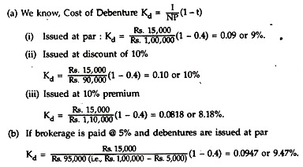
Example 2:
ZED Ltd. has issued 12% Debentures of face value of Rs. 100 for Rs. 60 lakh. The floating charge of the issue is 5% on face value. The interest is payable annually and the debentures are redeemable at a premium of 10% after 10 years.
What will be the cost of debentures if the tax is 50%?
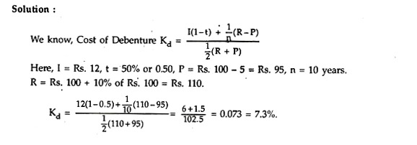

B. Cost of Preference Share Capital:
For preference shares, the dividend rate can be considered as its cost, since it is this amount which the company wants to pay against the preference shares. Like debentures, the issue expenses or the discount/premium on issue/redemption are also to be taken into account.
(i) The cost of preference shares (K_{P}) = D_{P} / NP
Where, D_{P} = Preference dividend per share
NP = Net proceeds from the issue of preference shares.
(ii) If the preference shares are redeemable after a period of ‘n’, the cost of preference shares (K_{P}) will be:
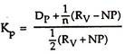
where NP = Net proceeds from the issue of preference shares
R_{V} = Net amount required for redemption of preference shares
D_{P} = Annual dividend amount.
There is no tax advantage for cost of preference shares, as its dividend is not allowed deduction from income for income tax purposes. The students should note that both in the case of debt and preference shares, the cost of capital is computed with reference to the obligations incurred and proceeds received. The net proceeds received must be taken into account while computing cost of capital.
Example 3:
A company issues 10% Preference shares of the face value of Rs. 100 each. Floatation costs are estimated at 5% of the expected sale price.
What will be the cost of preference share capital (K_{P}), if preference shares are issued (i) at par, (ii) at 10% premium and (iii) at 5% discount? Ignore dividend tax.
Solution:
We know, cost of preference share capital (K_{P}) = D_{P}/P
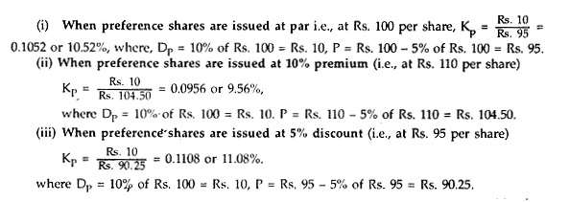
Example 4:
Ruby Ltd. issues 12%. Preference Shares of Rs. 100 each at par redeemable after 10 years at 10% premium.
What will be the cost of preference share capital?
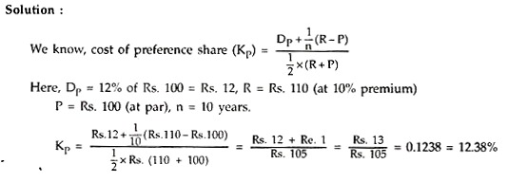
Example 5:
A company issues 12% redeemable preference shares of Rs. 100 each at 5% premium redeemable after 15 years at 10% premium. If the floatation cost of each share is Rs. 2, what is the value of K_{P} (Cost of preference share) to the company?
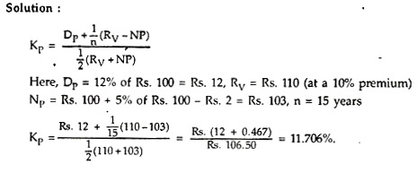

C. Cost of Equity or Ordinary Shares:
The funds required for a project may be raised by the issue of equity shares which are of permanent nature. These funds need not be repayable during the lifetime of the organisation. Calculation of the cost of equity shares is complicated because, unlike debt and preference shares, there is no fixed rate of interest or dividend payment.
Cost of equity share is calculated by considering the earnings of the company, market value of the shares, dividend per share and the growth rate of dividend or earnings.

(i) Dividend/Price Ratio Method:
An investors buys equity shares of a particular company as he expects a certain return (i.e. dividend). The expected rate of dividend per share on the current market price per share is the cost of equity share capital. Thus the cost of equity share capital is computed on the basis of the present value of the expected future stream of dividends.
Thus, the cost of equity share capital (K_{e}) is measured by:
K_{e} = where D = Dividend per share
P = Current market price per share.
If dividends are expected to grow at a constant rate of ‘g’ then cost of equity share capital
(K_{e}) will be K_{e} = D/P + g.
This method is suitable for those entities where growth rate in dividend is relatively stable. But this method ignores the capital appreciation in the value of shares. A company which declares a higher amount of dividend out of given quantum of earnings will be placed at a premium as compared to a company which earns the same amount of profits but utilizes a major part of it in financing its expansion programme.
Example 6:
XY Company’s share is currently quoted in market at Rs. 60. It pays a dividend of Rs. 3 per share and investors expect a growth rate of 10% per year.
You are required to calculate:
(i) The company’s cost of equity capital.
(ii) The indicated market price per share, if anticipated growth rate is 12%.
(iii) The market price, if the company’s cost of equity capital is 12%, anticipated growth rate is 10% p.a., and dividend of Rs. 3 per share is to be maintained.
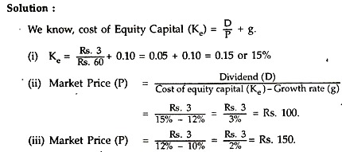
Example 7:
The current market price of a share is Rs. 100. The firm needs Rs. 1,00,000 for expansion and the new shares can be sold at only Rs. 95. The expected dividend at the end of the current year is Rs. 4.75 per share with a growth rate of 6%.
Calculate the cost of capital of new equity.
Solution:
We know, cost of Equity Capital (K_{e}) = D/P + g
(i) When current market price of share (P) = Rs. 100
K = Rs 4.75 / Rs. 100 + 6% = 0.0475 + 0.06 = 0.1075 or 10.75%.
(ii) Cost of new Equity Capital = Rs. 4.75 / Rs. 95 + 6% = 0.11 or, 11%.
Example 8:
A company’s share is currently quoted in the market at Rs. 20. The company pays a dividend of Rs. 2 per share and the investors expect a growth rate of 5% per year.
You are required to calculate (a) Cost of equity capital of the company, and (b) the market price per share, if the anticipated growth rate of dividend is 7%.
Solution:
(a) Cost of equity share capital (K_{e}) = D/P +g = Rs. 2/Rs. 20 + 5% = 15%
(b) K_{e} = D/P + g
or, 0.15 = Rs. 2 / P + 0.07 or, P = 2/0.08 = Rs. 25.

Example 9:
Green Diesel Ltd. has its equity shares of Rs. 10 each quoted in a stock exchange at a market price of Rs. 28. A constant expected annual growth rate of 6% and a dividend of Rs. 1.80 per share has been paid for the current year.
Calculate the cost of equity share capital.
Solution:
D₀ (1 + g)/ P₀ + g = 1.80 (1 + .06)/ 28 + 0.06
= 0.0681 + 0.06 = 12.81%
(ii) Earnings/Price Ratio Method:
This method takes into consideration the earnings per share (EPS) and the market price of share. Thus, the cost of equity share capital will be based upon the expected rate of earnings of a company. The argument is that each investor expects a certain amount of earnings whether distributed or not, from the company in whose shares he invests.
If the earnings are not distributed as dividends, it is kept in the retained earnings and it causes future growth in the earnings of the company as well as the increase in market price of the share.
Thus, the cost of equity capital (K_{e}) is measured by:
K_{e} = E/P where E = Current earnings per share
P = Market price per share.
If the future earnings per share will grow at a constant rate ‘g’ then cost of equity share capital (K_{e}) will be
K_{e} = E/P+ g.
This method is similar to dividend/price method. But it ignores the factor of capital appreciation or depreciation in the market value of shares. Adjustment of Floatation Cost There are costs of floating shares in market and include brokerage, underwriting commission etc. paid to brokers, underwriters etc.
These costs are to be adjusted with the current market price of the share at the time of computing cost of equity share capital since the full market value per share cannot be realised. So the market price per share will be adjusted by (1 – f) where ‘f’ stands for the rate of floatation cost.
Thus, using the Earnings growth model the cost of equity share capital will be:
K_{e} = E / P (1 – f) + g
Example 10:
The share capital of a company is represented by 10,000 Equity Shares of Rs. 10 each, fully paid. The current market price of the share is Rs. 40. Earnings available to the equity shareholders amount to Rs. 60,000 at the end of a period.
Calculate the cost of equity share capital using Earning/Price ratio.
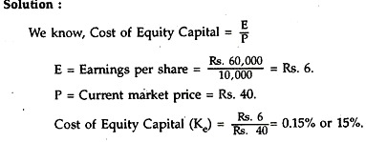
Example 11:
A company plans to issue 10,000 new Equity Shares of Rs. 10 each to raise additional capital. The cost of floatation is expected to be 5%. Its current market price per share is Rs. 40.
If the earnings per share is Rs. 7.25, find out the cost of new equity.
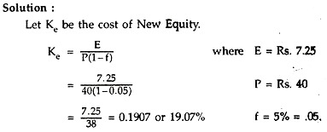

D. Cost of Retained Earnings:
The profits retained by a company for using in the expansion of the business also entail cost. When earnings are retained in the business, shareholders are forced to forego dividends. The dividends forgone by the equity shareholders are, in fact, an opportunity cost. Thus retained earnings involve opportunity cost.
If earnings are not retained they are passed on to the equity shareholders who, in turn, invest the same in new equity shares and earn a return on it. In such a case, the cost of retained earnings (K_{r}) would be adjusted by the personal tax rate and applicable brokerage, commission etc. if any.
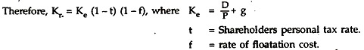
Many accountants consider the cost of retained earnings as the same as that of the cost of equity share capital. However, if the cost of equity share capital i9 computed on the basis of dividend growth model (i.e., D/P + g), a separate cost of retained earnings need not be computed since the cost of retained earnings is automatically included in the cost of equity share capital.
Therefore, K_{r} = K_{e} = D/P + g.
Example 12:
It is given that the cost of equity of a company is 20%, marginal tax rate of the shareholders is 30% and the Broker’s Commission is 2% of the investment in share. The company proposes to utilise its retained earnings to the extent of Rs. 6,00,000.
Find out the cost of retained earnings.
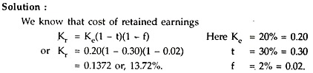

E. Overall or Weighted Average Cost of Capital:
A firm may procure long-term funds from various sources like equity share capital, preference share capital, debentures, term loans, retained earnings etc. at different costs depending on the risk perceived by the investors.
When all these costs of different forms of long-term funds are weighted by their relative proportions to get overall cost of capital it is termed as weighted average cost of capital. It is also known as composite cost of capital. While taking financial decisions, the weighted or composite cost of capital is considered.
The weighted average cost of capital is used by an enterprise because of the following reasons:
(i) It is useful in taking capital budgeting/investment decisions.
(ii) It recognises the various sources of finance from which the investment proposal derives its life-blood (i.e., finance).
(iii) It indicates an optimum combination of various sources of finance for the enhancement of the market value of the firm.
(iv) It provides a basis for comparison among projects as a standard or cut-off rate.
I. Computation of Weighted Average Cost of Capital:
Computation of Weighted Average cost of capital is made in the following ways:
(i) The specific cost of each source of funds (i.e., cost of equity, preference shares, debts, retained earnings etc.) is to be calculated.
(ii) Weights (i.e., proportion of each, source of fund in the capital structure) are to be computed and assigned to each type of funds. This implies multiplication of each source of capital by appropriate weights.
Generally, the-following weights are assigned:
(a) Book values of various sources of funds
(b) Market values of various sources of capital
(c) Marginal book values of various sources of capital.
Book values of weights are based on the values reflected by the balance sheet of a concern, prepared under historical basis and ignoring price level changes. Most of the financial analysts prefer to use market value as the weights to calculate the weighted average cost of capital as it reflects the current cost of capital.
But the determination of market value involves some difficulties for which the measurement of cost of capital becomes very difficult.
(iii) Add all the weighted component costs to obtain the firm’s weighted average cost of capital.
Therefore, weighted average cost of capital (K_{o}) is to be calculated by using the following formula:
K_{o} = K₁w₁ + K₂w₂ + …………
where K₁, K₂ ……….. are component costs and W₁, W₂ ………….. are weights.
Example 13:
Jamuna Ltd has the following capital structure and, after tax, costs for the different sources of fund used:
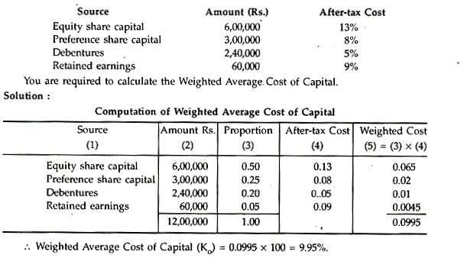
Example 14:
Excel Ltd. has assets of Rs. 1,60,000 which have been financed with Rs. 52,000 of debt and Rs. 90,000 of equity and a general reserve of Rs. 18,000. The firm’s total profits after interest and taxes for the year ended 31st March 2006 were Rs. 13,500. It pays 8% interest on borrowed funds and is in the 50% tax bracket. It has 900 equity shares of Rs. 100 each selling at a market price of Rs. 120 per share.
What is the Weighted Average Cost of Capital?
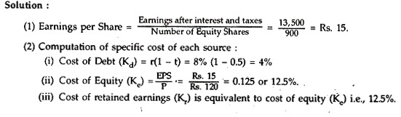
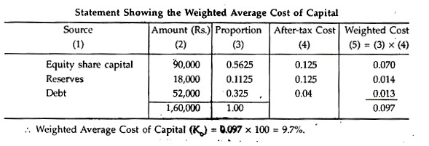
Example 15:
RIL Ltd. opts for the following capital structure:
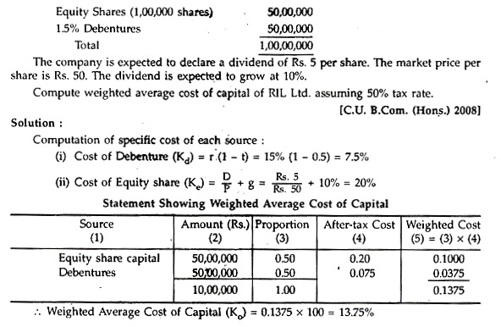

Example 16:
In considering the most desirable capital structure for a company, the following estimates of the cost Debt and Equity Capital (after tax) have been made at various levels of debt-equity mix:
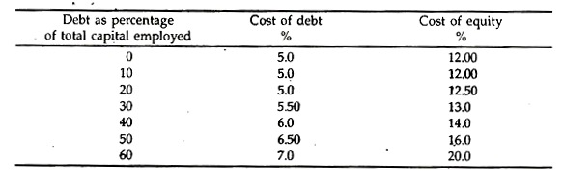
You are required to determine the optimum debt-equity mix for the company by calculating composite cost of capital.
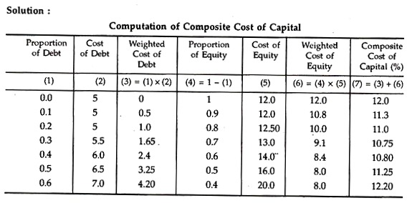
Optimal debt-equity mix for the company is at the point where the composite cost of capital is minimum. Hence, the composite cost of capital is minimum (10.75%) at the debt-equity mix of 3: 7 (i.e., 30% debt and 70% equity). Therefore, 30% of debt and 70% equity mix would be an optimal debt-equity mix for the company.

