Department of Botany
B.Sc. CBZ
List of Rank Holders 2018-19
Sl. No. | Name of The Student | Reg No. | Marks obtained | Percentage | University Rank
 | Kum. Sumaya IRS   | 16412592 | 3382/3840 | 88.02 | 3
 | Kum. P. Sai Bindhu   | 16412524 | 3332/3840 | 86.77 | 5

Department of Botany
B.Sc. CBZ
List of Rank Holders 2019-2020
Sl.No. | Name of the Student | RegisterNo. | Marks Obtained | % | University Rank
1. | Ms. Chitra Hugar  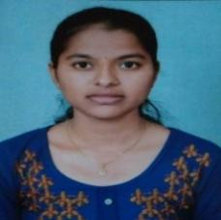 | 17412439 | 3529/3840 | 91.90 | 2

Department of Botany
B.Sc. CBZ
List of Rank Holders 2020-21
Sl. No. | Name of The Student | Reg No. | Marks obtained | Percentage | University Rank
 | KUM.H.N.AISHWARYA  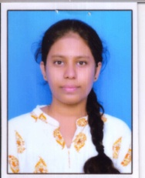 | S1813277 | 2954/3280 | 90.06 | 4
 | KUM.KULSUM  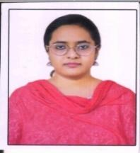 | S1813305 | 2920/3280 | 89.02 | 5
 | KUM. A.PALLAVI  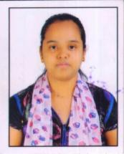 | S1813202 | 2904/3280 | 88.54 | 8

Department of Botany
B.Sc. CBZ
List of Rank Holders 2021-22

Sl. No. | Name of The Student | Reg No. | Marks obtained | Percentage | University Rank
 | Ms. D. Bhagyasree | 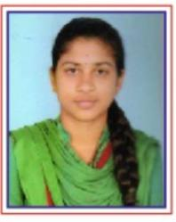 | 3073/3280 | 93.69 | IV
 | MS. Suhana Tasleem | 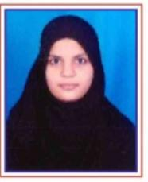 | 3024/3280 | 92.20 | VI
 | Ms. Akshatha Patil | 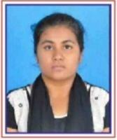 | 2965/3280 | 90.40 | X

Department of Botany
B.Sc. CBZ
List of Rank Holders 2022-23

Sl. No. | Name of The Student | Reg. No. | Marks obtained | Percentage | University Rank
 | Ms. Tasleem Banu P | S2013409 | 3045 / 3280 | 92.84% | II Rank
 | Ms.Parayanam Keerthana   | S2013335 | 3025 / 3280 | 92.23% | IV Rank
3 | Ms Sudha K  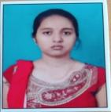 | S2013396 | 2983 / 3280 | 90.95% | VIII Rank
4 | Ms.GL Buela Rani | S2013266 | 2974 / 3280 | 90.34% | IX Rank

