Department Events and Activities:-
- Orientation Programme to our PUC students organized as a social responsibility from our
Department. The programme was held on 15/02/2014.
Resource Persons -
- Sri. T. Vishwanath – Motivational Trainer, Corporate Speaker & Student Counsellor.
Spoke on “How to overcome the Examination Phobia”.

- Dr. Sai Prasad Reddy–- Doctor by Profession
Spoke on “Co-ordination between the mind and the body with concern to students’
studies”.
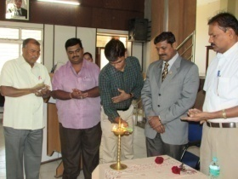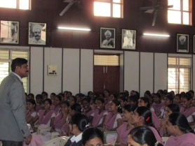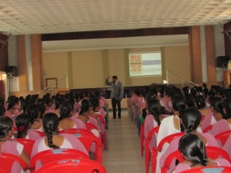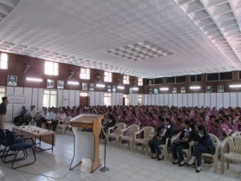

- Orientation and a Inter Collegiate Competition on the topic “Effective Public Speaking” organized in association with Junior Chamber International (JCI), Ballari Steel City, Ballari – This programme was held on 22/03/2014.

Guests & Juries from JCI -
- JC Vishwanath – President, JCI, Ballari Steel City, Ballari.
- JC Raghavendra Urs
- JC Pawan Kumar
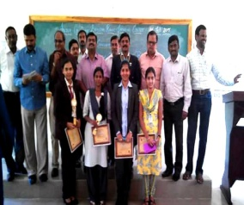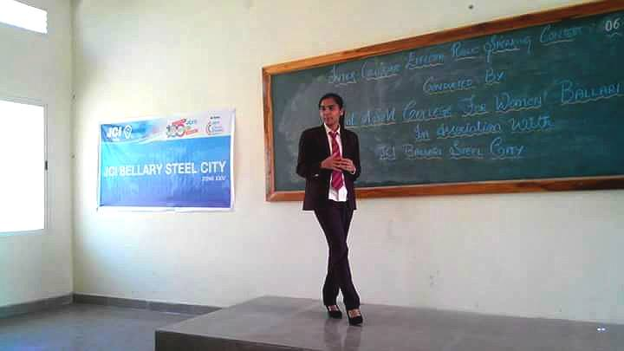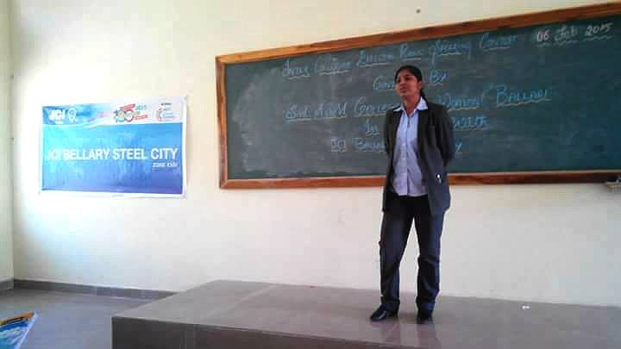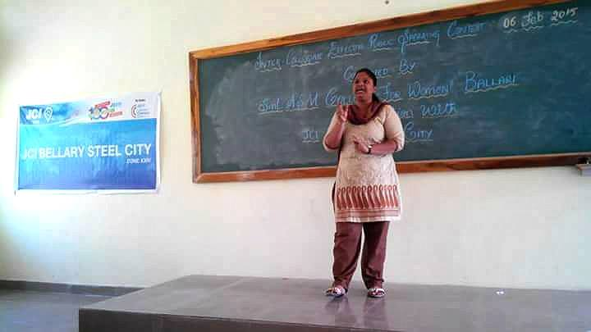

3) Orientation on the topic “Banking and Future Trends” - held on 20/09/2014.
Resource Person Smt. B.K. Shreelakshmi – Asst. Professor – Manipal Academy of Banking,
Bangalore.
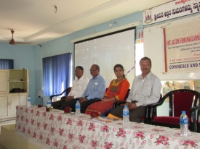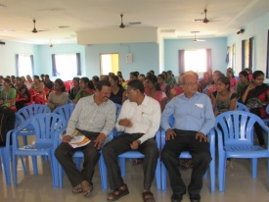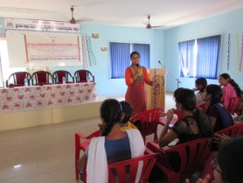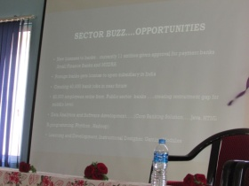

4) One Day Work Shop on the Topic “LITE” - held on10/10/2014.

L – Leadership Training
I – Interview Techniques
T – Team Building
E – Effective Communication Skills

Resource Person –
Sri.Vishwanath, Motivational Trainer, Corporate Speaker & Student Counsellor.

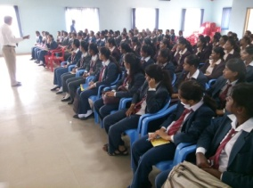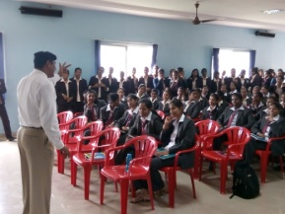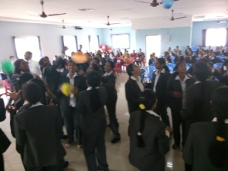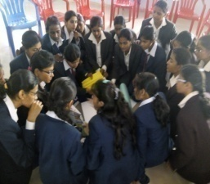

5) One day workshop on the topic “Learn Self Safety Techniques” a self defence programme
was held on 24/01/2014.
Resource Person –
Mr.Vijay Vittal – KBI Budokon International Karate, Bangalore.

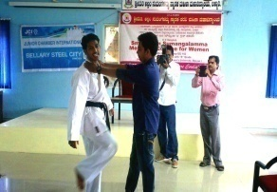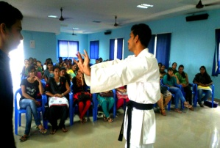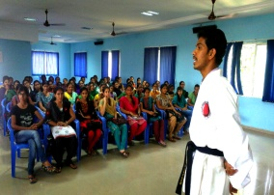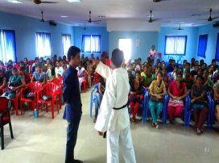

6) One day Workshop on the Topic “Attitude Wins Altitude” - held on 21/03/2015.
Resource Person –
Sri. Vishwanath - Motivational Trainer, Corporate Speaker & Student Counsellor.
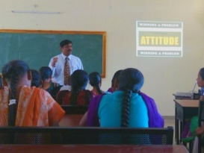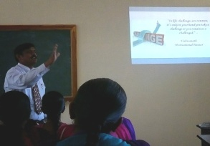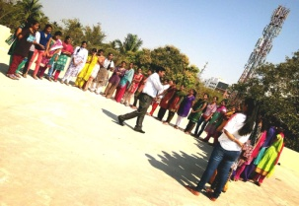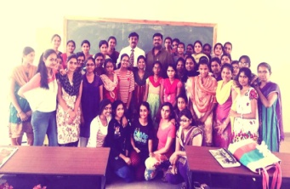

7) An interactive workshop to address the challenges of the modern woman “Young Woman
Rising” was held on 29/01/2016.
Resource Person –
Smt. Priya Dutt – Ex. M.P. from Maharashtra and a Social Activist.
Dr.Seema Sadiq – Famous Anti Aging Doctor and NGO Social Activist.


  

