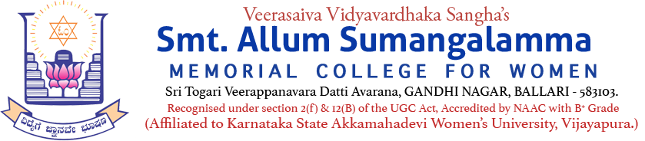
Internal Quality Assurance Cell (IQAC)
The Bharat Scouts & Guides Rangers Unit activity
Rovers & Rangers’ Officers Training Programme (A One Day Workshop)
Name of the Programme | Rangers’ Officers Training Programme (Workshop)
Category | Extension activity
Venue, Date & Time | Seminar Hall, 04.07.2026, 11.00am to 06.00p
Target Audience &  Participation of Students and Staff | Karnataka State Rangers’ Officers
Brief Report on activity | The Bharat Scouts and Guides Unit of Karnataka, District Organization, Ballari and Veerasaiva Vidyavardhaka Sangha’s Smt. Allum Sumangalamma Memorial College for Women, Ballari in association with Vijayanagara Sri Krishnadevaraya University, Ballari, jointly organized a one-day induction camp for graduate and undergraduate lecturers and a one-day workshop for Rover Scout Leaders and Rangers Leaders at the Library Seminar Hall of College on 06.07.2026. In this program, Dr.Kuppagal Veeresh, District Scouts Commissioner, Smt. Kathyayani M Maridevaiah, College Governing Council Chairperson, Principal Dr. Dupam Satish, Secretary of Bellary District Scouts and Guides Shri Vijaya Simha, District Training Commissioner of Scouts and Guides Shri M Nagaraj, District Resident Commissioner of Scouts and Guides Shri Ananth Kumar Shetty, Rover Scouts Leader Shri Chandrashekhar Reddy, College Ranger Leader Dr. Mangala B.N., District Organizer Shri Mohammed Sharfuddin were present. The program was presided over by District Scouts Commissioner Dr. Kuppagal Veeresh, as well as the Chairperson of the College Governing Council Smt. Kathyayani M Maridevaiah, Principals Dr. Dupam Satish, Dr. Govindaraj B and District Secretary Shri Srivijaya Simha, Shri Shashidhar Kellur, Rover Ranger Nodule Officer Shri Ashok Ji, Director of Fire were the chief guests. Shri Chandrashekhar Reddy, Dr. Mangala BN, Shri Shambhunath, Shri M Nagaraj acted as the resource persons of this workshop. The program began with the inauguration of the prayer song and flag hoisting as per the rules of The Bharat Scout and Guides Rangers Unit. All the dignitaries on the stage inaugurated the program by watering the saplings. Shri M Nagaraj delivered the introductory speech. The Principal of the College Dr. Dupam Satish appreciated the work of the Ranger Unit of the college and told the lecturers about the importance of Rover and Ranger. The Chairperson of the College Council Smt. Kathyayani M Maridevaiah, congratulated the newly-inducted Ranger Leader and Rover Leaders. Dr. Veeresh, who presided over the program, informed all the lecturers about what is Rover Ranger? What is the need for these units for undergraduate and graduate colleges. After the workshop, the Principal Dr. Govindaraj B, distributed certificates to all the lecturers who participated in the workshop and the program was presented by Dr. Mangala B N. The welcome was delivered by Shri Shambunath.
Geo Tagged Photos Social Media Web link | https://www.facebook.com/share/p/1B5BQks5pF/
HEI Web link of the Event | https://www.smtasmc.org/index.php/latest-news-home-left/the-bharat-scouts-guides-rangers-unit-activity-held-on-04-07-2026-seminar-hall
