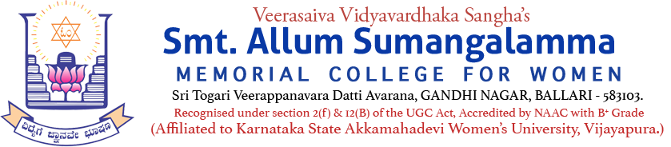
Internal Quality Assurance Cell (IQAC)
Chemistry Department
Programme: UG - BSc Departments: CBZ
Name of the Programme | Chemistry Day – 2026
Category | Importance of the Day
Venue, Date & Time | Seminar Hall, 03.08.2026, 11.00am
Resource Person | Dr. B.GOVINDARAJU
Target Audience &  Participation of Students and Staff | UG Students & Staff  (Attendance Sheet Copy Enclosed)
Brief Report on activity | The Department of Chemistry, in association with the Internal Quality Assurance Cell (IQAC) of V.V. Sangha's Smt. Allum Sumangalamma Memorial College for Women, Ballari, organized the "National Chemistry Day Celebration–2026" on 3rd August, 2026, at 11:00am in the Library Seminar Hall to commemorate the birth anniversary of Prof. Acharya Prafulla Chandra Ray, the Father of Indian Chemistry. The programme was presided over by the Principal, Dr. Dupam Satheesh, who addressed the gathering and appreciated the efforts of the Department of Chemistry in organizing the event. In his presidential address, he motivated the students to develop a scientific outlook, emphasized the importance of research and innovation, and inspired them to contribute meaningfully to society through science. He also highlighted the invaluable contributions of Prof. Acharya Prafulla Chandra Ray to the development of chemistry in India. The Chief Guest of the programme, Dr. B. Govindraju, principal of VVS College, addressed the students on the significance of chemistry and the remarkable contributions of Prof. Acharya Prafulla Chandra Ray to the field of science and chemical education. Dr. Bindu P. J., Head, Department of Chemistry, delivered a brief note on the significance of National Chemistry Day. She emphasized the importance of celebrating the birth anniversary of Prof. Acharya Prafulla Chandra Ray, whose pioneering contributions laid the foundation for modern chemical education and research in India. The programme was organized under the guidance of Dr. Bindu P. J., Head, Department of Chemistry, with the support of the faculty members Mr. Basavaraj, Ms. Rohinaz, Ms. Lakshmi, and Sri Basavanagouda. The programme commenced with an invocation by Ms. R. Deepthi of V Semester. Ms. Indira Chowdhary of V Semester welcomed the guest and the gathering. The programme was compered by Ms.Anees Fathima of V Semester. As part of the celebration, an Elocution Competition was conducted for the final-year BSc Chemistry students. The V Semester students participated enthusiastically. The winners of the competition were:  First Prize - Ms. Sahana (PCM) Ms. Kanchana (PCM)  Second Prize - Ms. Sushmita (PCM) Ms. Savitha(PCM)  The vote of thanks was delivered by Ms. Amrutha, who expressed sincere gratitude on behalf of the Department of Chemistry to the Chairperson, Smt. Kathyayani M. Maridevaiah, Principal, Dr. Dupam Satheesh, IQAC Coordinator Dr. Syeda K. Tanveer, faculty members of the organizing committee, students, and all those who contributed to the successful conduct of the National Chemistry Day celebration. The programme concluded with the distribution of prizes to the winners. Around 100 students from the III and V Semester BSc Chemistry classes attended and benefited from the programme. The event concluded on a positive note with the active participation of faculty members and students, making the celebration both informative and inspiring.
Geo Tagged Photos Social Media Web link | https://www.facebook.com/share/p/1B9vRTeQQP/
HEI Web link of the Event | "Chemistry Day" observed on 03.08.2026

