NSS Activities 2019-20
Awareness Programme on Save Soil
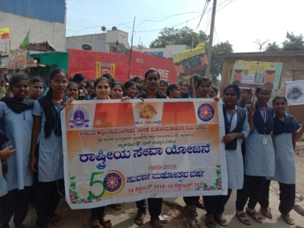
Awareness Programme on Historical Culture

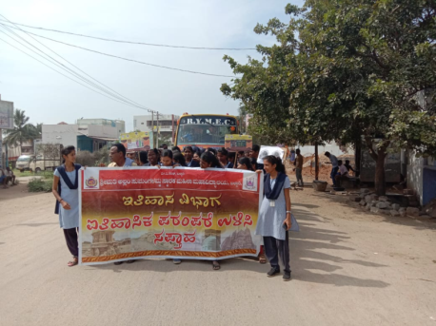
Awareness Programme on Agricultural Activities – Farmers Day

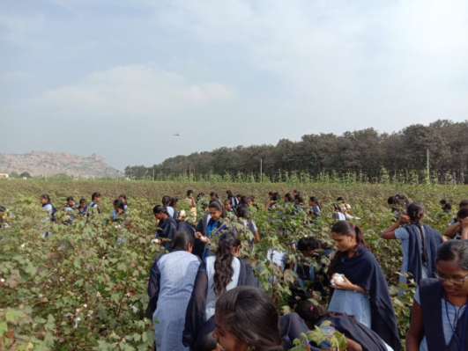
Awareness Programme on Agricultural Activities

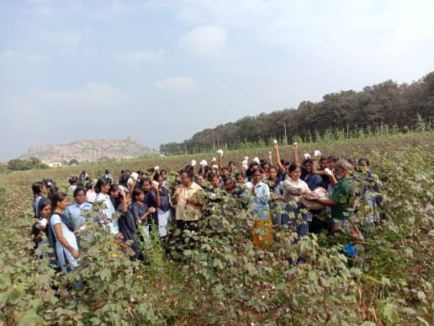

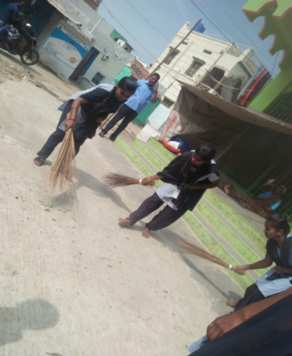
Swachhata Abhiyaan in Sangankal Village

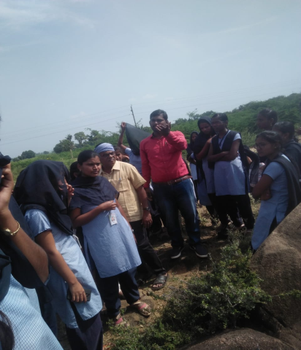
Awareness Programme on Protect Environment

