Smt. A.S.M. College for Women, Ballari.

Department of Sociology

About Department:-
The Department of Sociology was started in the 1985. Initially, it was started with Pre-University Course and B.A.-I Year with a moderate strength. Today, the strength has gone up to sixty four for the academic year 2016-17. The foundation was laid by Smt. Lajvanthi Puranikmath and Dr.S.D.Shapeti as the founder Staff of the Department. Later on Smt.P.V.Kalpana joined in the 1987 as a Lecturer in Sociology and served the Department upto 2000. In the meanwhile, Mr. Ashok took over the workload of Smt.P.V.Kalpana and served till 2012 and then Dr.H.B.Jalajakshi being deputed from Veerashaiva College and serving the Department till date.
The Sociology subject has become popular in the recent years. Its role is not less than significant in enriching our culture and heritage. It helps the students to great extent in preparing for the competitive examinations conducted by the UPSC, SSC and KPSC. Presently, both the Teachers are Ph.D., holders and actively engaged in research oriented activities. They have been continuously guiding and motivating the students to involve in research oriented activities on various social issues in the society.

Vision & Mission:
Vision:
“To excel in the study of social problems and produce experts to contribute
to community development in the society”

Mission:
- To develop continuously in the areas of teaching, training and research in the Sociology subject.
- To develop scientific and interpretative capacity for understanding social and cultural forces.

Objectives:
- To apply sociological concepts to real life conditions.
- To examine critically social issues.
- To integrate social theory and research.
- To disseminate new knowledge in the field Sociology.
- To conduct outreach programmes.
- To foster social responsibility and improve the quality of life.

Faculty of the Department:
Sl. No. | Name | Designation | Mobile Number and E-Mail ID
1. | 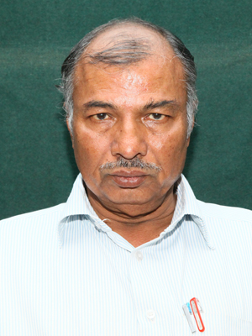  Dr. S.D. Shapeti,  M.A., M.Phil., Ph.D., | Associate Professor  &  Head of Department | 9449626299
2. | 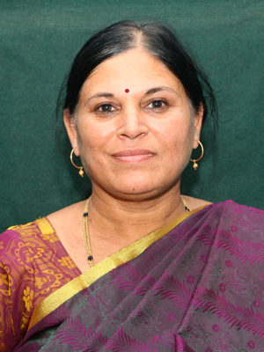  Dr. H.B. Jalajakshi,  M.A., Ph.D., | Assistant Professor | 9945626621  jalajakshi001@gmail.com

Events:-
The students of the Department play an active role in all activities conducted by the College. The activities include academic related events like seminars, talks, discussions, debates, paper presentations in the classroom.

Apart from the department regularly organized various talks, seminars and discussions by many eminent personalities in the discipline of Sociology.
* * *

