Smt. A.S.M. College for Women, Ballari.

About Department:-
The Department of English was started in the year 1969 with the initial strength of 64 students. The Department was headed by Miss. Rogasi Fernandis and later on the department responsibility was shouldered with the support extended by Smt. Rajalakshmi, Smt. Asha Rani, Dr.G.Uma Maheshwar and Smt.Rafath Ahmed. Presently, the Department is headed by Mr.K.Vijayendra Ranga Prasad with the support of two Guest Faculty Mr.Ramesh and Mr.Kotresh.N. Since the time the department has marked an overall results of 90 percent that includes all programmes. The department is also bestowed with “Sarojini Literary Association” - a forum which aims at exploring the skills and talents of the students by conducting essay writing, elocution competitions. The faculty also handles Communicative English classes for the IV Semester of B.A and B.Sc students which is a part of regular curriculum. The department is guiding at its best to make the students to overcome from the conventional feeling that English is a foreign subject and to enable them to learn it as other common subjects.

Vision and Mission:-
Vision:
“Learn English to Learn Everything”

Mission:
- To overcome the conventional feeling of English being a foreign and tough language.
- To create a communicative competency among learners to face global challenges.

Objectives:
- To equip students with the advanced method of learning English.
- To make use of Language Lab to develop communicative skills.
- To provide comprehensive approach in learning English as a ‘Global Link Language’.
- To transform the continental language into a common language of opportunities.

Faculty of the Department:-
Sl. No. | Name | Designation | Mobile Number and E-Mail ID
1. | 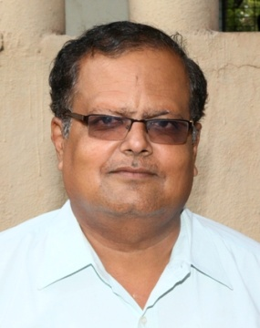  Mr. K.Vijayendra Ranga Prasad,  M.A., M.Phil., | Assistant Professor  &  Head of Department | 9481718358  karanamvijayendra.1@gmail.com
2. | 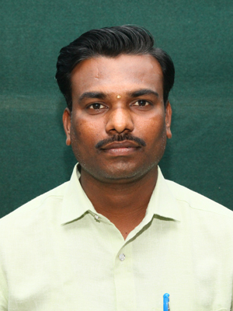  Mr. S.M. Ramesh,  M.A., B.Ed., M.Phil., | Lecturer | 9731444301  rameshteacher1983@gmail.com
3. | 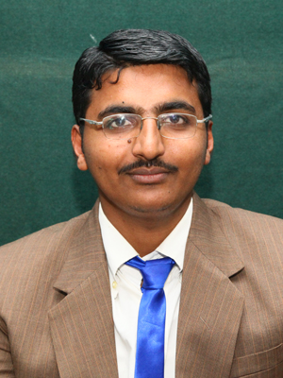  Mr. Kotresha.N.,  M.A., B.Ed., | Lecturer | 9739292926  manuparva90@gmail.com
EVENTS CONDUCTED BY ENGLISH DEPARTMENT AND SAROJINI LITERACY ASSOCIATION
Elocution: An Elocution competition was held on the topic–“English and Mother Language”. Dr.Shashikiran.G., Prof.A.Mallikarjuna Reddy and Sri.Umesh were the judges. Number of students actively participated in the event and presented their topics in their own style and stance. Kum.Priyanka of B.Sc III Sem and Kum.Sumayya of B.Com.-III semester were the winners.
A Seminar on “Speaking Skills and Presentation” was held for M.Com students. H.O.D. of English K.Vijayendra Ranga Prasad was the Coordinator for the event and Faculty members Mr.Kotresh.N., carried out the seminar successfully. Kum. Anisha & Kum.Bharathi and other students presented the topic through PPT and explained various aspects about the topic.
The Department of English had conducted “Love Kannada - Learn English” an English Awareness Programme in ShreedharaGadda village near Ballari. The English faculty Sri.K.Vijayendra Ranga Prasad, Sri.Ramesh S.M. and Sri.Kotresha.N., visited the houses in the village and explained the benefits of learning, English as a continental language along with Mother Language Kannada. The president of the Grama Panchayat Smt.Huligamma lauded the efforts of the English faculty.
The Department of English had conducted “Examination Motivation Event” for PUC II year students. Mr.Kotresha.N., Faculty Member carried out the event explaining on the topic “How to overcome Examination Fear” He also interacted with the students on the occasion. H.O.D. Sri. Vijayendra Ranga Prasad, described the significance and benefits of learning English. Prof. Channaveerappa, Principal, ASM PU College presided over the event commended the efforts of Dept. of English in encouraging the students to appear the forthcoming examination without stress or fear.
The Department of English had organised one week “An Intensive Grammar Course for Slow Learners”. Mr. Ramesh S.M., Guest Faculty was the Resource Person. He explained various topics of Grammar and created confidence among the students in learning English. H.O.D. Sri.Vijayendra Ranga Prasad explained important clues in attempting grammar questions.
“Anuvada Event” - An event to check the power and ability of translation among the students. The department has conducted this interdisciplinary event. The event was jointly held by the Department of English and Kannada. The degree students took an active part in the event and translated the sentences of both the languages.
* * *

