Bachelor of Business Administration (B.B.A.)
About Department:-
Smt.Allum Sumangalamma Memorial College for Women is one of the premier institution in the Hyderabad-Karnataka region of the state, shouldered the greater responsibility of fostering Women education which was established in the 1969 by the prestigious Veerashaiva Vidyavardhaka Sangha, Ballari.
Keeping in pace with the growing demand for Management courses on the trend of Privatization, Globalisation and Liberalisation and Ballari is recognised as Steel City, the Gulbarga University has permitted to open different professional and self financing courses. The V.V.Sangha, Ballari has recognised the importance and realised the necessity of opening the Management Course in our College. Hence, the BBM course was commenced in the year 1996-97 with the initial intake of 30 students. Because of growing demand for management course in the year 2002-2003 the permission limit was increased from 30 to 40 students.
As per the recommendation of Nanjundappa Committee, the Government of Karnataka has started a separate Women’s University for Karnataka state in Vijayapura in the year 2007. Hence, our College is now affiliated to K.S.W.U., Vijayapura.
The year 2010 was a landmark in the history of our Department because in that year the “Business Laboratory” was inaugurated for the exclusive benefit of the students pursuing Management course. This Laboratory is well equipped with 32 computers with latest configuration. The dedicated faculty of the department identifies every promising students and help in boosting their confidence and competence by conducting extra classes, special coaching and tests. Similarly, the slow learners are also identified by the respective staff dealing with the subject and taken care of by tutorials and special remedial classes. This is evident in the form of feedback obtained in parents-teachers meet and mentoring system in practice in the College. The faculty is consistently engaged in motivating the students to organise marketing fairs, exhibitions, seminars and workshops at regular intervals.
At present, there are four full time faculty members viz., Sri.Channappa Kowtal, Coordinator of BBA, Sri.Ajith Paul, Sri.Umesh.K.E., Miss.Gayatri.M.P., and five visiting faculty viz.,Sri.Rajeshekarappa, Sri.Bhemeeshwara, Sri.Ramesh, Miss.Srivani, Miss.Bhagyasree. Apart from, all the Staff members are regularly attending the State Level, National Level and International Level Seminars, Conferences and Workshops and presenting papers at regular intervals. Thus, the department is growing by leaps and bounds with the unsolicited co-operation from the Management, Principal, the Teaching and Non-Teaching Staff members and above all the students in general and parents in particular.

Vision:
Generating competent management professionals to become part of the industry by providing education in the discipline of management.

Mission:
To produce capable business leaders who are prepared with necessary management and research skills to make high quality business decisions in either an entrepreneurial or staff capacity.

Objectives:
- To educate the students to apply management fundamentals in practical world.
- To identify, formulate and solve managerial problems.
- To enhance entrepreneurship abilities so that the students are induced to undertake independent ventures.
- To train the students to acquire professional and ethical responsibility to serve the society.
- To inculcate the habit of self-learning and functioning in multi-disciplinary teams in the organisation.

Sl. No. | Name | Designation | Mobile Number and  E-Mail ID
1. | 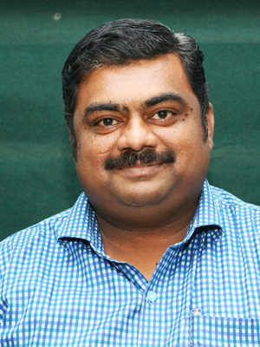  Sri. K. Channappa,  M.B.A., | Lecturer & Coordinator | 9886509959  channappakowtal@gmail.com
2. | 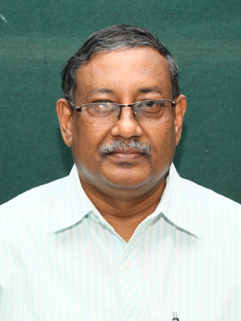  Sri. Ajith Paul,  MBA, LLB, | Lecturer | 9844077677  ajith.paul@gmail.com
3. | 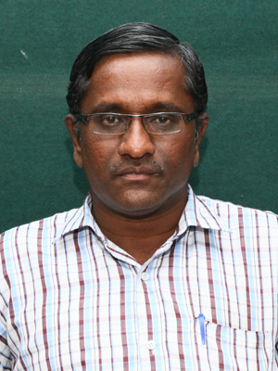  Sri. K.E. Umesh  MBA, M.Phil., | Lecturer | 9886651908  k.e.umeshg@gmail.com
4. | 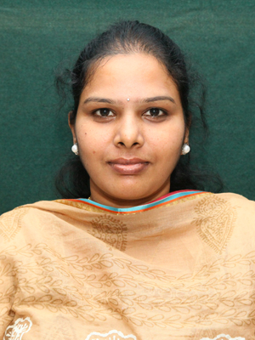  Kum. Gayatri.M.P.,  M.B.A., | Guest Faculty | 8123387123  mp.gayatri@gmail.com
5. | 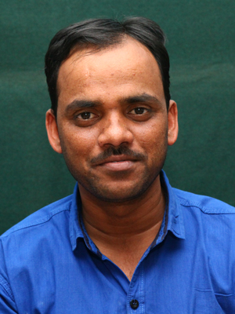  Sri. Bheemeshwara.K.M.  M.Com., B.Ed., | Guest Faculty | 9916322380  bheemeshbmv@gmail.com

Department Events and Activities:-
- Orientation Programme to our PUC students organized as a social responsibility from our
Department. The programme was held on 15/02/2014.
Resource Persons -
- Sri. T. Vishwanath – Motivational Trainer, Corporate Speaker & Student Counsellor.
Spoke on “How to overcome the Examination Phobia”.

- Dr. Sai Prasad Reddy–- Doctor by Profession
Spoke on “Co-ordination between the mind and the body with concern to students’
studies”.
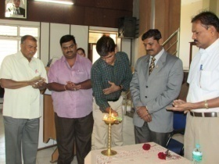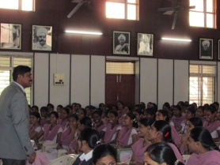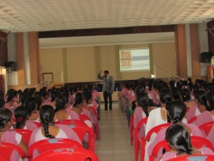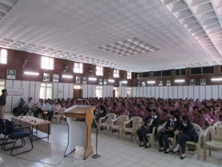

- Orientation and a Inter Collegiate Competition on the topic “Effective Public Speaking” organized in association with Junior Chamber International (JCI), Ballari Steel City, Ballari – This programme was held on 22/03/2014.

Guests & Juries from JCI -
- JC Vishwanath – President, JCI, Ballari Steel City, Ballari.
- JC Raghavendra Urs
- JC Pawan Kumar
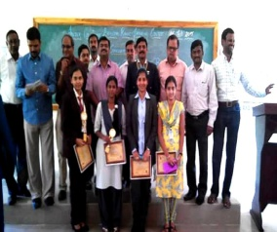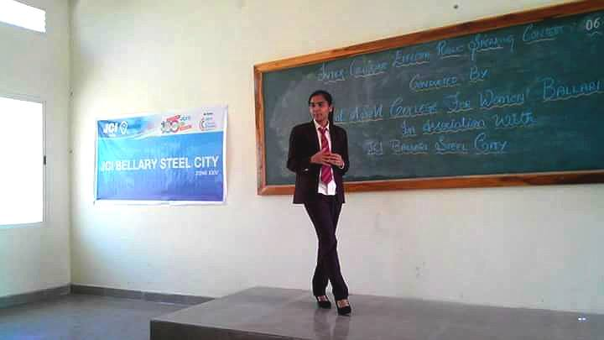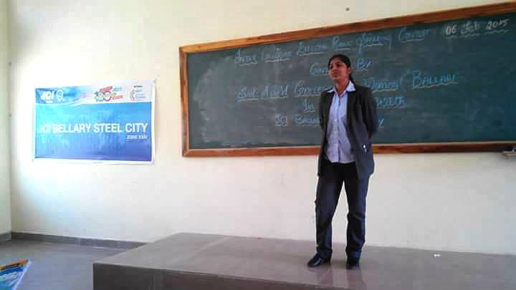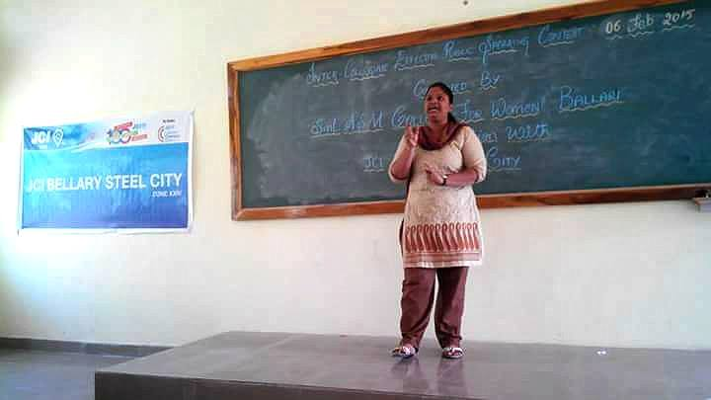

3) Orientation on the topic “Banking and Future Trends” - held on 20/09/2014.
Resource Person Smt. B.K. Shreelakshmi – Asst. Professor – Manipal Academy of Banking,
Bangalore.
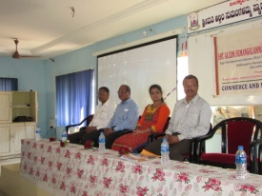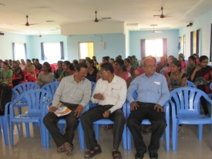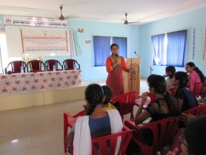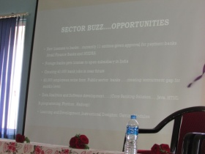

4) One Day Work Shop on the Topic “LITE” - held on10/10/2014.
L – Leadership Training
I – Interview Techniques
T – Team Building
E – Effective Communication Skills
Resource Person –
Sri.Vishwanath, Motivational Trainer, Corporate Speaker & Student Counsellor.

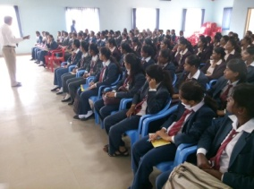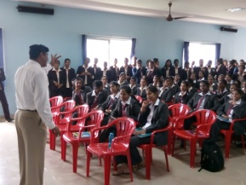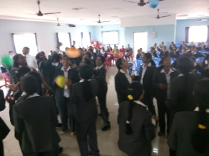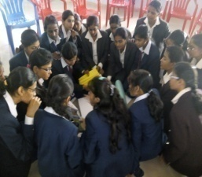

5) One day workshop on the topic “Learn Self Safety Techniques” a self defence programme
was held on 24/01/2014.
Resource Person –
Mr.Vijay Vittal – KBI Budokon International Karate, Bangalore.

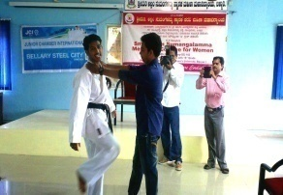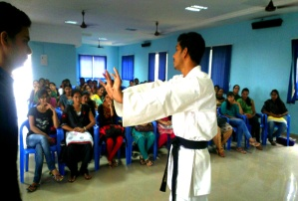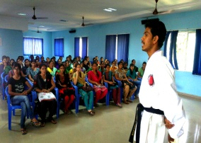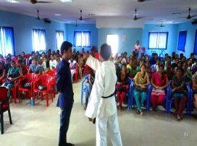
6) One day Workshop on the Topic “Attitude Wins Altitude” - held on 21/03/2015.
Resource Person –
Sri. Vishwanath - Motivational Trainer, Corporate Speaker & Student Counsellor.
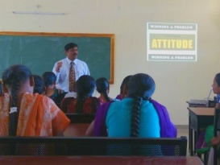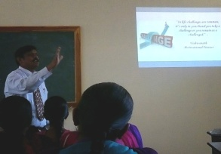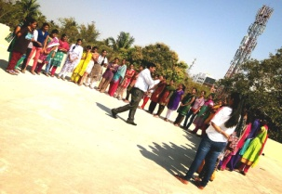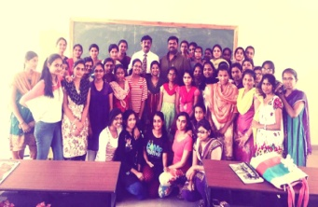
7) An interactive workshop to address the challenges of the modern woman “Young Woman
Rising” was held on 29/01/2016.
Resource Person –
Smt. Priya Dutt – Ex. M.P. from Maharashtra and a Social Activist.
Dr.Seema Sadiq – Famous Anti Aging Doctor and NGO Social Activist.

  

